**UNIT 4. IT Jobs**

*1. Repeat the following words and phrases after the teacher (minding stresses) and memorise them.*

Webmaster

Technical writer

Network administrator

Cryptographer

Database administrator

Systems analyst

Programmer (or developer)

Data architect

Computer technical support specialist

User interface designer

Applications architect

Cloud solutions architect

Web developer

Information security analyst

Mobile application developer

Front-end web developer

Back-end developer

*2. Read out the words and give their Russian equivalents.*

1 to develop

2 to maintain

3 backup

4 updating resources

5 to be involved in

6 to encourage

7 to expand

8 to increase

9 to manage

10 to be responsible for

11 implementation

12 maintenance

13 related to

14 encryption

15 to determine

16 to access

17 to utilize

18 preliminary investigation

19 to troubleshoot

20 to oversee

21 to ensure (to make sure)

22 readily accessible

23 to handle data

24 ˏingeʹnuity

25 to be hampered

26 to employ

27 diverse

28 scalaʹbility

29 website layout

30 to be highly proficient with

31 debugging

*3. (Track 02) Listen to six people introducing themselves. What jobs do they do? Complete the sentences. Then compare answers with a partner.*

1 database administrator

2 helpdesk supervisor

3 project manager

4 software developer

5 support technician

6 systems analyst

*4. Listen again. Complete these collocations.*

1 to write *software*

2 to supervise __________

3 to have __________

4 to be responsible __________ IT projects

5 to look __________ computers

6 to install __________

7 to diagnose __________

8 to design __________

9 to maintain __________

10 to write __________ for software

*5. (Track 03) Listen to an IT employee telling his new manager about his job. What do you think his job is?*

*Listen again. Tick 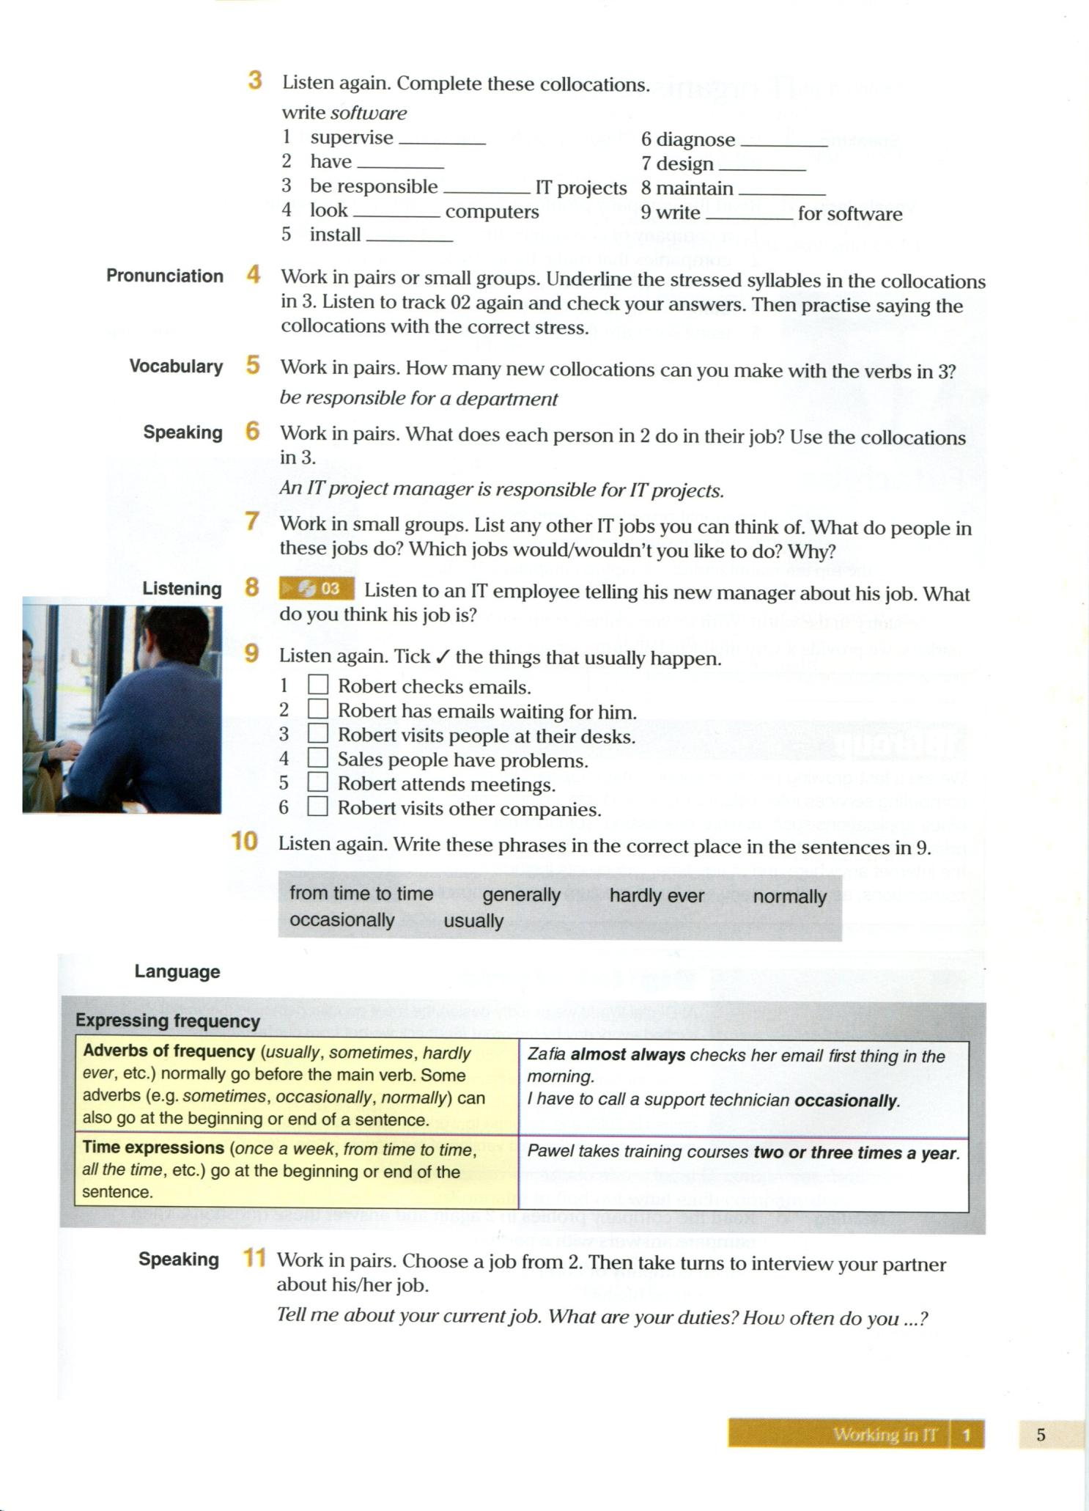 the things that usually happen.*

1 □ Robert checks emails.

2 □ Robert has emails waiting for him.

3 □ Robert visits people at their desks.

4 □ Sales people have problems.

5 □ Robert attends meetings.

6 □ Robert visits other companies.

*6. Listen again. Write these phrases in the correct place in the sentences in Task 5.*

1 from time to time

2 generally

3 hardly ever

4 normally

5 occasionally

6 usually

*7. While watching the video try to find the answers to the questions about a 12-year-old programmer.*

*(https://www.youtube.com/watch?v=Fkd9TWUtFm0).*

1 What is his main interest in life?

2 What is the name of Thomas’ first app?

3 Why did he create the app about Justin Bieber?

4 When did he release it?

5 Where do you go to find out how to make an app?

6 Can parents teach their children? Why not?

7 How much did his parents pay to be able to put his apps on the App Store?

8 What has he started at school?

9 Who is sponsoring the club?

10 What do they do there?

*8. Watch the video again and find English equivalents to the words below.*

1 притягивать, привлекать к чему-либо

2 делиться

3 гадалка

4 удача, счастье; богатство, состояние

5 игра «убить крота»

6 решил

7 разрешил демонстрацию, выпустил

8 разузнавать, узнавать

9 комплект, набор инструментов; дистрибутив

10 убедил, уговорил

11 поддержка, ободрение, побуждение

12 вдохновение

13 конструировать, проектировать

14 проблема, трудность

15 учреждения образования

16 признавать

17 сторонний

*9. Read the descriptions of IT jobs and be ready to differentiate between them.*

**Webmaster**s develop and maintain Web sites and resources. The job may include backup of the company Web site, updating resources, or development of new resources. Webmasters are often involved in the design and development of the Web site. Some Webmasters monitor traffic on the site and take steps to encourage users to visit the site. Webmasters also may work with marketing personnel to increase site traffic and may be involved in development of Web promotions.

**Technical writer**s prepare instruction manuals, technical reports, and other scientific or technical documents. Most technical writers work for computer software firms, government agencies, or research institutions. They translate technical information into easily understandable instructions or summaries. As new technology continues to develop and expand, the need for technical writers who can communicate technical expertise to others is expected to increase.

**Network administrator**s manage a company’s networks. They may be responsible for design, implementation, and maintenance of networks. Responsibilities usually include maintenance of both hardware and software related to a company’s networks. Network administrators are typically responsible for diagnosing and repairing problems with these networks. Some network administrators are responsible for planning and implementation of network security as well.

**Cryptographer**sdesign systems, break systems, and do research on encryption. Responsibilities typically do not include building and maintaining the computer networks that use cryptography; these are the duties of security engineers and network administrators. In general, cryptographers are mathematicians who specialize in making and breaking codes. Many cryptographers work as consultants or professors of cryptography, yet there are full-time positions available at some large corporations or for the government.

**Database administrator**s use database management software to determine the most efficient ways to organize and access a company’s data. Additionally, database administrators are typically responsible for maintaining database security and backing up the system. Database administration is a fast-growing industry and substantial job growth is expected.

A **systems analyst** follows the steps described in the systems life cycle. Analysts plan and design new systems or reorganize a company’s computer resources to best utilize them. Analysts follow the systems life cycle through all its steps: preliminary investigation, analysis, design, development, implementation, and maintenance.

**Programmer**s **or developer**s(in general) create, test, and troubleshoot programs used by computers. Programmers also may update and repair existing programs. Most computer programmers are employed by companies that create and sell software, but programmers also may be employed in various other businesses. Many computer programmers work on a project basis as consultants, meaning they are hired by a company only to complete a specific program.

**Data architects** oversee the design and maintenance of data across a variety of information systems and databases. The main goal of data architects is to ensure that data in a system or database is accurate and readily accessible. More than just administering a system, data architects must employ knowledge and analytical skills to determine if data is being handled in the best, most efficient way possible, and what methods can be implemented to improve existing systems. Data architects work alongside other IT professionals in teams.

**Computer technical support specialists** engage in troubleshooting and problem solving, both within a corporation and for individual clients. Computer technical support specialists draw on general knowledge of computer systems, hardware, and software, as well as knowledge of specific products, to improve technological issues. Some individuals in this field work for technical support service companies, while others work within corporations or agencies. Computer technical support specialists must maintain up-to-date knowledge of current technologies and technological issues.

**User interface designers** work to ensure that software functions smoothly and logically for users and consumers.

User interface designers operate within a software development team to design, create, and troubleshoot the user interface aspects of software. User interface designers rely on technical knowledge, familiarity with a variety of programming languages, critical thinking, and ingenuity to ensure that the user experience for software is not hampered by a poorly designed interface.

**Applications architects** ensure individual software projects follow the organization’s application development methodology and parameters. They also ensure the project fits a company’s technology infrastructure and business strategy.

Typically, large companies employ applications architects to work with a diverse set of existing applications that need to be integrated with numerous new application development projects. Based on an employer’s design standards, applications architects design components of applications.

**Cloud solutions architects** design solutions for companies seeking to move their IT infrastructure and services from on-premise servers to a cloud-based storage solution.

Cloud solutions architects define the cloud structure for a company and work with business analysts to make sure the architecture is in line with business requirements. They also make sure the cloud service provides high availability, scalability, and fault tolerance. Cloud solutions architects manage cloud infrastructure and ensure that private and public clouds interface well.

**Web developers** collect or create web content and plan website layouts and navigation, as well as coding for web pages. They also test and optimize a website for user experience and optimum performance.

Web developers draw on expert knowledge in programming languages used for the web to develop front-end and back-end aspects of websites and applications. They need to be highly proficient with HTML, Javascript, and CSS, and should be familiar with server-side programming languages to develop more complex applications. Web developers typically work in teams alongside web designers and other IT professionals.

**Information security analysts** develop and implement computer security strategies and systems to protect vital information from computer crime and cyber warfare.

Information security analysts monitor networks for security breaches and, when required, respond to attacks with countermeasures. Information security analysts must understand the current state of threats in the field, the needs of their employers, and current systems available for combating threats to information security. Information security analysts also educate employees on computer security.

**Mobile application developers** create applications for mobile devices, such as iPhones and Androids.

Mobile application developers utilize multiple programming languages to optimize application functioning on a variety of mobile platforms. Individuals in this field may find diverse project and employment opportunities, including optimizing mobile versions of existing applications, designing game apps, or designing functional lifestyle apps.

**Front-end web development**, also known as client-side development is the practice of producing HTML, CSS and JavaScript for a website or Web Application so that a user can see and interact with them directly. The challenge associated with front end development is that the tools and techniques used to create the front end of a website change constantly and so the developer needs to constantly be aware of how the field is developing.

A front-end developer architects and develops websites and applications using web technologies (i.e., HTML, CSS, DOM, and JavaScript), which run on the Open Web Platform or act as compilation input for non-web platform environments (i.e., React Native).

**Back-end**developers primarily develop and maintain the core functional logic and operations of a software application or information system. Typically, a back-end developer has expert programming skills in C++, C#, Java and other high-level programming languages. The key job role of a back-end developer is to ensure that the data or services requested by the front-end system or software are delivered through programmatic means. Back-end developers also create and maintain the entire back-end of a system, which consists of the core application logic, databases, data and application integration, API and other back-end processes. Moreover, a back-end developer performs the testing and debugging of any back-end application or system.

*10. Watch the video “A Day in the Life of a Software Engineer” and discuss your future career perspectives in teams.*

*11. Choose 2 or 3 jobs from Task 9 that appeal to you and describe them to your partner (work in pairs).*