Great Britain

1 Прочтите и запомните следующие слова и выражения:
To be situated – располагаться, находиться.
Total area – общая территория.
To be washed by – омываться чем-либо.
The English Channel – пролив Ла-Манш.
The Strait of Dover – пролив Па-де-Кале.
′Mountainous – гористый, возвышенный.
Lowland – низменный.
Peak – горная вершина.
To form a natural border – образовывать естественную границу.
Mild and damp climate – мягкий влажный климат.
Natural resources – полезные ископаемые.
Deposits – залежи.
Densely populated – густонаселенный.

2 Прочтите и переведите текст.
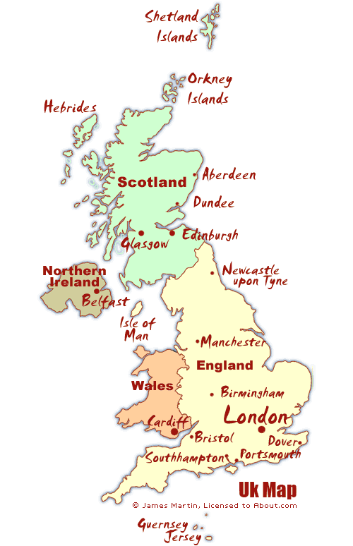

The United Kingdom of Great Britain and Northern Ireland (the U.K.) consists of England, Wales, Scotland and Northern Ireland. It is situated on the British Isles, which lie off the north-west of the European continent. G.B. and Ireland are the largest islands and there are also about 5000 small islands. The total area of the U.K. is about 244,000 km²; it is the 75th place among other countries of the world.
It is washed by the Atlantic Ocean in the north-west, north and south-west. In the west Great Britain is washed by the Irish Sea. The eastern coast of G.B. is separated from France by the English Channel, the narrowest part of which is called the Strait of Dover. It is only 32 km wide.
The island of G.B. is quite distinctly divided into two parts: ´mountainous (North and West) and lowland, sometimes hilly (South and East). The mountains are not very high; the highest peak is Ben-Nevis in Scotland (1343). The Cheviot Hills form a natural border between England Scotland. The Cambrian Mountains occupy the greater part of Wales.
The rivers in G.B. are short. The Severn is the longest river, while the Thames is the busiest and the most important river in England. It is wide and deep and is quite suitable for navigation. England, Ireland and Scotland have a lot of beautiful lakes, the most famous ones are in the Lake District. It is the most popular holiday district in the country.
The fauna and flora of G.B. is similar to that of the Northwest of Europe.
The climate of the British Isles is mild, not very cold in winter and not very hot in summer. The Atlantic Ocean and the warm waters of the Gulf Stream influence the weather. The rivers do not freeze in winter. All parts of the British Isles have a lot of rain in all seasons. In winter thick fog covers many parts of G.B. The mild and damp climate is very good for agriculture, especially for vegetable farming.
The U.K. is not very rich in natural resources; it has some deposits of coal and iron ore, and vast deposits of oil and gas discovered in the North Sea. The U.K. is a highly developed capitalist country. Most of its industries produce iron and steel goods, textiles and chemicals, all of which play an important role in the national economy of the country. G.B is a densely populated country. In the number of population (about 58 million people) it holds one of the 1st places among the European countries. There are 4 main nationalities: Englishmen, Scotsmen, Irishmen and Welshmen. The official language is English.
The large industrial cities of the country are London, Glasgow, Liverpool, Manchester, Sheffield and others.

3 Заполните пропуски подходящими словами:
consists of densely populated mountainous and lowland
in winter the Gulf Stream
1. The island of Great Britain is divided into two parts: … and … . 2. The United Kingdom of Great Britain and Northern Ireland … England, Wales, Scotland and Northern Ireland. 3. The rivers do not freeze … . 4. The Atlantic Ocean and … influence the weather. 5. Great Britain is a … country. Its population is about 58 million people.

4 Выберите правильный вариант:
1. The … is the longest river in Great Britain.
a) Severn b) Thames c) Mississippi
2. The Thames is wide and deep and is quite suitable for ….
a) travelling b) navigation c) communication
3. Lake District is the most popular … in the country.
a) industrial district b) financial district c) holiday district
4. The climate of the British Isles is generally … .
a) cold b) warm c) mild
5. The large industrial cities of the country are … .
a) London, Glasgow, Boston b) Liverpool, Manchester, New-York c) London, Glasgow, Manchester

5 Ответьте на вопросы:
1. Where is the United Kingdom of Great Britain and Northern Ireland situated? 2. What is the total area of the country? 3. What is the longest river and what is the most important river in England? 4. What is the climate of the British Isles? 5. When do the British Isles have a lot of rain? 6. Is the U.K. rich in natural resources? 7. What do British industries produce?

6 Перескажите текст “Great Britain”.

