**User Interfaces**

**User interface** - the features of a computer system which allow the user to interact with it.

A user interface, also sometimes called a human-computer interface, comprises both hardware and software components. It handles the interaction between the user and the system.

There are different ways of interacting with computer systems which have evolved over the years. There are five main types of user interface:

* command line (cli)
* graphical user interface (GUI)
* menu driven (mdi)
* form based (fbi)
* natural language (nli)

***Command line interface*** is the oldest of the interfaces. It involves the computer responding to commands typed by the operator. This type of interface has the drawback that it requires the operator to remember a range of different commands and is not ideal for novice users.

***Graphical user interface*** (GUI) is sometimes also referred to as WIMP because it uses *Windows*, *Icons*, *Menus* and *Pointers*. Operators use a pointing device (such as a mouse, touchpad or trackball) to control a pointer on the screen which then interacts with other on-screen elements. It allows the user to interact with devices through graphical icons and visual indicators such as secondary notations. The first commercially available GUI, called "PARC," was developed by Xerox.

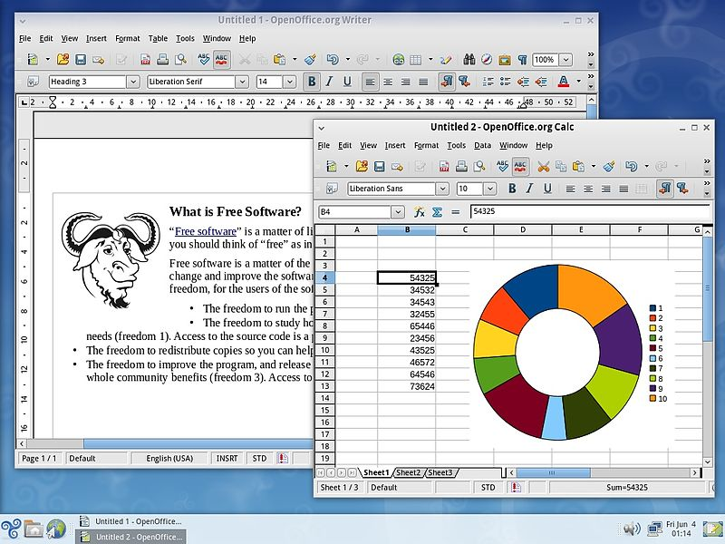

A ***menu driven interface*** is commonly used on cash machines (also known as automated teller machines (ATM’s), ticket machines and information kiosks (for example in a museum). They provide a simple and easy to use interface comprised of a series of menus and sub-menus which the user accesses by pressing buttons, often on a touch-screen device.

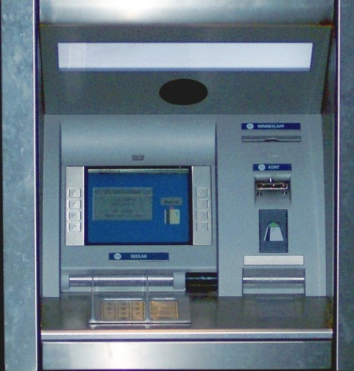

A ***form-based interface*** uses text-boxes, drop-down menus, text areas, check boxes, radio boxes and buttons to create an electronic form which a user completes in order to enter data into a system. This is commonly used on websites to gather data from a user, or in call centres to allow operators to quickly enter information gathered over the phone.

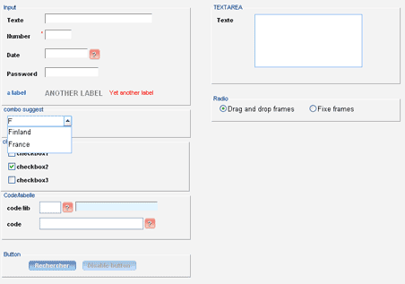

A ***natural language interface*** is a spoken interface where the user interacts with the computer by talking to it. Sometimes referred to as a “conversational interface”, this interface simulates having a conversation with a computer. An Example of this type of interface is Voice Recognition. This is the kind of interface used by the popular [iPhone](https://en.wikipedia.org/wiki/iPhone) application called [Siri](https://en.wikipedia.org/wiki/Siri) and [Cortana](https://en.wikipedia.org/wiki/Cortana) in [Windows](https://en.wikipedia.org/wiki/Windows).