Software

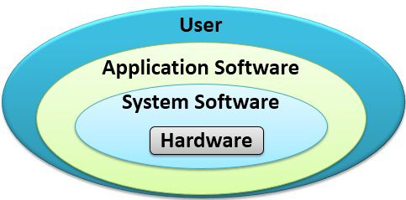

End-users interact with application software.

System software interacts with the computer.

Software is another name for programs. Programs are the instructions that tell the computer how to process data into the form you want. In most cases, the words software and programs are interchangeable.
There are two major kinds of software – application software and system software.
Application software is end-user software. It performs useful work on general-purpose tasks such as word processing and cost estimating. It may be packaged or custom-made.
- Packaged software consists of any program prewritten by professional programmers and is offered for sale on a disk.
- Custom-made software, or custom programs, is software made by individual order.

These programs can be categorized as either basic or specialized applications.
Basic applications are widely used in nearly all career areas. They are the kinds of programs you have to know to be considered computer competent. One of these basic applications is a browser to navigate, explore, and find information on the Internet. One of the most widely used browsers is Google Chrome.
Other general-purpose programs that we call “basic tools” are:
- Word processors, used to prepare written documents
- Electronic spreadsheets, used to analyze and summarize data
- File and database managers, used to organize and manage data and information
- Graphics programs, used to present data visually, as charts and graphs
- Communications programs, used to transmit and receive data
- Integrated programs, which combine some or all of these programs in one package

Specialized applications include thousands of other programs that are more narrowly focused on specific disciplines and occupations. Some of the best known are graphics, audio, video, multimedia, Web authoring, artificial intelligence programs, and cell phone apps.

System software enables the application software to interact with the computer. System software is computer “background” software. It includes programs that help the computer manage its own internal resources.
The most important system software program is the operating system, which interacts between the application software and the computer. The operating system handles such details as running (“executing”) programs, storing data and programs, and processing (“manipulating”) data.
The most popular microcomputer operating systems are Windows, MacOS and Linux.
- Utilities perform specific tasks related to managing computer resources. For example, the Windows utility called Disk Defragmenter locates and eliminates unnecessary file fragments and rearranges files and unused disk space to optimize computer operations.
- Device drivers are specialized programs designed to allow particular input or output devices to communicate with the rest of the computer system.

Task 1. MULTIPLE CHOICE.
1. There are two major kinds of software – … .
a) applications; b) packaged; c) custom-made; d) systems
2. File and database managers are used to organize and manage data and … .
a) documents; b) information; c) programs; d) table
3. Communications programs are used to transmit and … data.
a) create; b) perform; c) receive; d) use
4. Systems software enables the applications software to interact with the… .
a) people; b) operating system; c)”end-user”; d) computer
5. The operating system interacts between the computer and the … .
a) applications software; b) systems software; c) data; d) ”end-user”

Task 2. TRUE OR FALSE.
1. Applications software may be packaged or custom-made.
2. There are over 11,000 different types of applications packages available for microcomputers alone.
3. Word processing programs are used to prepare written documents.
4. The most important systems software is applications software.
5. OS/2 is the operating system developed for IBM’s less powerful microcomputers.

Task 3. FILL IN THE BLANKS.
1. Programs are the … that tell the computer how … into the … .
2. A program might compute payroll checks, …, calculate sales commissions, … .
3. Integrated programs … some or all of the programs in one … .
4. Systems software is…software.
5. Microcomputer operating systems are in the process of changing as the machines themselves become … and … the older operating systems.

Task 4. ANSWER THE QUESTIONS.
1. How many major kinds of software do you know?
2. How do we name certain universal programs?
3. What are the most popular so-called “basic tools” you know?
4. What system handles such details as running programs, storing data and programs, and processing data?
5. What most popular microcomputer operating systems can you name?

