Лабораторная работа №1

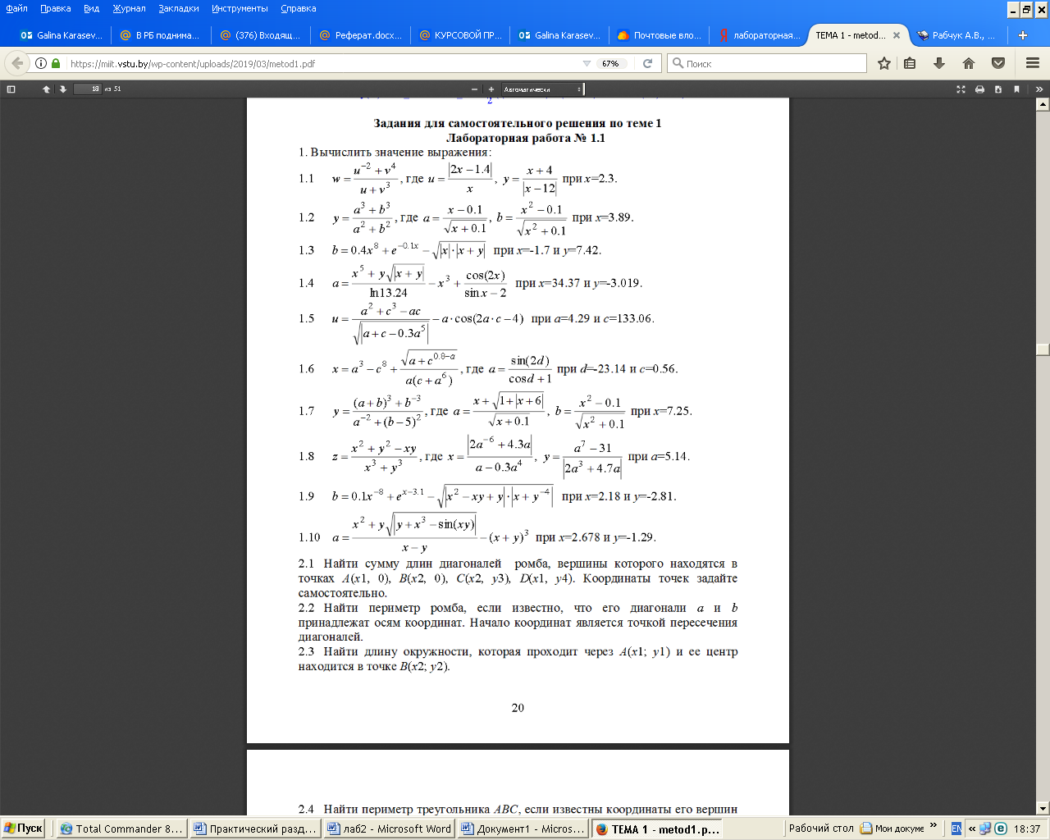
- Найти сумму длин диагоналей ромба, вершины которого находятся в точка $A\left(x1, 0\right)$, $B\left(x2, 0\right)$, $C\left(x3, y3\right)$, $D\left(x4, y3\right)$. Координаты точек задаются самостоятельно.
- Найти периметр ромба, если известно, что его диагонали $a$и $b$ принадлежат осям координат. Начало координат является точкой пересечения диагоналей.
- Найти длину окружности, которая проходит через $A\left(x1, y1\right)$ и её центр находится в точке $B\left(x2, y2\right)$.
- Найти периметр треугольника, если известны координаты его вершин $A\left(x1, y1\right)$, $B\left(x2, y2\right)$, $C\left(x3, y3\right)$.
- Найти сумму длин диагоналей прямоугольника, противоположные вершины которого находятся в точках $A\left(x1, y1\right)$ и $C\left(x3, y3\right)$.
- Найти площадь поверхности прямоугольного параллелепипеда, если длина его рёбер $a$, $b$ и $c$.
- Найти площадь треугольника $\text{ABC}$, если известны координаты его вершин $A\left(x1, y1\right)$, $B\left(x2, y2\right)$, $C\left(x3, y3\right)$.
- Найти площадь боковой поверхности конуса, если даны его высота $h$ и радиус основания $R$.
- Найти площадь круга, радиус которого проходит через $A\left(x1, y1\right)$ и его центр находится в точке $B\left(x2, y2\right)$.
- Прямоугольник с вершинами $A\left(x, 0\right)$, $B\left(x, y\right)$, $C\left(0, y\right)$, $D\left(0, 0\right)$ вращается вокруг стороны $\text{CD}$. Найти площадь полученной фигуры.

Лабораторная работа №2
Решение задач линейной алгебры

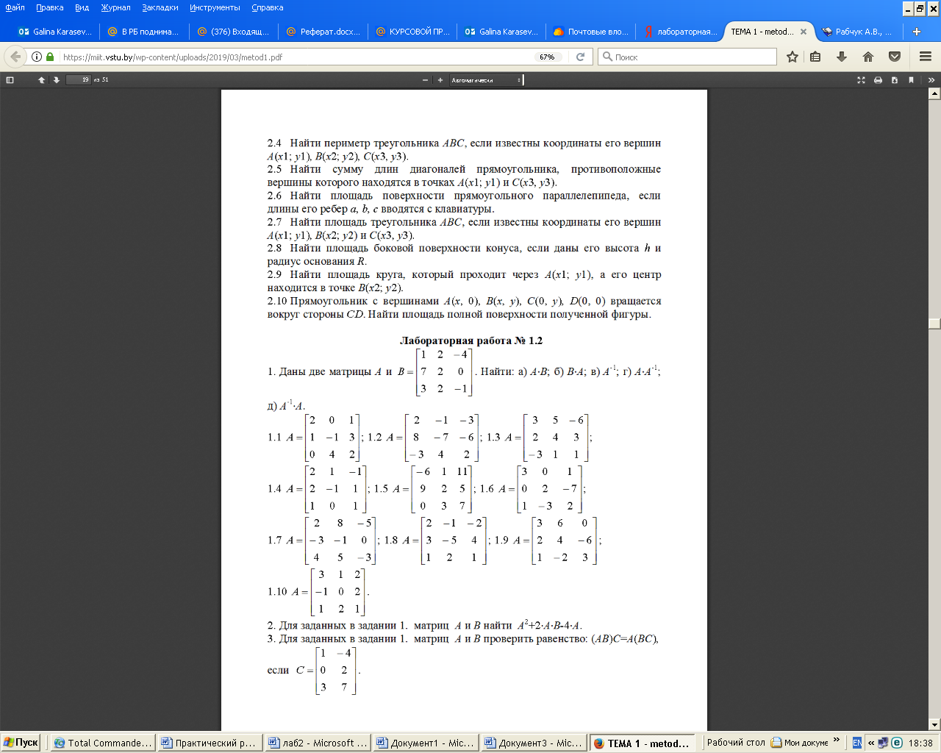
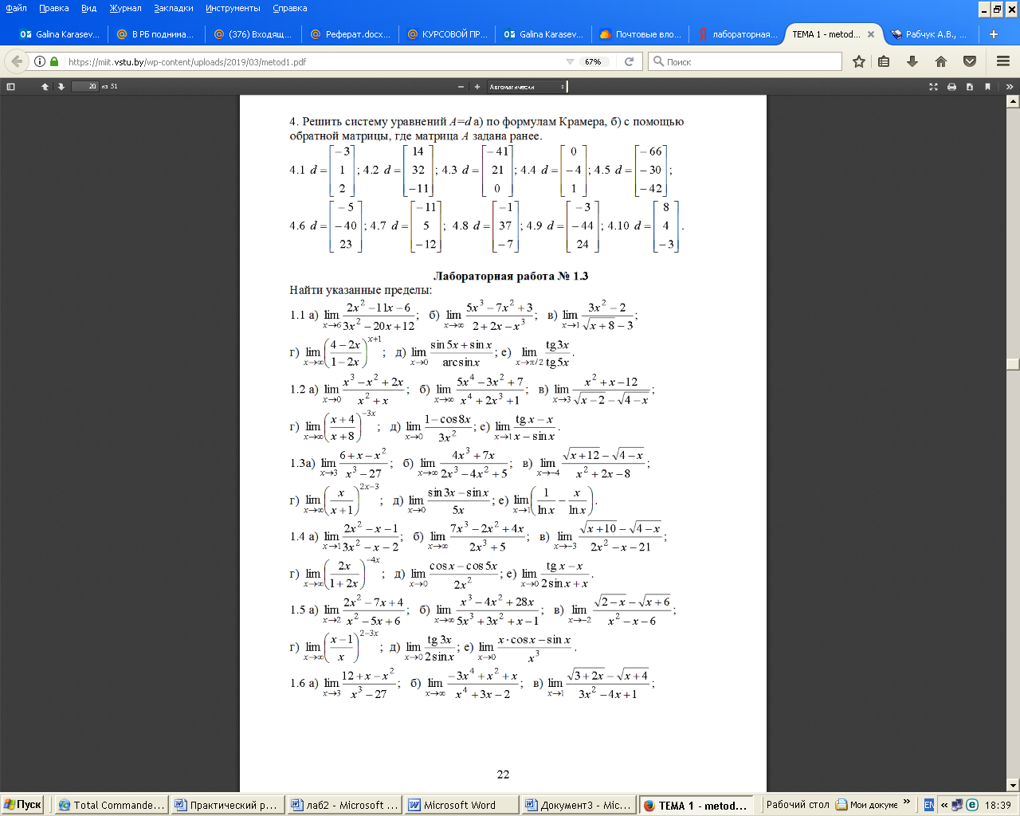
5. Найдите методом простых итераций приближенное решение линейной системы $\text{Ax}=b$. Организовать интерактивный ввод исходных данных.

№ | Задания | № | Задания
1 | $А=\left(\begin{matrix}\text{100} & −\text{14} & \text{13} \\ 0\text{.}5 & \text{200} & 9\text{.}5 \\ −9 & 9 & \text{300}\end{matrix}\right)$, $B=\left(\begin{matrix}−\text{1232} \\ \text{326} \\ \text{4335}\end{matrix}\right)$ | 7 | $А=\left(\begin{matrix}\text{700} & −8 & 7 \\ 3\text{.}5 & \text{1400} & 6\text{.}5 \\ −3 & 3 & \text{2100}\end{matrix}\right)$, $B=\left(\begin{matrix}−\text{5600} \\ \text{9824} \\ \text{16850}\end{matrix}\right)$
2 | $А=\left(\begin{matrix}\text{200} & −\text{13} & \text{12} \\ 1 & \text{400} & 9 \\ −8 & 8 & \text{600}\end{matrix}\right)$, $B=\left(\begin{matrix}−\text{2470} \\ \text{904} \\ \text{7920}\end{matrix}\right)$ | 8 | $А=\left(\begin{matrix}\text{800} & −7 & 6 \\ 4 & \text{1600} & 6 \\ −2 & 2 & \text{2400}\end{matrix}\right)$, $B=\left(\begin{matrix}−\text{5614} \\ \text{12810} \\ \text{16830}\end{matrix}\right)$
3 | $А=\left(\begin{matrix}\text{300} & −\text{12} & \text{11} \\ 1\text{.}5 & \text{600} & 8\text{.}5 \\ −7 & 7 & \text{900}\end{matrix}\right)$, $B=\left(\begin{matrix}−\text{3504} \\ \text{1884} \\ \text{1091}\end{matrix}\right)$ | 9 | $А=\left(\begin{matrix}\text{900} & −6 & 5 \\ 4\text{.}5 & \text{1800} & 5\text{.}5 \\ −1 & 1 & \text{2700}\end{matrix}\right)$, $B=\left(\begin{matrix}−\text{5424} \\ \text{16210} \\ \text{16220}\end{matrix}\right)$
4 | $А=\left(\begin{matrix}\text{400} & −\text{11} & \text{10} \\ 2 & \text{800} & 8 \\ −6 & 6 & \text{1200}\end{matrix}\right)$, $B=\left(\begin{matrix}−\text{4334} \\ \text{3226} \\ \text{13290}\end{matrix}\right)$ | 10 | $А=\left(\begin{matrix}\text{1000} & −5 & 4 \\ 5 & \text{2000} & 5 \\ 0 & 0 & \text{3000}\end{matrix}\right)$, $B=\left(\begin{matrix}−\text{5030} \\ \text{20000} \\ \text{15000}\end{matrix}\right)$
5 | $А=\left(\begin{matrix}\text{500} & −\text{10} & 9 \\ 2\text{.}5 & \text{1000} & 7\text{.}5 \\ −5 & 5 & \text{1500}\end{matrix}\right)$, $B=\left(\begin{matrix}−\text{4960} \\ \text{5050} \\ \text{15080}\end{matrix}\right)$ | 11 | $А=\left(\begin{matrix}\text{1100} & −4 & 3 \\ 5\text{.}5 & \text{2200} & 4\text{.}5 \\ 1 & −1 & \text{3300}\end{matrix}\right)$, $B=\left(\begin{matrix}−\text{4432} \\ \text{24200} \\ \text{13190}\end{matrix}\right)$
6 | $А=\left(\begin{matrix}\text{600} & −9 & 8 \\ 3 & \text{1200} & 7 \\ −4 & 4 & \text{1800}\end{matrix}\right)$, $B=\left(\begin{matrix}−\text{5382} \\ \text{72360} \\ \text{16260}\end{matrix}\right)$ | 12 | $А=\left(\begin{matrix}\text{1200} & −3 & 2 \\ 6 & \text{2400} & 4 \\ 2 & −2 & \text{3600}\end{matrix}\right)$, $B=\left(\begin{matrix}−\text{3630} \\ \text{2879} \\ \text{1077}\end{matrix}\right)$

Лабораторная работа №3
Операции и функции математического анализа

Задание 1
Найти суммы рядов$\sum_{n=1}^{∞}{a_{n}}$, $\sum_{n=1}^{\text{20}}{b_{n}}$, $\sum_{n=1}^{\text{25}}{c_{n}}$и $\sum_{n=1}^{\text{30}}{d_{n}}$

№ | $$a_{n}$$ | $$b_{n}$$ | $$c_{n}$$ | $$d_{n}$$
1 | $$\frac{2}{n^{2}+n}$$ | $$\frac{1}{\sqrt{n}}\text{sin}\frac{2}{2n^{2}+1}$$ | $$\frac{n!}{2^{n}+1}$$ | $$\frac{n3^{n}}{7^{n}}$$
2 | $$\frac{\text{54}}{n^{2}+5n+4}$$ | $$\frac{{\text{arctgn}}^{2}}{n^{2}}$$ | $$\frac{2^{n}}{((n−1)!)^{2}}$$ | $${\text{arcsin}}^{n}\frac{3}{7n}$$
3 | $$\frac{\text{72}}{n^{2}+5n+4}$$ | $$\frac{1−\text{sin}n}{n(n^{2}+1)}$$ | $$\frac{n!\sqrt{n}}{4^{n}}$$ | $$\frac{(n+2)3^{n}}{n^{n}}$$
4 | $$\frac{\text{72}}{n^{2}+6n+4}$$ | $$\frac{1}{\sqrt{n}}\text{sin}\frac{2}{2n+1}$$ | $$\frac{n!}{(3n)!}\text{tg}\frac{1}{3^{n}}$$ | $$n^{2}{\left(\frac{n+3}{3n+1}\right)}^{n}$$
5 | $$\frac{\text{36}}{n^{2}+n+2}$$ | $$\frac{\text{ln}n}{n(n^{2}+1)}$$ | $$n\text{!sin}\frac{1}{2^{n}+1}$$ | $$\frac{n^{2}}{{\text{ln}}^{n}(n+2)}$$
6 | $$\frac{\text{18}}{n^{2}−n−2}$$ | $$\frac{1}{\sqrt{n+4}}\text{sin}\frac{1}{2n+1}$$ | $$\frac{3n!}{2^{n}+3}$$ | $$2^{n}3^{2−n}$$
7 | $$\frac{\text{36}}{n^{2}−5n+4}$$ | $$\text{ln}\left(\frac{n^{2}+3}{n^{2}−n}\right)$$ | $$\frac{n+1}{2^{n}(n−1)!}$$ | $$\frac{n}{5^{n}}{\left(\frac{3n+1}{n}\right)}^{n}$$
8 | $$\frac{\text{54}}{n^{2}−\text{11}n+\text{28}}$$ | $$\frac{n+1}{n\left(n^{2}\sqrt[3]{n}−1\right)}$$ | $$\frac{(n+1)3^{n}}{{\left(\left(n+2\right)!\right)}^{2}}$$ | $$\frac{(n+1)3^{n}}{7^{n}}$$
9 | $$\frac{\text{18}}{n^{2}−n−2}$$ | $$\text{exp}\left(\frac{\sqrt[3]{n^{2}}}{n^{3}+1}\right)−1$$ | $$3n!\text{arctg}\frac{1}{2^{n}+3}$$ | $$\frac{n}{5^{n}}{\left(\frac{5n+1}{2n}\right)}^{n}$$
10 | $$\frac{\text{12}}{n^{2}+3n}$$ | $$\frac{\text{arctgn}}{n(n^{2}+1)}$$ | $$\frac{n!}{n^{n−2}}$$ | $$2^{n}\frac{7^{2−n}}{2^{3−n}}$$
11 | $$\frac{\text{36}}{n^{2}+\text{10}n+\text{10}}$$ | $$\text{sin}\frac{\sqrt[4]{n}}{2n^{2}+1}$$ | $$\frac{n!\sqrt{n+2}}{4^{n+2}}$$ | $$\frac{3n^{3}}{{\text{ln}}^{n}(n+3)}$$
12 | $$\frac{\text{90}}{n^{2}−5n+4}$$ | $$n^{2}\text{cos}\frac{1}{n\sqrt[3]{n^{2}+1}}−n^{2}$$ | $$\frac{(n+\text{12})!\sqrt{n+\text{12}}}{2^{n+2}+\text{12}}$$ | $$\frac{(n+\text{12})2^{n}}{n^{n}}$$
13 | $$\frac{\text{72}}{n^{2}−7n+\text{10}}$$ | $$\frac{n+\text{11}}{n(n\sqrt[3]{n}+\text{11})}$$ | $$\frac{n!\sqrt{n^{3}+2}}{(n−1)4^{n+2}}$$ | $$3n{\left(\frac{n+1}{3n}\right)}^{n}$$

Задание 2
Найдите производную функции. Вычислите значение производной в точке $x=1$.
№ | $$f(x)$$ | № | $$f(x)$$
1 | $$\text{tg}\left(x^{3}+x^{2}\text{sin}\frac{2}{x}\right)$$ | 7 | $$x+\text{arcsin}\left(x^{2}\text{sin}\frac{6}{x}\right)$$
2 | $$\text{arctg}\left(x\text{cos}\frac{1}{5x}\right)$$ | 8 | $$\text{tg}\left(2^{x^{2}\text{cos}\frac{1}{8x}}−1+x\right)$$
3 | $$\text{sin}\left(x\text{sin}\frac{3}{x}\right)$$ | 9 | $$\text{arctgx}\text{sin}\frac{7}{x}$$
4 | $$\text{arcsin}\left(x^{2}\text{cos}\frac{1}{9x}\right)$$ | 10 | $$2x^{2}+x^{2}\text{cos}\frac{1}{9x}$$
5 | $$\text{ln}\left(1−\text{sin}\left(x^{3}\text{sin}\frac{1}{x}\right)\right)$$ | 11 | $$x^{2}\text{cos}\frac{\text{11}}{9x}$$
6 | $$\text{sin}\left(\text{exp}\left(x^{2}\text{sin}\frac{5}{x}\right)−1\right)+x$$ | 12 | $$2x^{2}+x^{2}\text{cos}\frac{1}{x}$$

Задание 3
Найти первую и вторую производные функций
№ | $f1$ | $$f2$$ | $f3$
1 | $$\sqrt[n]{3}$$ | $${\left(−1\right)}^{n}\left(1−\text{cos}\frac{1}{n}\right)$$ | $$2\text{ln}\left(\text{12}n−2\right)$$
2 | $$\text{arctg}(n^{2})$$ | $${\left(−1\right)}^{n}\frac{n}{n^{2}+1}$$ | $$\sqrt{n+2}$$
3 | $$\sqrt[n]{3\text{.}5}$$ | $${\left(−1\right)}^{n}\left(\sqrt{n}−\sqrt{n+1}\right)$$ | $$\text{ln}\left(2n+2\right)$$
4 | $$\frac{6n^{2}+5}{n^{2}+1}$$ | $${\left(−1\right)}^{n}\left(1−2^{\frac{1}{n}}\right)$$ | $$\sqrt[3]{n+2}$$
5 | $$\sqrt[n]{4\text{.}3}$$ | $$\frac{1}{n}\text{sin}n$$ | $$5\text{ln}\left(2n+5\right)$$
6 | $$\text{arctg}(n^{2}+1)$$ | $${\left(−1\right)}^{n}\frac{6n^{2}+5}{n^{3}+1}$$ | $$\text{ln}\left(2n^{2}−2n\right)$$
7 | $$\sqrt[n]{3\text{.}7}$$ | $$\text{sin}\left({\left(−1\right)}^{n}\frac{1}{n}\right)$$ | $$\sqrt[4]{n^{4}+1}$$
8 | $$\frac{1−6n}{n+1}$$ | $$\text{ln}\left(1+{\left(−1\right)}^{n}\frac{1}{n}\right)$$ | $$\text{ln}\left(n^{4}−2n\right)$$
9 | $$\sqrt[n]{4\text{.}8}$$ | $${\left(−1\right)}^{n}\text{arctg}\frac{1}{n}$$ | $$\sqrt{n^{2\text{.}\text{01}}}\text{arctgn}$$
10 | $$\text{ln}\left(\frac{6n^{2}+5}{n^{2}+1}\right)$$ | $${\left(−1\right)}^{n}\frac{1−6n}{n^{2}+1}$$ | $$2\text{ln}\left(n+\text{10}\right)$$
11 | $$\sqrt[n]{5\text{.}5}$$ | $${\left(−1\right)}^{n}\text{ntg}\frac{1}{n^{2}}$$ | $$\sqrt[3]{n^{3\text{.}\text{02}}+5}$$
12 | $$\frac{4n−3}{2n+1}$$ | $${\left(−1\right)}^{n}n^{2}\text{sin}\frac{1}{n^{3}}$$ | $$\text{12}\text{ln}\left(n+1\right)$$

Задание 4
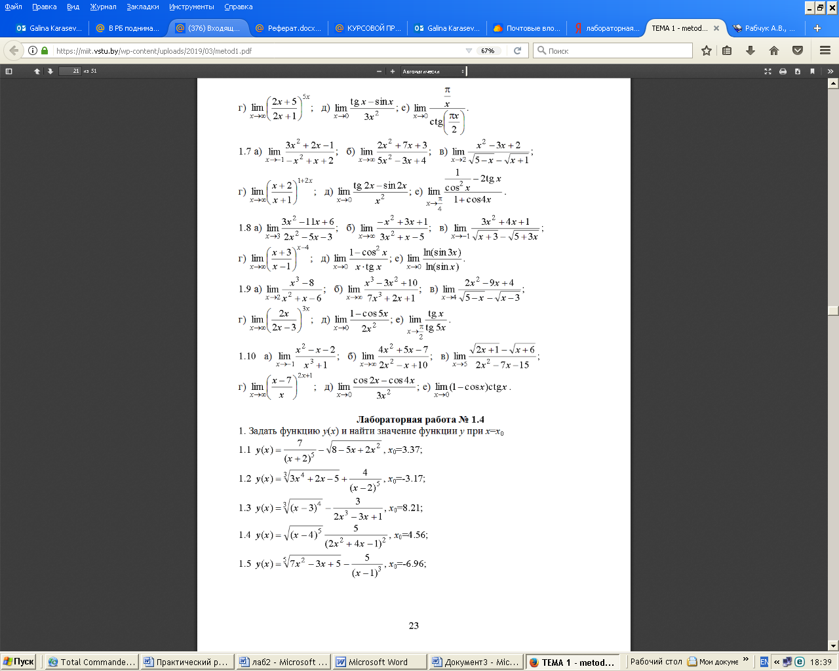

Задание 5
Найдите предел функции $f(x)$ в точке $x=a$.
№ | $$f(x)$$ | $$a$$ | № | $$f(x)$$ | $$a$$
1 | $$\frac{\left(x^{2}−1\right)\left(x+3\right)}{x−1}$$ | $$1$$ | 7 | $$\frac{\left(x^{4}−1\right)\left(x+5\right)}{x−1}$$ | 2
2 | $$\frac{\text{ln}\text{tgx}}{\text{cos}2x}$$ | $$\frac{π}{4}$$ | 8 | $$\frac{\text{cos}3x−\text{cos}x}{{\text{tg}}^{2}2x}$$ | $$b$$
3 | $$\frac{\sqrt{1+2x}−3}{\sqrt{x}−2}$$ | 4 | 9 | $$\frac{\text{arctg}\left(x^{2}−2x\right)}{\text{sin}3πx}$$ | 2
4 | $$\frac{\left(x^{3}−1\right)\left(x+3\right)}{x−1}$$ | 1 | 10 | $$\frac{1−x^{2}}{\text{sin}πx}$$ | 1
5 | $$\frac{\sqrt[3]{x−6}+2}{x^{3}+8}$$ | -2 | 11 | $$\frac{\sqrt[3]{\text{16}x}−4}{\sqrt{4+x}−\sqrt{2x}}$$ | 4
6 | $$\frac{2^{x}−2}{\text{ln}x}$$ | 1 | 12 | $$\frac{\sqrt[3]{8+3x−x^{2}}−2}{\sqrt[3]{x^{2}+x^{3}}}$$ | 1

Задание 6
Найдите частные производные $\frac{∂^{2}f}{∂x∂y}$, $\frac{∂^{2}f}{∂x^{2}}$, $\frac{∂^{2}f}{∂x∂z}$, $\frac{∂^{2}f}{∂y^{2}}$, $\frac{∂^{2}f}{∂z^{2}}$
№ | $$f(x,y,z)$$ | $$(x_{0},y_{0},z_{0})$$
1 | $$\text{xyz}\text{exp}\left(x+2y+3z\right)$$ | $$(1,0,1)$$
2 | $$\text{sin}(\text{xyz})\text{cos}\left(x+2y+3z\right)$$ | $$(\frac{π}{2},0,π)$$
3 | $$(x^{2}−y^{2}+z)\text{sin}\left(x+2y+3z\right)$$ | $$(\frac{π}{2},0,π)$$
4 | $$\text{xy}\text{exp}\left(x+2z\right)$$ | $$(1,1,0)$$
5 | $$\sqrt{x^{2}+2\text{xy}+3\text{xz}}$$ | $$(1,1,1)$$
6 | $${\text{xy}}^{2}\text{exp}\left(x^{2}+2y+3z\right)$$ | $$(1,1,1)$$
7 | $$\sqrt{(\text{xyz})^{3}}\text{sin}\frac{\text{xy}}{z}$$ | $$(\frac{π}{2},0,π)$$
8 | $$\text{exp}\frac{\text{xy}}{z}$$ | $$(1,1,1)$$
9 | $$\text{cos}(\text{xyz})\text{cos}\left(x+2y+3z\right)$$ | $$(\frac{π}{2},0,π)$$
10 | $$\sqrt{x^{2}+2\text{xyz}+3z^{3}}$$ | $$(1,1,1)$$
11 | $${\text{xyz}}^{2}\text{exp}\left(x+2y^{2}+3z\right)$$ | $$(1,0,0)$$
12 | $$(x^{2}−y^{2}+z)\text{cos}\left(x+2y+3z\right)$$ | $$(\frac{π}{2},0,π)$$

Задание 7
Вычислите неопределенный интеграл $\int{f(x)\text{dx}}$ и проверьте правильность вычислений

№ | $$f(x)$$ | № | $$f(x)$$
1 | $$\frac{1}{{\text{sin}}^{2}x(1−\text{cos}x)}$$ | 7 | $$\frac{1+\text{cos}x}{1+\text{cos}x+\text{sin}x}$$
2 | $$\frac{\text{cos}x−\text{sin}x}{(1+\text{sin}x)^{2}}$$ | 8 | $$\frac{\text{sin}x}{1+\text{cos}x+\text{sin}x}$$
3 | $$\frac{1}{\text{sin}x(1−\text{sin}x)}$$ | 9 | $$\frac{\text{cos}x}{1+\text{cos}x+\text{sin}x}$$
4 | $$\frac{\text{cos}x}{5+4\text{cos}x}$$ | 10 | $$\frac{\text{cos}x}{1+\text{cos}x−\text{sin}x}$$
5 | $$\frac{\text{cos}x}{1+\text{sin}x−\text{cos}x}$$ | 11 | $$\frac{\text{cos}x}{(1+\text{cos}x+\text{sin}x)^{2}}$$
6 | $$\frac{\text{cos}x}{2+\text{sin}x}$$ | 12 | $$\frac{\text{sin}x}{(1+\text{sin}x)^{2}}$$

Задание 8
Вычислите определенный интеграл $\int_{a}^{b}{f(x)\text{dx}}$.
№ | $$f(x)$$ | $$x^{2}−0\text{.}\text{16}$$ | № | $$f(x)$$ | $$\left[a,b\right]$$
1 | $$x^{2}−9$$ | $$\left[0,3\right]$$ | 11 | $$x^{2}−8x+7$$ | $$\left[1,5\right]$$
2 | $$x^{2}−1$$ | $$\left[−1,1\right]$$ | 12 | $$x^{2}−9/4$$ | $$\left[2,3\right]$$
3 | $$(x−1)(x+3)$$ | $$\left[−3,1\right]$$ | 13 | $$x^{2}+4x+4$$ | $$\left[−2,2\right]$$
4 | $$(x+1)(x+3)$$ | $$\left[−2,0\right]$$ | 14 | $$x^{2}−4x+4$$ | $$\left[2,4\right]$$
5 | $$x^{2}−3x+2$$ | $$\left[2,4\right]$$ | 15 | $$x^{2}−\text{16}$$ | $$\left[0,4\right]$$
6 | $$x^{2}+3x+2$$ | $$\left[−1,3\right]$$ | 16 | $$x^{2}−0,\text{25}$$ | $$\left[−0\text{.}5,0\text{.}5\right]$$
7 | $$x^{2}−0\text{.}\text{16}$$ | $$\left[−0\text{.}4,0\text{.}6\right]$$ | 17 | $$x^{2}−\text{100}$$ | $$\left[5,\text{10}\right]$$
8 | $$x^{2}−x−2$$ | $$\left[−3,1\right]$$ | 18 | $$(x+1)(x−3)$$ | $$\left[−1,3\right]$$
9 | $$(x−7)(x−1)$$ | $$\left[1,7\right]$$ | 19 | $$(x−1)(x−3)$$ | $$\left[1,4\right]$$
10 | $$(x+7)(x−1)$$ | $$\left[−7,1\right]$$ | 20 | $$x^{2}+5x−4$$ | $$\left[1,3\right]$$

Задание 9
Вычислите определенный интеграл $\int_{a}^{b}{f(x)\text{dx}}$.
№ | $$f(x)$$ | $$x^{2}−0\text{.}\text{16}$$ | № | $$f(x)$$ | $$x^{2}−0\text{.}\text{16}$$
1 | $$\sqrt{\text{256}−x^{2}}$$ | $$\left[0,\text{16}\right]$$ | 7 | $$\frac{1}{{\left(\text{64}−x^{2}\right)}^{3/2}}$$ | $$\left[0,4\sqrt{3}\right]$$
2 | $$x^{2}\sqrt{1−x^{2}}$$ | $$\left[0,1\right]$$ | 8 | $$\frac{x^{4}}{{\left(\text{16}−x^{2}\right)}^{3/2}}$$ | $$\left[0,2\sqrt{2}\right]$$
3 | $$\frac{1}{\left(\text{25}+x^{2}\right)\sqrt{\text{25}+x^{2}}}$$ | $$\left[0,5\right]$$ | 9 | $$\frac{1}{{\left(1+x^{2}\right)}^{3/2}}$$ | $$\left[0,\sqrt{3}\right]$$
4 | $$\sqrt{\frac{2−x}{x−6}}$$ | $$\left[3,5\right]$$ | 10 | $$\sqrt{\frac{9−2x}{2x−\text{21}}}$$ | $$\left[6,9\right]$$
5 | $$\frac{1}{{\left(5−x^{2}\right)}^{3/2}}$$ | $$\left[0,\frac{\sqrt{5}}{2}\right]$$ | 11 | $$\sqrt{\frac{6−x}{x−\text{14}}}$$ | $$\left[8,\text{12}\right]$$
6 | $$\frac{x^{4}}{{\left(1−x^{2}\right)}^{3/2}}$$ | $$\left[0,\frac{\sqrt{2}}{2}\right]$$ | 12 | $$\sqrt{\frac{4−x}{x−\text{12}}}$$ | $$\left[6,\text{10}\right]$$

Задание 10
Запишите для заданной функции формулу Тейлора указанного порядка в окрестности точки $x_{0}$.

№ | $$f(x)$$ | $$x_{0}$$ | $$n$$ |  |  | $$x_{0}$$ | $$n$$
1 | $$x^{2}−2\text{exp}(x−1)$$ | 1 | 5 | 11 | $$(x−1)\text{sin}(x−1)−x^{2}+2x$$ | 1 | 4
2 | $$x^{2}−4x−(x−2)\text{ln}(x−1)$$ | 2 | 4 | 12 | $$\text{sin}(x−1)−x^{2}+2x$$ | 1 | 5
3 | $$\text{cos}x+\text{chx}$$ | 0 | 5 | 13 | $$x^{2}−4x+3+2\text{ln}x$$ | 1 | 6
4 | $$x^{2}−2x−(x−1)\text{ln}x$$ | 1 | 6 | 14 | $$−\text{cos}x−\text{chx}$$ | 0 | 6
5 | $${\text{sin}}^{2}(x−1)−x^{2}+2x$$ | 1 | 5 | 15 | $$−x^{2}−2e^{x−1}$$ | 1 | 5
6 | $$x^{2}−2x+1+2\text{ln}(x+1)$$ | 0 | 6 | 16 | $$x^{3}−3x^{2}−6x−5+6e^{x}$$ | 0 | 5
7 | $$\text{sin}x+\text{shx}−2x$$ | 0 | 6 | 17 | $$2x−\text{sin}x−\text{shx}$$ | 0 | 6
8 | $${\text{sin}}^{2}(x−2)−x^{2}+4x−4$$ | 2 | 5 | 18 | $$1−2x−x^{2}−2\text{cos}(x+1)$$ | -1 | 5
9 | $$(x−2)\text{sin}(x−2)−x^{2}+4x$$ | 2 | 6 | 19 | $${\text{sin}}^{2}(x+2)−x^{2}−4x−4$$ | -2 | 5
10 | $$x^{2}−2x−2\text{exp}(x−2)$$ | -2 | 5 | 20 | $$\text{16}+\text{15}x+6x^{2}+x^{3}−6e^{x+1}$$ | -1 | 5

Лабораторная работа №4
Тема «Решение нелинейных уравнений и неравенств»

1. Решить рациональные уравнения

№ | Задание | № | Задание
1 | $$x^{4}−1=0$$  $$\frac{x^{2}+1}{x}+\frac{x}{x^{2}+1}=2\text{.}9$$ | 7 | $${\left(x^{2}−5x+7\right)}^{2}−\left(x−2\right)\left(x−3\right)=1$$  $$x^{6}−\text{64}=0$$
2 | $$x^{3}+x−2=0$$  $$\frac{3}{1+x+x^{2}}=3−x−x^{2}$$ | 8 | $$\frac{x^{2}−1}{x^{2}−x+1}−\frac{x^{2}−x+2}{x^{2}−x−2}=1$$  $$x^{3}−4x^{2}+x+6=0$$
3 | $$x^{3}+9x^{2}+\text{23}x+\text{15}=0$$  $${\left(x−1\right)}^{3}+{\left(2x+3\right)}^{3}=\text{27}x^{3}+8$$ | 9 | $$\frac{1}{x^{2}−3x+3}+\frac{2}{x^{2}−3x+4}=\frac{6}{x^{2}−3x+5}$$  $$x^{3}−x^{2}−\frac{8}{x^{3}−x^{2}}=2$$
4 | $$2x^{4}−\text{21}x^{3}+\text{74}x^{2}−\text{105}x+\text{50}=0$$  $$x^{4}+5x^{3}+4x^{2}−\text{24}x−\text{24}=0$$ | 10 | $$x\left(x−1\right)\left(x−2\right)\left(x−3\right)=\text{15}$$  $$\left(x−1\right)x\left(x+1\right)\left(x+2\right)=\text{24}$$
5 | $$x^{5}−4x^{4}+4x^{3}−x^{2}+4x−4=0$$  $$x^{5}+4x^{4}−6x^{3}−\text{24}x^{2}−\text{27}x−\text{108}=0$$ | 11 | $$\left(x+1\right)\left(x+2\right)\left(x+3\right)\left(x+4\right)=3$$  $${\left(8x+7\right)}^{2}\left(4x+3\right)\left(x+1\right)=4\text{.}5$$
6 | $$\left(x+1\right)\left(x^{2}+2\right)+\left(x+2\right)\left(x^{2}+1\right)=2$$  $$3\left(x+\frac{1}{x^{2}}\right)−7\left(1+\frac{1}{x}\right)=0$$ | 12 | $${\left(x−4\text{.}5\right)}^{4}+{\left(x−5\text{.}5\right)}^{4}=1$$  $${\left(x+3\right)}^{4}+{\left(x+5\right)}^{4}=\text{16}$$

2. Решить иррациональные уравнения

№ | Задание | № | Задание
1 | $$\sqrt{3x−5}−\sqrt{x−2}=1$$  $$\sqrt{x+1}−\sqrt{9−x}=\sqrt{2x−\text{12}}$$ | 11 | $$x^{2}−4x−6=\sqrt{2x^{2}−8x+\text{12}}$$  $$\sqrt{x^{2}−3x+5}+x^{2}=3x+7$$
2 | $$\sqrt{2x\text{55}}+\sqrt{5x+6}=\sqrt{\text{12}x+\text{25}}$$  $$\sqrt{x−2}+\sqrt{x+3}=2$$ | 12 | $$\left(x+4\right)\left(x+1\right)−3\sqrt{x^{2}+5x+2}=6$$  $$x^{2}−3x−5\sqrt{9x^{2}+x−2}=2\text{.}\text{75}−\frac{\text{28}}{9}x$$
3 | $$\sqrt{x}−\sqrt{x+1}+\sqrt{x+9}−\sqrt{x+4}=0$$  $$\sqrt{4−2x}+\sqrt{2+x}=2\sqrt{2}$$ | 13 | $$\sqrt{x\sqrt[5]{x}}−\sqrt[5]{x\sqrt{x}}=\text{56}$$  $$\sqrt[7]{\frac{5−x}{x+3}+}\sqrt[7]{\frac{x+3}{5−x}}=2$$
4 | $$\sqrt{x−1}−\sqrt{3−x}=1$$  $$\sqrt{2x+\sqrt{6x^{2}+1}}=x+1$$ | 14 | $$\sqrt[4]{\frac{2−x}{3+x}}+\sqrt[4]{\frac{3+x}{2−x}}=2$$  $$\sqrt{x^{2}−2x}⋅\sqrt{3x−7}=3−x$$
5 | $$1−x=\sqrt{1−\sqrt{4x^{2}−7x^{4}}}$$  $\sqrt{1−\sqrt{x^{4}−x^{2}}}=x−1$ | 15 | $$\sqrt{x^{2}−3x}⋅\sqrt{2x−4}=x+1$$  $$x+\sqrt[3]{x}−2=0$$
6 | $$\sqrt{7+\sqrt[3]{x^{2}+7}}=3$$  $$\sqrt{5+\sqrt[3]{x}}+\sqrt{5−\sqrt[3]{x}}=\sqrt[3]{x}$$ | 16 | $$x−4\sqrt[3]{x^{2}}+\sqrt[3]{x}+6=0$$  $$4x−3\sqrt[3]{x}−1=0$$
3. Решить тригонометрические уравнения

№ | Задание
1 | $2{\text{cos}}^{2}x−3\text{sin}x\text{cos}x+5{\text{sin}}^{2}x=3$; $\left(2{\text{sin}}^{4}\frac{x}{2}−1\right)\frac{1}{{\text{cos}}^{4}\frac{x}{2}}=2$
2 | $${\text{sin}}^{6}x+{\text{sin}}^{4}x{\text{cos}}^{2}x={\text{sin}}^{3}x{\text{cos}}^{3}x+\text{sin}x{\text{cos}}^{5}x$$  $$\text{sin}x\text{cos}\frac{π}{8}+\text{cos}x\text{sin}\frac{π}{8}=\frac{1}{2} \text{где} −\frac{3π}{2}≤x≤π$$
3 | ${\text{sin}}^{2}x{\text{cos}}^{2}x−\text{10}\text{sin}x{\text{cos}}^{3}x+\text{21}{\text{cos}}^{2}x=0$; ${\text{sin}}^{4}x+{\text{cos}}^{4}x=\text{cos}4x \text{где} −5≤x≤5$
4 | $\frac{\sqrt{2}}{2}\text{sin}x−\frac{\sqrt{2}}{2}\text{cos}x=1$; $2{\text{sin}}^{4}2x−{\text{sin}}^{2}2x\text{sin}4x=2{\text{sin}}^{2}2x−\text{sin}4x \text{где} 0≤x≤π$
5 | $\sqrt{3}\text{sin}2x+\text{cos}2x=\sqrt{2}$; $\text{cos}4x+\frac{\text{tgx}}{1+{\text{tg}}^{2}x}=3 \text{где} \frac{3π}{2}≤x≤\frac{π}{2}$
6 | $\frac{1}{2}\text{sin}3x+\frac{\sqrt{3}}{2}\text{cos}3x=\text{sin}5x$; $\frac{2−3\text{sin}x−\text{cos}2x}{6x^{2}−πx−π^{2}}=0$
7 | $2\text{cos}3x+\sqrt{3}\text{sin}x+\text{cos}x=0$; $\frac{6{\text{sin}}^{2}x−6\text{sin}x+\text{cos}2x+1}{\text{12}x^{2}−8πx+π^{2}}=0$
8 | $\text{sin}x+\text{sin}2x+\text{sin}3x=0$; $4\text{sin}2x−{\text{tg}}^{2}\left(x−\frac{π}{4}\right)=4$
9 | $\text{sin}6x\text{cos}2x=\text{sin}5x\text{cos}3x−\text{sin}2x$; $2\text{sin}\text{17}x+\sqrt{3}\text{cos}5x+\text{sin}5x=0$
10 | ${\text{sin}}^{6}x+{\text{cos}}^{6}x=\frac{7}{\text{16}}$; $4{\text{cos}}^{3}\frac{x}{2}+3\sqrt{2}\text{sin}x=8\text{cos}\frac{x}{2}$
11 | $2{\text{cos}}^{2}x+\text{cos}5x=1$; $\frac{7}{4}\text{cos}\frac{x}{4}={\text{cos}}^{3}\frac{x}{4}+\text{sin}\frac{x}{2}$
12 | ${\text{sin}}^{6}x+{\text{cos}}^{6}x=\frac{7}{\text{16}}$; $4{\text{cos}}^{3}\frac{x}{2}+3\sqrt{2}\text{sin}x=8\text{cos}\frac{x}{2}$

4. Решить системы уравнений

№ | Задание | № | Задание
1 | $$\begin{aligned}\left\{x+y=−8 | \right.\end{aligned}$$  $$\begin{aligned}\left\{x^{3}−y^{3}=\text{19}\left(x−y\right) | \right.\end{aligned}$$  $$\begin{aligned}\left\{\sqrt{\frac{y}{x}}−2\sqrt{\frac{x}{y}}=1 | \right.\end{aligned}$$ | 7 | $$\begin{aligned}\left\{2x−y=−1 | \right.\end{aligned}$$  $$\begin{aligned}\left\{x^{2}+y^{2}=7+\text{xy} | \right.\end{aligned}$$  $$\begin{aligned}\left\{\sqrt[3]{x}+\sqrt[3]{y}=3 | \right.\end{aligned}$$

2 | $$\begin{aligned}\left\{2x−y=1 | \right.\end{aligned}$$  $\begin{aligned}\left\{x^{4}−y^{4}=\text{15} | \right.\end{aligned}$ $\begin{aligned}\left\{\sqrt{\frac{x^{3}}{y}}−\sqrt{\frac{y^{3}}{x}}=\frac{\text{65}}{6} | \right.\end{aligned}$ | 8 | $\begin{aligned}\left\{x+y=−1 | \right.\end{aligned}$ $\begin{aligned}\left\{x+y=5 | \right.\end{aligned}$  $$\begin{aligned}\left\{\sqrt[3]{x}+\sqrt[3]{y}=3 | \right.\end{aligned}$$
3 | $$\begin{aligned}\left\{x−y=1 | \right.\end{aligned}$$  $$\begin{aligned}\left\{x^{2}+\text{xy}+y^{2}=\text{19}{\left(x−y\right)}^{2} | \right.\end{aligned}$$  $$\begin{aligned}\left\{y^{2}+\sqrt{3y^{2}−2x+3}=\frac{2}{3}x+5 | \right.\end{aligned}$$ | 9 | $$\begin{aligned}\left\{x+2y+3z=−1 | \right.\left\{2x+3y+4z=−1 | \right.\end{aligned}$$  $$\begin{aligned}\left\{x^{4}−x^{2}y^{2}+y^{4}=\text{601} | \right.\end{aligned}$$  $$\begin{aligned}\left\{x^{2}+x\sqrt[3]{{\text{xy}}^{2}}=\text{80} | \right.\end{aligned}$$
4 | $$\begin{aligned}\left\{3x+5y=2 | \right.\end{aligned}$$  $$\begin{aligned}\left\{x^{2}+4\text{xy}−2y^{2}=5\left(x+y\right) | \right.\end{aligned}$$  $$\begin{aligned}\left\{5\sqrt[3]{x−2y}+3\sqrt[3]{x+y}=\text{13} | \right.\end{aligned}$$ | 10 | $$\begin{aligned}\left\{x+y+z=3 | \right.\left\{x+2y−z=2 | \right.\end{aligned}$$  $\begin{aligned}\left\{x^{5}+y^{5}=\text{33} | \right.\end{aligned}$ $\begin{aligned}\left\{\sqrt[3]{\frac{y+1}{x}}−2\sqrt[3]{\frac{x}{y+1}}=1 | \right.\end{aligned}$
5 | $\begin{aligned}\left\{2x^{2}−3y=\text{23} | \right.\end{aligned}$ $\begin{aligned}\left\{x^{2}+y^{2}=\text{34} | \right.\end{aligned}$  $$\begin{aligned}\left\{\frac{\sqrt[3]{2x+y}}{y}+\frac{\sqrt[3]{2x+y}}{2x}=\frac{\text{81}}{\text{182}} | \right.\end{aligned}$$ | 11 | $\begin{aligned}\left\{x^{2}+3y^{2}\text{xz}=6 | \right.\left\{2x−y+3z=\text{11} | \right.\end{aligned}$ $\begin{aligned}\left\{x^{3}y+{\text{xy}}^{3}=\frac{\text{10}}{9}{\left(x+y\right)}^{2} | \right.\end{aligned}$  $$\begin{aligned}\left\{\sqrt{x}+\sqrt{y+1}=1 | \right.\end{aligned}$$
6 | $\begin{aligned}\left\{x^{2}+2y=−5 | \right.\end{aligned}$ $\begin{aligned}\left\{x+y+x^{2}+y^{2}=\text{18} | \right.\end{aligned}$  $$\begin{aligned}\left\{\sqrt{2x−y+\text{11}}−\sqrt{3x+y−9}=3 | \right.\end{aligned}$$ | 12 | $\begin{aligned}\left\{\text{xy}=2 | \right.\end{aligned}$ $\begin{aligned}\left\{\frac{x^{5}+y^{5}}{x^{3}+y^{3}}=\frac{\text{31}}{\text{17}} | \right.\end{aligned}$  $$\begin{aligned}\left\{2\sqrt{\frac{5y}{x}}=\sqrt{x+y}+\sqrt{x−y} | \right.\end{aligned}$$

5. Решить неравенства

№ | Задание | № | Задание
1 | $$x{\left(x−1\right)}^{2}<0$$  $$\left|−\frac{5}{x+2}\right|<\left|\frac{\text{10}}{x−1}\right|$$  $$\sqrt{\left(x−3\right)\left(x+1\right)}>3\left(x+1\right)$$ | 7 | $$\left(\text{16}−x^{2}\right)\left(x^{2}+4\right)\left(x^{2}+x+1\right)\left(x^{2}−x−3\right)≤0$$  $$\left|\frac{x^{2}−3x−1}{x^{2}+x+1}\right|≤3$$  $$\sqrt{x+1}−\sqrt{x−2}≤1$$
2 | $$\left(2−x\right)\left(3x+1\right)\left(2x−3\right)>0$$  $$\left|1−2x\right|>3−x$$  $$\sqrt{\left(x+4\right)\left(2x−1\right)}<2\left(x+4\right)$$ | 8 | $$\left(x^{2}−4\right)\left(x^{2}−4x+4\right)\left(x^{2}−6x+8\right)\left(x^{2}+4x+4\right)<0$$  $$\left|\frac{x^{2}−5x+4}{x^{2}−4}\right|≥1$$  $$\sqrt{x+3}−\sqrt{x−4}≥2$$
3 | $$\left(3x−2\right){\left(x−3\right)}^{3}{\left(x+1\right)}^{3}{\left(x+2\right)}^{4}<0$$  $$\left|4−3x\right|≥2−x$$  $$\sqrt{\left(x+2\right)\left(x−5\right)}<8−x$$ | 9 | $$\left(2x^{2}−x−5\right)\left(x^{2}−9\right)\left(x^{2}−3x\right)≤0$$  $$x^{2}+2\left|x\right|−3≤0$$  $$\sqrt{3x+1}+\sqrt{x−4}−\sqrt{4x+5}<0$$
4 | $$−x^{2}−\text{16}+8x≥0$$  $$\left|2x−3\right|≥2x−3$$  $$\sqrt{x^{2}−x−\text{12}}<x$$ | 10 | $$\frac{x^{2}−5x+6}{x^{2}−\text{12}x+\text{35}}>0$$  $$x^{2}+5\left|x\right|−\text{24}>0$$  $$2\sqrt{x+1}−\sqrt{x−1}≥2\sqrt{x−3}$$
5 | $$x^{2}+5x+8>0$$  $$\left|5x^{2}−2x+1\right|<1$$  $$\frac{\sqrt{\text{17}−\text{15}x−2x^{2}}}{x+3}>0$$ | 11 | $$\frac{x^{2}−4x−2}{9−x^{2}}<0$$  $$\left|x^{2}−3x−\text{15}\right|<2x^{2}−x$$  $$\sqrt{x−3}+\sqrt{1−x}>\sqrt{8x−5}$$
6 | $$x^{4}+8x^{3}+\text{12}x^{2}≥0$$  $$\left|6x^{2}−2x+1\right|≤1$$  $$\sqrt{9x−\text{20}}<x$$ | 12 | $$\frac{x^{3}+x^{2}+x}{9x^{2}−\text{25}}≥0$$  $$\left|x^{2}+x+\text{10}\right|≤3x^{2}+7x+2$$  $$\sqrt{\text{17}−4x}+\sqrt{x−5}≤\sqrt{\text{13}x+1}$$

Лабораторная работа №5
Тема «Операции символьной арифметики»

1. Упростить алгебраические выражения:

№ | Задания
1 | $\frac{\frac{1}{a}−\frac{1}{b+c}}{\frac{1}{a}+\frac{1}{b+c}}\left(1+\frac{b^{2}+c^{2}−a^{2}}{2\text{bc}}\right):\frac{a−b−c}{\text{abc}}$;  $\frac{\frac{x−y}{\sqrt{x}−\sqrt{y}}−\frac{x−y}{\sqrt{x}+\sqrt{y}}}{\frac{\sqrt{x}−\sqrt{y}}{x−y}+\frac{\sqrt{x}+\sqrt{y}}{x−y}}⋅\frac{2\sqrt{\text{xy}}}{y−x}$;
2 | $\frac{x^{3}+y^{3}}{x+y}:\left(x^{2}−y^{2}\right)+\frac{2y}{x+y}−\frac{\text{xy}}{x^{2}−y^{2}}$;  $2{\left(a+b\right)}^{−1}{\left(\text{ab}\right)}^{\frac{1}{2}}{\left(1+\frac{1}{4}{\left(\sqrt{\frac{a}{b}}−\sqrt{\frac{b}{a}}\right)}^{2}\right)}^{\frac{1}{2}}$;
3 | $\left(\left({\left(\frac{a+1}{a−1}\right)}^{2}+3\right):\left({\left(\frac{a−1}{a+1}\right)}^{2}+3\right)\right):\frac{a^{3}+1}{a^{3}−1}−\frac{2a}{a−1}$;  $\frac{b−x}{\sqrt{b}−\sqrt{x}}−\frac{b^{\frac{3}{2}}−x^{\frac{3}{2}}}{b−x}$;
4 | $\left({\left(\frac{y}{y−x}\right)}^{−2}−\frac{{\left(x+y\right)}^{2}−4\text{xy}}{x^{2}−\text{xy}}\right)\frac{x^{4}}{x^{2}y^{2}−y^{4}}$;  $\left(\frac{1}{{\left(a^{\frac{1}{2}}+b^{\frac{1}{2}}\right)}^{−2}}−{\left(\frac{\sqrt{a}−\sqrt{b}}{a^{\frac{3}{2}}−b^{\frac{3}{2}}}\right)}^{−1}\right){\left(\text{ab}\right)}^{−\frac{1}{2}}$;
5 | $\left(\frac{a}{a^{2}−4}−\frac{8}{a^{2}+2a}\right)\frac{a^{2}−2a}{4−a}+\frac{a+8}{a+2}$;  $\left(\frac{m+\sqrt{m^{2}−n^{2}}}{m−\sqrt{m^{2}−n^{2}}}−\frac{m−\sqrt{m^{2}−n^{2}}}{m+\sqrt{m^{2}−n^{2}}}\right)\frac{n^{2}}{4m\sqrt{m^{2}−n^{2}}}$;
6 | $a−\left(\frac{\left(\text{16}−a\right)a}{a^{2}−4}+\frac{3+2a}{2−a}+\frac{3a−2}{a+2}\right):\frac{a−1}{a\left(a^{2}+4a+4\right)}$;  $a{\left(\frac{\sqrt{a}+\sqrt{b}}{2b\sqrt{a}}\right)}^{−1}+b{\left(\frac{\sqrt{a}+\sqrt{b}}{2a\sqrt{b}}\right)}^{−1}$;

№ | Задания
7 | $\left(6a^{2}+5a−1+\frac{a+4}{a+1}\right):\left(3a−2+\frac{3}{a+1}\right)$;  $\frac{\frac{1}{\sqrt{a−1}}+\sqrt{a+1}}{\frac{1}{\sqrt{a+1}}−\frac{1}{\sqrt{a−1}}}:\frac{\sqrt{a+1}}{\left(a−1\right)\sqrt{a+1}−\left(a+1\right)\sqrt{a−1}}$;
8 | $\left(\frac{\sqrt{2}}{{\left(1−x^{2}\right)}^{−1}}+\frac{2^{\frac{3}{2}}}{x^{−2}}\right):{\left(\frac{x^{−2}}{1+x^{−2}}\right)}^{−1}$;  $\frac{1}{2}\left(\frac{\sqrt{5}+1}{1+\sqrt{5}+\sqrt{a}}+\frac{\sqrt{5}−1}{1−\sqrt{5}+\sqrt{a}}\right)\left(\sqrt{a}−\frac{4}{\sqrt{a}}+2\right)\sqrt{0,\text{002}}$;
9 | $\left(\frac{1}{a}+\frac{1}{b}−\frac{2c}{\text{ab}}\right)\left(a+b+2c\right):\left(\frac{1}{a^{2}}+\frac{1}{b^{2}}+\frac{2}{\text{ab}}−\frac{4c^{2}}{a^{2}b^{2}}\right)$;  $\left(\frac{x^{\frac{1}{2}}+y^{\frac{1}{2}}}{x^{\frac{1}{2}}−y^{\frac{1}{2}}}−\frac{x^{\frac{1}{2}}−y^{\frac{1}{2}}}{x^{\frac{1}{2}}+y^{\frac{1}{2}}}\right)\left(y^{−\frac{1}{2}}−x^{−\frac{1}{2}}\right)$;
10 | $\frac{2b+a−\frac{4a^{2}−b^{2}}{a}}{b^{3}+2{\text{ab}}^{2}−3a^{2}b}⋅\frac{a^{3}b−2a^{2}b^{2}+{\text{ab}}^{3}}{a^{2}−b^{2}}$;  ${\left(\frac{\sqrt{a}}{2}−\frac{1}{2\sqrt{a}}\right)}^{2}\left(\frac{\sqrt{a}−1}{\sqrt{a}+1}−\frac{\sqrt{a}+1}{\sqrt{a}−1}\right)$;
11 | $\left(\frac{1}{a−\sqrt{2}}−\frac{a^{2}+4}{a^{3}−\sqrt{8}}\right):{\left(\frac{a}{\sqrt{2}}+1+\frac{\sqrt{2}}{a}\right)}^{−1}$;  $\left(a+a^{\frac{1}{2}}b^{\frac{1}{2}}\right){\left(a+b\right)}^{−1}\left(\sqrt{a}{\left(\sqrt{a}−\sqrt{b}\right)}^{−1}−{\left(\frac{\sqrt{a}+\sqrt{b}}{\sqrt{b}}\right)}^{−1}\right)$;
12 | $\frac{\sqrt[3]{a^{5}b^{\frac{1}{2}}\sqrt[4]{a^{−1}}}}{{\left(a^{2}\sqrt[5]{{\text{ab}}^{3}}\right)}^{2}}$;  $\frac{2\sqrt{b}}{\sqrt{a}+\sqrt{b}}+\left(\frac{a^{\frac{3}{2}}+b^{\frac{3}{2}}}{\sqrt{a}+\sqrt{b}}−\frac{1}{{\left(\text{ab}\right)}^{−\frac{1}{2}}}\right){\left(a−b\right)}^{−1}$;

2. Упростить тригонометрические выражения:

№ | Задания
1 | $\frac{1−\text{tg}\left(π−2α\right)\text{tg}α}{\text{tg}\left(\frac{3}{2}π−α\right)+\text{tg}α}$;  $\frac{\text{sin}\left(2π+\frac{α}{4}\right)\text{ctg}\frac{α}{8}−\text{cos}\left(2π+\frac{α}{4}\right)}{\text{cos}\left(\frac{α}{4}−3π\right)\text{ctg}\frac{α}{8}+\text{cos}\left(\frac{7}{2}π−\frac{α}{4}\right)}$;
2 | $\frac{{\text{ctg}}^{2}\left(α+\frac{π}{2}\right){\text{cos}}^{2}\left(α−\frac{π}{2}\right)}{{\text{ctg}}^{2}\left(α−\frac{π}{2}\right)−{\text{cos}}^{2}\left(α+\frac{π}{2}\right)}$;  $\text{cos}α\left(1+{\text{cos}}^{−1}α+\text{tg}α\right)\left(1−{\text{cos}}^{−1}α+\text{tg}α\right)$;
3 | $\frac{\text{ctg}\left({\text{270}}^{∘}−α\right)}{1−{\text{tg}}^{2}\left(α−{\text{180}}^{∘}\right)}⋅\frac{{\text{ctg}}^{2}\left({\text{360}}^{∘}−α\right)−1}{\text{ctg}\left({\text{180}}^{∘}+α\right)}$;  ${\text{sin}}^{2}α\left(1+{\text{sin}}^{−1}α+\text{ctg}α\right)\left(1−{\text{sin}}^{−1}α+\text{ctg}α\right)$;
4 | $\frac{{\text{cos}}^{2}\left(α−{\text{270}}^{∘}\right)}{{\text{sin}}^{−2}\left(α+{\text{90}}^{∘}\right)−1}+\frac{{\text{sin}}^{2}\left(α+{\text{270}}^{∘}\right)}{{\text{cos}}^{−2}\left(α−{\text{90}}^{∘}\right)−1}$;  ;
5 | $\frac{\left(1+{\text{tg}}^{2}\left(α−{\text{90}}^{∘}\right)\right)\left({\text{sin}}^{−2}\left(α−{\text{270}}^{∘}\right)−1\right)}{\left(1+{\text{ctg}}^{2}\left(α+{\text{270}}^{∘}\right)\right){\text{cos}}^{−2}\left(α+{\text{90}}^{∘}\right)}$;  $\text{cos}\left(\frac{π}{6}−\frac{α}{2}\right)\text{sin}\left(\frac{π}{3}−\frac{α}{2}\right)\text{sin}\frac{α}{2}$;
6 | $\frac{{\text{sin}}^{2}\left(\frac{π}{2}+α\right)−{\text{cos}}^{2}\left(α−\frac{π}{2}\right)}{{\text{tg}}^{2}\left(\frac{π}{2}+α\right)−{\text{ctg}}^{2}\left(α−\frac{π}{2}\right)}$;  ${\text{sin}}^{2}\left(\frac{α}{2}+2β\right)−{\text{sin}}^{2}\left(\frac{α}{2}−2β\right)$;
7 | $\frac{\text{tg}\left(\frac{α}{2}\right)−\text{ctg}\left(\frac{α}{2}\right)}{\text{tg}\left(\frac{α}{2}\right)+\text{ctg}\left(\frac{α}{2}\right)}$;  $\frac{{\text{cos}}^{−1}2x+\text{sin}2\text{xtg}2x}{1+\text{cos}4x}+\frac{1}{4{\text{sin}}^{2}\left(\frac{π}{4}−x\right)\text{ctg}\left(\frac{π}{4}−x\right)}$;

№ | Задания
8 | $\frac{{\text{cos}}^{2}\left(2α−{\text{90}}^{∘}\right)+{\text{ctg}}^{2}\left({\text{90}}^{∘}+2α\right)+1}{{\text{sin}}^{2}\left(2α−{\text{270}}^{∘}\right)+{\text{tg}}^{2}\left({\text{270}}^{∘}+2α\right)+1}$;  ${\text{cos}}^{2}\left(α+2β\right)+{\text{sin}}^{2}\left(α−2β\right)−1$;
9 | $\frac{{\text{sin}}^{2}\left(4α−\frac{π}{2}\right)}{\text{ctg}\left(\frac{3}{2}π−2α\right)+\text{tg}\left(\frac{3}{2}π+2α\right)}$;  ${\text{sin}}^{2}\left(α+2β\right)+{\text{sin}}^{2}\left(α−2β\right)−1$;
10 | $\begin{aligned}\frac{1}{2\text{tg}\left(\frac{3}{2}π−α\right){\text{cos}}^{2}\left(α−\frac{π}{2}\right)}+\frac{1−\text{cos}\left(4α−π\right)}{{\text{sin}}^{3}2α}− \\ −\frac{1}{2\text{ctg}\left(α+\frac{3}{2}π\right){\text{sin}}^{2}\left(α−\frac{3}{2}π\right)}\end{aligned}$;  ${\left(\text{cos}α−\text{cos}2β\right)}^{2}+{\left(\text{sin}α+\text{sin}2β\right)}^{2}$;
11 | $\frac{{\text{cos}}^{2}α+2{\text{sin}}^{2}\left(α−π\right)}{{\text{cos}}^{3}\left(α−4π\right)}+\frac{{\text{cos}}^{2}α+4\text{sin}α+{\text{sin}}^{2}\left(α+π\right)}{\text{cos}α\left(4\text{sin}α+1\right)}$;  $\frac{\left(1−\text{cos}2α\right)\text{cos}\left({\text{45}}^{∘}+2α\right)}{2{\text{sin}}^{2}2α−\text{sin}4α}$;
12 | $\text{sin}\left(2α−\frac{3}{2}π\right)+\text{cos}\left(2α−\frac{8}{3}π\right)+\text{cos}\left(\frac{2}{3}π+2α\right)$;  ${\text{cos}}^{2}\left(\frac{3}{8}π−\frac{α}{4}\right)−{\text{cos}}^{2}\left(\frac{\text{11}}{8}π+\frac{α}{4}\right)$;

3. Преобразовать в произведение:

№ | Задания
1 | $$\text{sin}4α−2{\text{cos}}^{2}2α+1$$
2 | $$\text{tg}\frac{α}{2}+\text{ctg}\frac{α}{2}+2$$
3 | $${\text{cos}}^{−4}α−{\text{sin}}^{−4}α$$
4 | $$\frac{{\text{tg}}^{4}α−{\text{tg}}^{2}α}{{\text{ctg}}^{4}α−{\text{ctg}}^{2}α}$$
5 | $$1−3{\text{tg}}^{2}\left(α+{\text{270}}^{∘}\right)$$
6 | $$1−3{\text{tg}}^{2}\left(α−{\text{180}}^{∘}\right)$$
7 | ${\text{tg}}^{2}\left(α−\frac{3}{2}π\right)−{\text{ctg}}^{2}\left(α+\frac{3}{2}π\right)$
8 | $$3{\text{sin}}^{2}\left(α−{\text{270}}^{∘}\right)−{\text{cos}}^{2}\left(α+{\text{270}}^{∘}\right)$$
9 | $${\text{sin}}^{2}\left(α+{\text{90}}^{∘}\right)−3{\text{cos}}^{2}\left(α−{\text{90}}^{∘}\right)$$
10 | $${\text{sin}}^{2}\left(β−\frac{π}{2}\right)−{\text{cos}}^{2}\left(α−\frac{3π}{2}\right)$$
11 | $$3−4{\text{cos}}^{2}\left(\frac{3}{2}π−α\right)$$
12 | $$1+\text{cos}\left(\frac{π}{2}+3α\right)−\text{sin}\left(\frac{3}{2}π−3α\right)+\text{ctg}\left(\frac{5}{2}π+3α\right)$$

Лабораторная работа №6
Тема «Исследование аналитических функции»

- Найдите (аналитически и графически) точки, в которых достигаются наибольшее и наименьшее значения заданной на отрезке непрерывной функции. Найдите нуль функции на заданном отрезке (решите уравнение f(x)=0).

№ | f(x) | Отрезок
1 | $$\sqrt[3]{2{\left(x−2\right)}^{2}\left(8−x\right)−1}$$ | [0,6]
2 | $$4−x−\frac{4}{x^{2}}$$ | [1,4]
3 | $$x^{2}+\frac{\text{16}}{x}−\text{16}$$ | [1,4]
4 | $$\frac{2\left(x^{2}+3\right)}{x^{2}−2x+5}−1$$ | [-3,3]
5 | $$2\sqrt{x}−x−0\text{.}5$$ | [0,4]
6 | $$1+\sqrt[3]{2{\left(x−1\right)}^{2}\left(x−7\right)}$$ | [-1,5]
7 | $$x−4\sqrt{x}+3$$ | [1,9]
8 | $$\frac{\text{10}x}{x^{2}+1}$$ | [0,3]
9 | $$−2+\sqrt[3]{2{\left(x+1\right)}^{2}\left(5−x\right)}$$ | [-3,3]
10 | $$2x^{2}+\frac{\text{108}}{x^{2}}−\text{59}$$ | [2,4]
11 | $$2−x−\frac{4}{{\left(x+2\right)}^{2}}$$ | [-1,2]
12 | $$\sqrt[3]{2x^{2}\left(x−3\right)}$$ | [-1,6]

2. Найдите точки разрыва заданных функций.
Замечание: Для вычисления $\text{arcctgx}$ и $\text{arccos}x$ используйте тождества $\text{arctgx}+\text{arcctgx}=\frac{π}{2}$ и $\text{arcsin}x+\text{arccos}x=\frac{π}{2}$ .
№ | f(x) | g(x) | h(x)
1 | $$\sqrt{|x|}⋅\text{sin}\frac{1}{x}$$ | $$\text{arctg}\frac{1}{x−π}$$ | $$3^{\frac{1}{x}}$$
2 | $$\sqrt[3]{x−1}⋅\text{arctg}\frac{1}{x−1}$$ | $$\text{arcctg}\frac{1}{x−1}$$ | $$\frac{x−1}{x^{2}−2x+1}$$
3 | $$\sqrt[3]{x+1}⋅\text{arctg}\frac{1}{x+1}$$ | $$\frac{1}{1+\text{exp}\left(−\frac{1}{x}\right)}$$ | $$\frac{1}{x^{2}−1}$$
4 | $$\text{sin}x\text{sin}\frac{1}{x}$$ | $$\frac{2}{1+\text{exp}\left(−\frac{1}{x}\right)}$$ | $$3^{−\frac{1}{x}}$$
5 | $$\left(e^{x}−1\right)⋅\text{sin}\frac{1}{x}$$ | $$\frac{1}{1+\text{exp}\frac{1}{x}}$$ | $$\frac{x+1}{x^{2}+2x+1}$$
6 | $$\text{arctgx}\text{sin}\frac{1}{x}$$ | $$\text{th}\frac{1}{x}$$ | $$x⋅2^{−\frac{1}{x}}$$
7 | $$\text{ln}\left(1+{\left(x−1\right)}^{2}⋅{\text{sin}}^{2}\frac{1}{x−1}\right)$$ | $$2\text{arctg}\frac{1}{x−1}$$ | $$3^{\frac{1}{x^{2}}}$$
8 | $$\text{ln}\left(2+x\text{cos}\frac{1}{x}\right)$$ | $$\text{th}\frac{1}{x+3}$$ | $$\frac{x}{1−e^{x^{2}}}$$
9 | $$\text{arcsin}x⋅\text{cos}\frac{1}{x}$$ | $$2\text{arctg}\frac{1}{x−π}$$ | $$\text{exp}\left(x+\frac{1}{x}\right)$$
10 | $$\left(e^{x−1}−1\right)⋅\text{sin}\frac{1}{x−1}$$ | $$\text{th}\frac{1}{x^{3}−1}$$ | $$\frac{1}{x^{4}−1}$$
11 | $$\text{sin}\left(x−1\right)⋅\text{sin}\frac{1}{x−1}$$ | $$2\text{arctg}\frac{1}{x^{2}−π^{2}}$$ | $${\left(\frac{1}{3}\right)}^{1/x}$$
12 | $$\sqrt{|x−1|}⋅\text{sin}\frac{1}{x−1}$$ | $$\text{arcctg}\frac{1}{x+1}$$ | $$3^{−\frac{1}{x^{3}}}$$

- Найдите минимум целевой функции f(x,y)=ax+by при указанных ограничениях.

№ | f(x,y) | Ограничения
1 | 3x+2y | $$x+y≤4$$ | $$x+2y≥5$$ | $$2x+y≥6$$ | $$x≥0$$ | $$y≥0$$
2 | 3x+2y | $$x+y≤6$$ | $$x+2y≥7$$ | $$2x+y≥8$$ | $$x≥0$$ | $$y≥0$$
3 | 3x+2y | $$x+y≤8$$ | $$x+2y≥8$$ | $$2x+y≥8$$ | $$x≥0$$ | $$y≥0$$
4 | 3x+2y | $$x+y≤9$$ | $$x+2y≥7$$ | $$2x+y≥6$$ | $$x≥0$$ | $$y≥0$$
5 | 3x+2y | $$x+y≤6$$ | $$x+2y≥5$$ | $$2x+y≥3$$ | $$x≥0$$ | $$y≥0$$
6 | 3x+2y | $$x+y≤8$$ | $$x+2y≥9$$ | $$2x+y≥7$$ | $$x≥0$$ | $$y≥0$$
7 | 3x+2y | $$x+y≤7$$ | $$x+2y≥7$$ | $$2x+y≥7$$ | $$x≥0$$ | $$y≥0$$
8 | 3x+2y | $$x+y≤\text{11}$$ | $$x+2y≥\text{11}$$ | $$2x+y≥\text{11}$$ | $$x≥0$$ | $$y≥0$$
9 | 3x+2y | $$x+y≤9$$ | $$x+2y≥9$$ | $$2x+y≥9$$ | $$x≥0$$ | $$y≥0$$
10 | 3x+2y | $$x+y≤\text{10}$$ | $$x+2y≤\text{10}$$ | $$2x+y≤\text{10}$$ | $$x≥0$$ | $$y≥0$$
11 | 2x+5y | $$x+y≥1$$ | $$x+2y≤\text{10}$$ | $$2x+y≤\text{10}$$ | $$x≥0$$ | $$y≥0$$
12 | 2x+5y | $$x+y≥4$$ | $$x+2y≤\text{12}$$ | $$2x+y≤\text{12}$$ | $$x≥0$$ | $$y≥0$$

Лабораторная работа №7
Тема: «Построение графиков функций»

1. Постройте в одной системе координат графики заданных функций. Используйте линии разных цветов, толщины и стилей. Добавьте заголовки. Измените начертание заголовка.
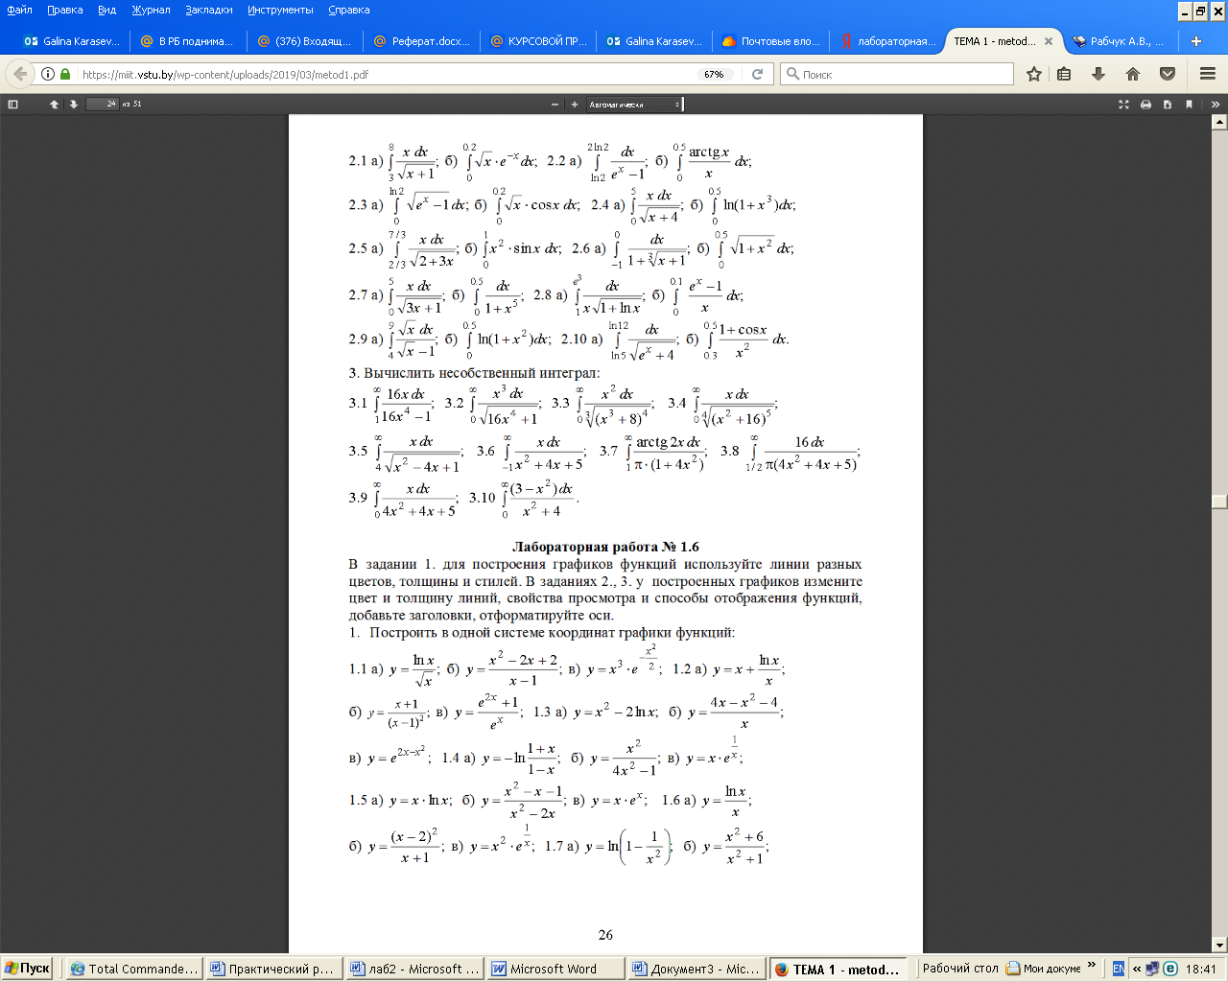
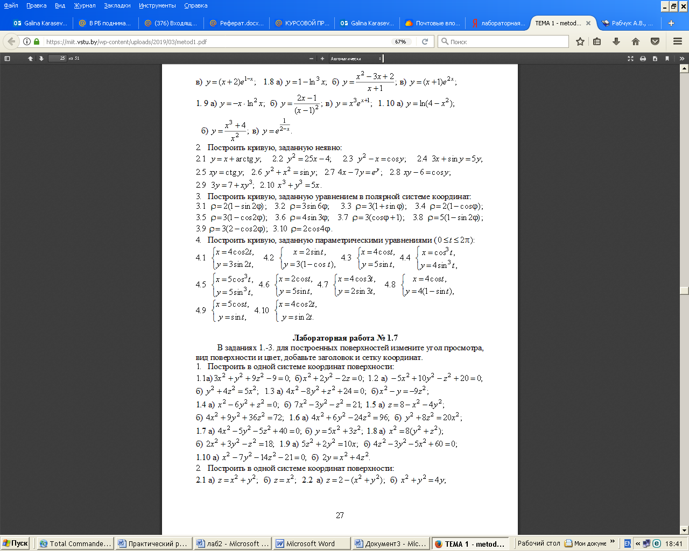
2. Изобразите график заданной функции и подтвердите построение аналитическим исследованием: найдите координаты точек пересечения с координатными осями, поиск экстремумов функции, проведите анализ функции на непрерывность.
№ | f(x) | № | f(x)
1 | $$\frac{4x^{2}+5}{4x+8}$$ | 7 | $$\frac{2−x^{2}}{\sqrt{9x^{2}−4}}$$
2 | $$\frac{\text{17}−x^{2}}{4x−5}$$ | 8 | $$\frac{x^{3}+3x^{2}−2x−2}{2−3x^{2}}$$
3 | $$\frac{x^{2}−3}{\sqrt{4x^{2}−3}}$$ | 9 | $$\frac{3x^{2}−7}{2x+1}$$
4 | $$\frac{x^{3}−4x}{3x^{2}−4}$$ | 10 | $$\frac{x^{2}−5}{\sqrt{9x^{2}−8}}$$
5 | $$\frac{4x^{3}+3x^{2}−8x−2}{2−3x^{2}}$$ | 11 | $$\frac{x^{2}−6x+4}{2−2x}$$
6 | $$\frac{x^{2}−3}{\sqrt{3x^{2}−2}}$$ | 12 | $$\frac{\text{21}−x^{2}}{7x+9}$$
3. Изобразите график заданной функции и подтвердите построение аналитическим исследованием: постройте график производной, найдите нули производной. Найдите координаты точек экстремума.

№ | f(x) | № | f(x)
1 | $$3\sqrt[3]{{\left(x+4\right)}^{2}}−2x−8$$ | 7 | $$3\sqrt[3]{(x−1)x}$$
2 | $$1−\sqrt[3]{x^{2}−2x}$$ | 8 | $$\frac{6\sqrt[3]{6x^{2}}}{{\left(x+2\right)}^{2}+8}$$
3 | $$\text{12}\sqrt[3]{{\left(x+2\right)}^{2}}−8x−\text{16}$$ | 9 | $$2x−2−3\sqrt[3]{{\left(x−1\right)}^{2}}$$
4 | $$\frac{\text{12}\sqrt[3]{6{\left(x−2\right)}^{2}}}{x^{2}+8}$$ | 10 | $$2+\sqrt[3]{8x(x+2)}$$
5 | $$8x−\text{16}−\text{12}\sqrt[3]{{\left(x+4\right)}^{2}}$$ | 11 | $$\frac{3\sqrt[3]{6{\left(x−4\right)}^{2}}}{x^{2}−4x+\text{12}}$$
6 | $$\frac{\text{12}\sqrt[3]{6{\left(x−1\right)}^{2}}}{{\left(x+1\right)}^{2}+8}$$ | 12 | $$3\sqrt[3]{{\left(x−2\right)}^{2}}−2x+4$$

4. Изобразите график заданной функции и подтвердите аналитические исследования.
№ | f(x) | № | f(x)
1 | $$\frac{8\left(x−1\right)}{{\left(x+1\right)}^{2}}$$ | 7 | $$\left(2x+4\right)e^{2(x+2)}$$
2 | $$\frac{5x}{x^{2}+3}$$ | 8 | $$2−\frac{3x}{x^{2}+3}$$
3 | $$\frac{x^{3}−\text{27}x+\text{54}}{x^{3}}$$ | 9 | $$−\left(x+4\right)e^{−x−3}$$
4 | $$−\frac{5x}{x^{2}+2}$$ | 10 | $${\left(2+\frac{1}{x}\right)}^{2}$$
5 | $${\left(\frac{x+2}{x−2}\right)}^{2}$$ | 11 | $$\frac{2x^{2}+1}{x^{2}+3}$$
6 | $$\left(x+1\right)e^{x+2}$$ | 12 | $$\left(2x−1\right)e^{2(1−x)}$$

5.Изобразите график заданной функции и подтвердите аналитические исследования. Используйте линии разных цветов, толщины и стилей.

№ | f(x) | № | f(x)
1 | $$\sqrt[3]{\left(1+x\right)\left(x^{2}+2x−2\right)}$$ | 7 | $$\sqrt[3]{\left(1−x\right)\left(x^{2}−2x−2\right)}$$
2 | $$\sqrt[3]{{\left(x^{2}−4x+3\right)}^{2}}$$ | 8 | $$\sqrt[3]{x^{2}{\left(x+2\right)}^{2}}$$
3 | $$\sqrt[3]{x^{2}\left(x+3\right)}$$ | 9 | $$\sqrt[3]{{\left(x+2\right)}^{2}\left(x−1\right)}$$
4 | $$\sqrt[3]{{\left(x+2\right)}^{2}\left(x−4\right)}$$ | 10 | $$\sqrt[3]{{\left(x−2\right)}^{2}\left(x+1\right)}$$
5 | $$\sqrt[3]{{\left(x+1\right)}^{2}}−\sqrt[3]{{\left(x+2\right)}^{2}}$$ | 11 | $$\sqrt[3]{{\left(x+2\right)}^{2}}−\sqrt[3]{{\left(x+3\right)}^{2}}$$
6 | $$\sqrt[3]{{\left(x+2\right)}^{2}}−\sqrt[3]{{\left(x−3\right)}^{2}}$$ | 12 | $$\sqrt[3]{{\left(x+3\right)}^{2}x}$$

6. Изобразите линии, заданные в декартовых координатах явно уравнением y=f(x) и неявно уравнением F(x, y)=0. Запишите уравнения касательной и нормали к каждой кривой в указанных точках и изобразите их на графике.
Уравнение касательной $y=f'\left(x_{0}\right)\left(x−x_{0}\right)+f\left(x_{0}\right)$ .
Уравнение нормали $y=−\frac{1}{f'\left(x_{0}\right)}\left(x−x_{0}\right)+f\left(x_{0}\right)$ .
Для функции, заданной в виде F(x, y)=0
$F_{x}'(x_{0},y_{0})\left(x−x_{0}\right)−F_{y}'(x_{0},y_{0})\left(y−y_{0}\right)=0$ – уравнение касательной,
$F_{y}'(x_{0},y_{0})\left(x−x_{0}\right)−F_{x}'(x_{0},y_{0})\left(y−y_{0}\right)=0$ – уравнение нормали.

№ | f(x) | $$x_{0}$$ | F(x,y) | $$(x_{0},y_{0})$$
 | $$\sqrt[3]{x{\left(x+6\right)}^{2}}$$ | -8 | $$\frac{y^{2}}{3}−\frac{x^{2}}{4}−1$$ | $$\left(1,−\frac{\sqrt{\text{15}}}{2}\right)$$
1 | $$\text{shx}$$ | 1 | $$\frac{x^{2}}{3}+\frac{y^{2}}{4}−1$$ | $$\left(\sqrt{\frac{3}{2}},\sqrt{2}\right)$$
2 | $$\text{ln}x$$ | 2 | $$\frac{x^{2}}{3}+\frac{y^{2}}{4}−1$$ | $$\left(−\sqrt{\frac{3}{2}},\sqrt{2}\right)$$
3 | $$1+\frac{1}{x}$$ | 1 | $$\frac{x^{2}}{3}+\frac{y^{2}}{4}−1$$ | $$\left(−\sqrt{\frac{3}{2}},−\sqrt{2}\right)$$
4 | $$1+\frac{1}{x}$$ | -1 | $$\frac{x^{2}}{3}+\frac{y^{2}}{4}−1$$ | $$\left(\sqrt{\frac{3}{2}},−\sqrt{2}\right)$$
5 | $$\frac{\left|x\right|\left(x−1\right)}{x+1}$$ | 2 | $$3y^{2}−4x^{2}−\text{12}$$ | $$\left(3,\frac{\sqrt{\text{15}}}{2}\right)$$
6 | $$\frac{\left|x\right|\left(x−1\right)}{x+1}$$ | -2 | $$\frac{x^{2}}{3}−\frac{y^{2}}{4}−1$$ | $$\left(\sqrt{9},\sqrt{8}\right)$$
7. Изобразите кривую, заданную в полярных координатах

№ | ρ(φ) | № | ρ(φ)
1 | $$ϕ$$ | 7 | $$\frac{3}{ϕ^{3}}$$
2 | $$2ϕ+1$$ | 8 | $$2\left(1−\text{cos}ϕ\right)$$
3 | $$\frac{2}{\text{sin}ϕ}+2$$ | 9 | $$5\text{sin}\frac{4ϕ}{3}$$
4 | $$2\text{sin}3ϕ$$ | 10 | $$\frac{2}{\text{sin}ϕ}+2$$
5 | $$2\text{cos}ϕ+3$$ | 11 | $$2^{ϕ}$$
6 | $$−2\text{ctg}ϕ$$ | 12 | $$5\text{sin}\frac{ϕ}{3}$$

Лабораторная работа №8
Тема: «Построение поверхности»
1
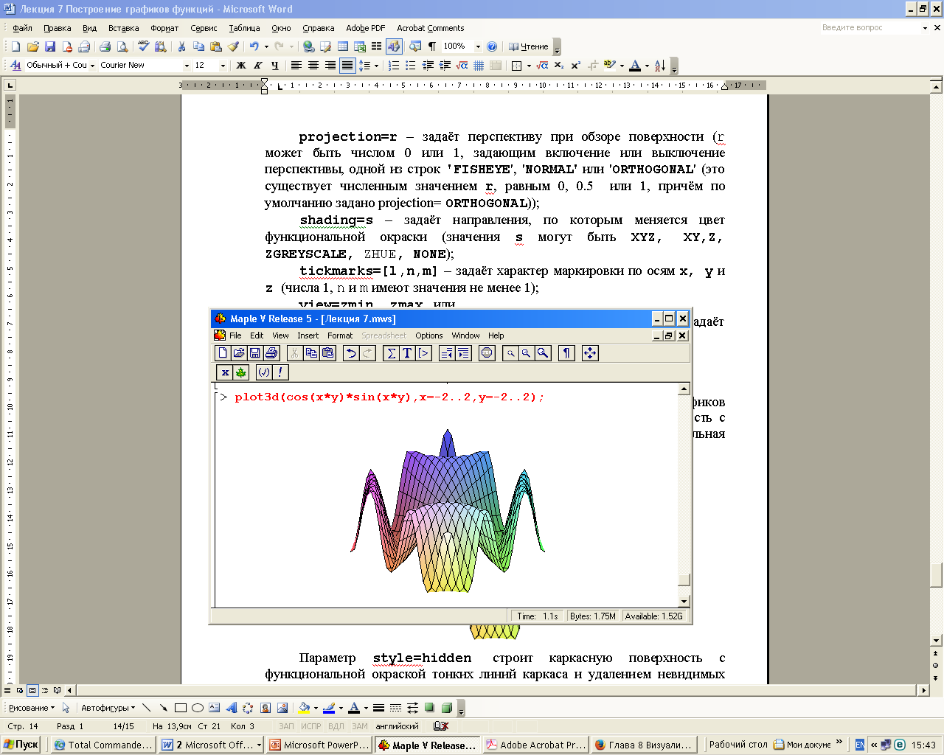
2
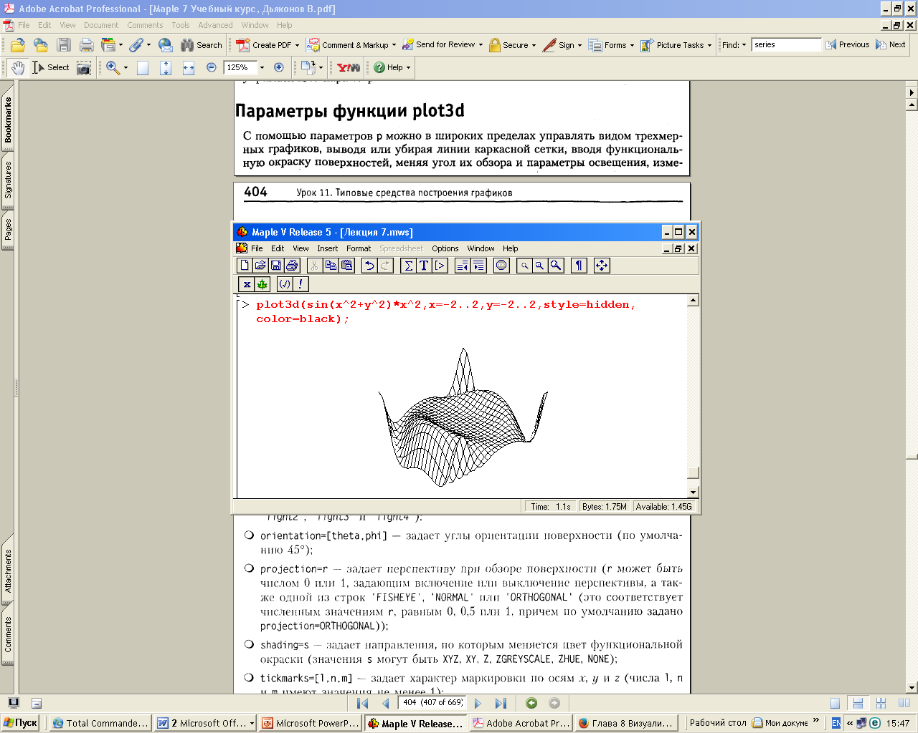

3 Изменение формата шрифтов надписи

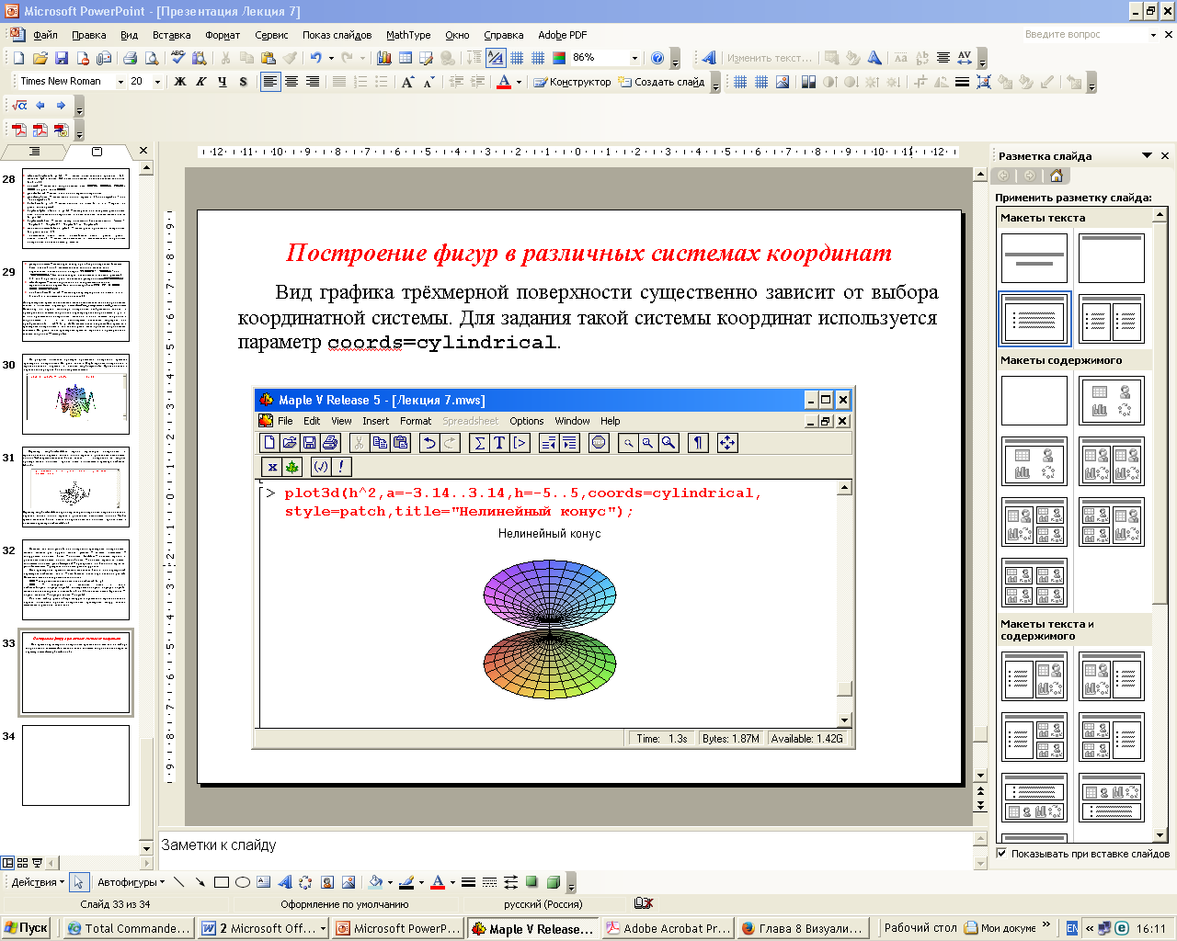

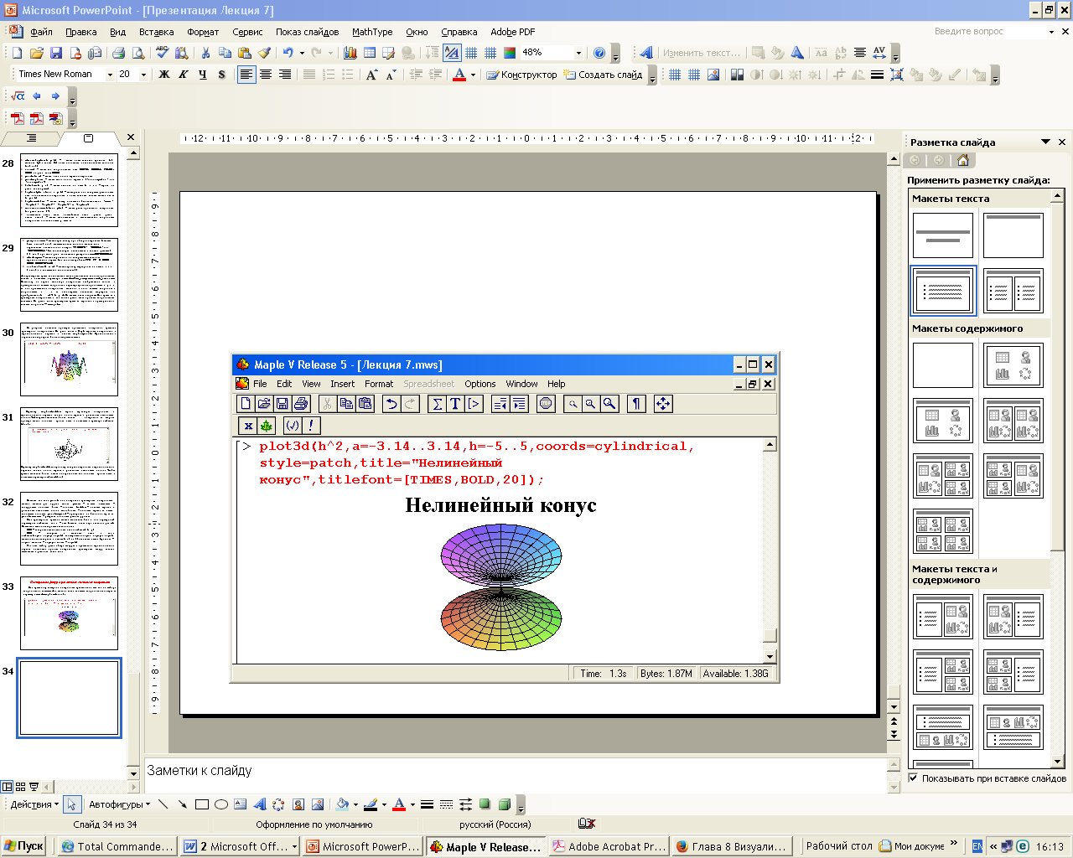

4 Построение фигур в различных системах координат

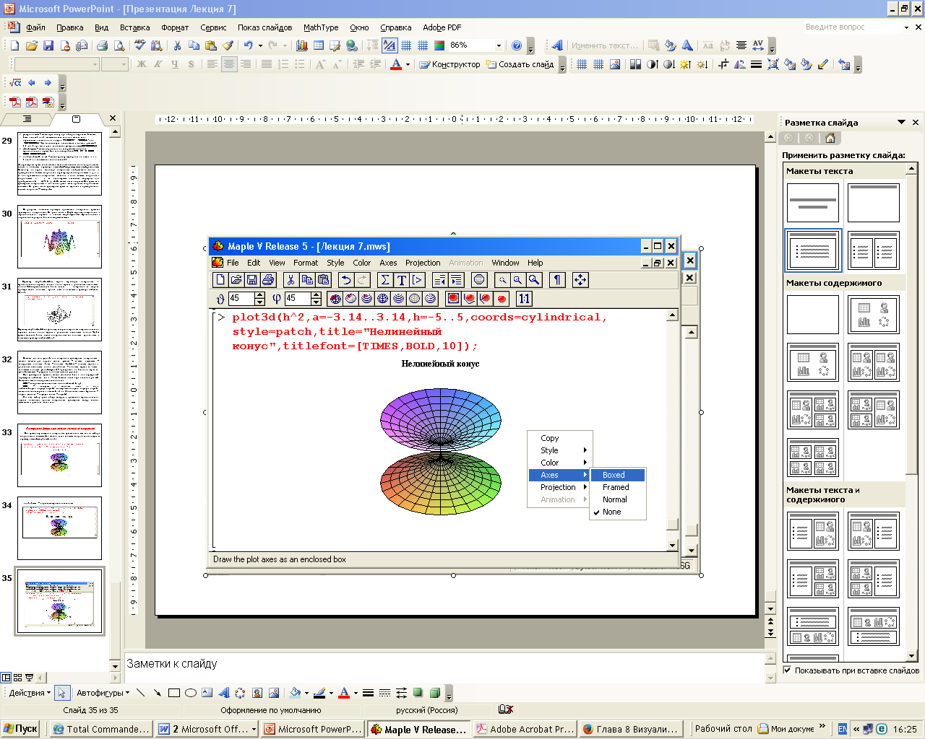

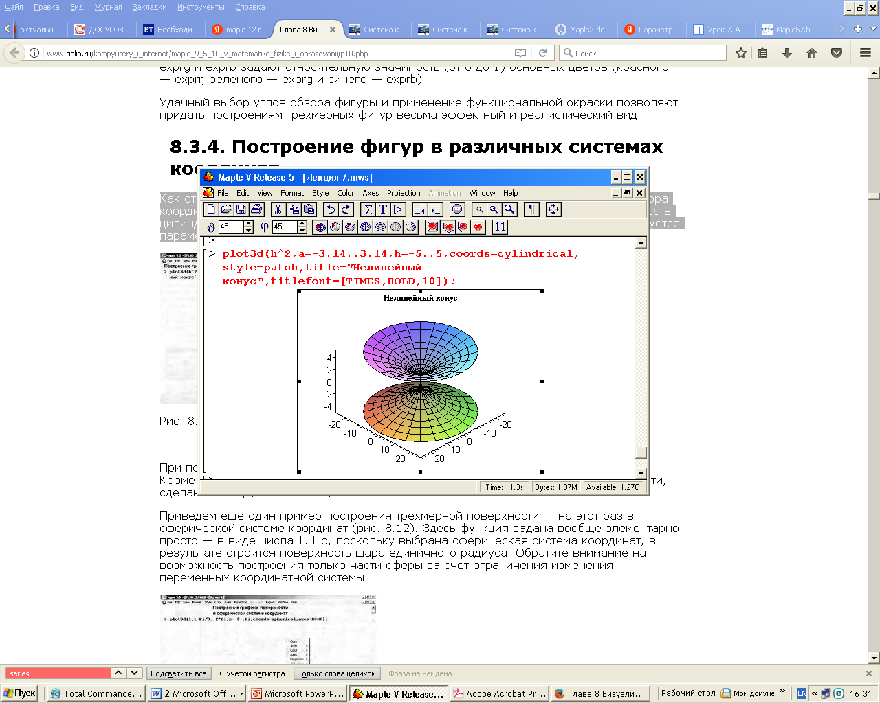

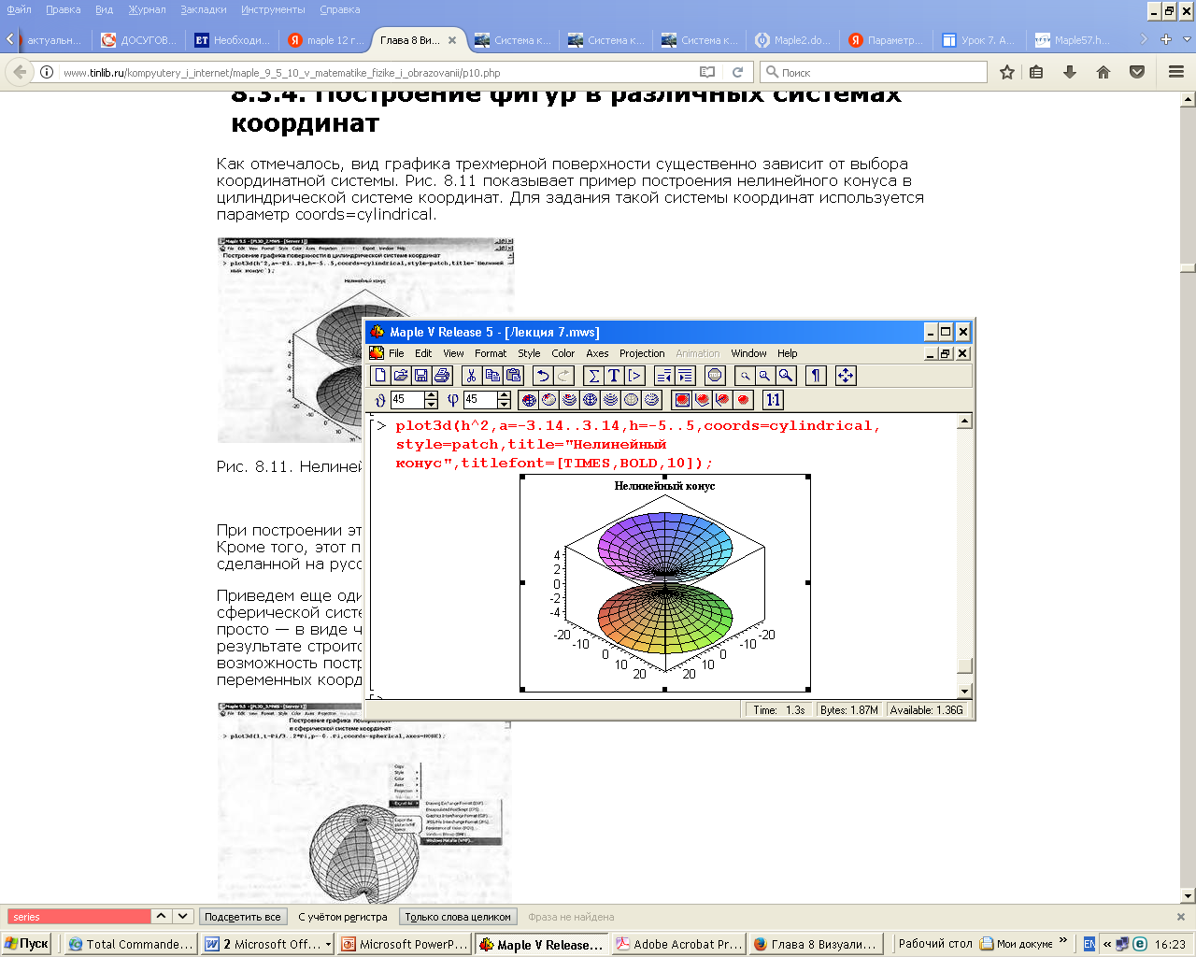

5 Графики в сферической системе координат

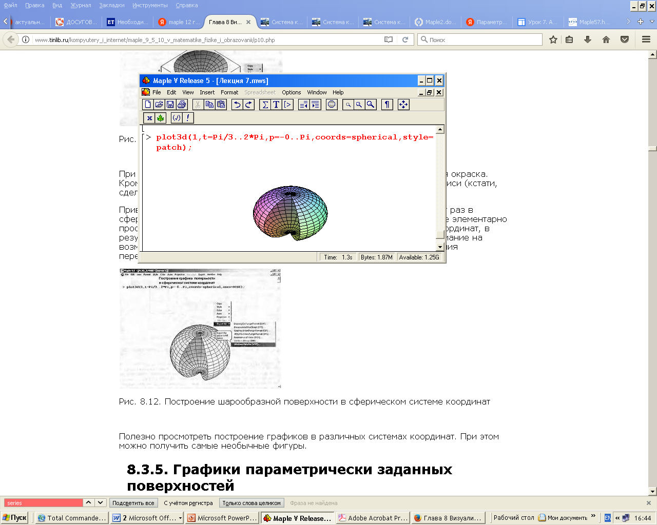

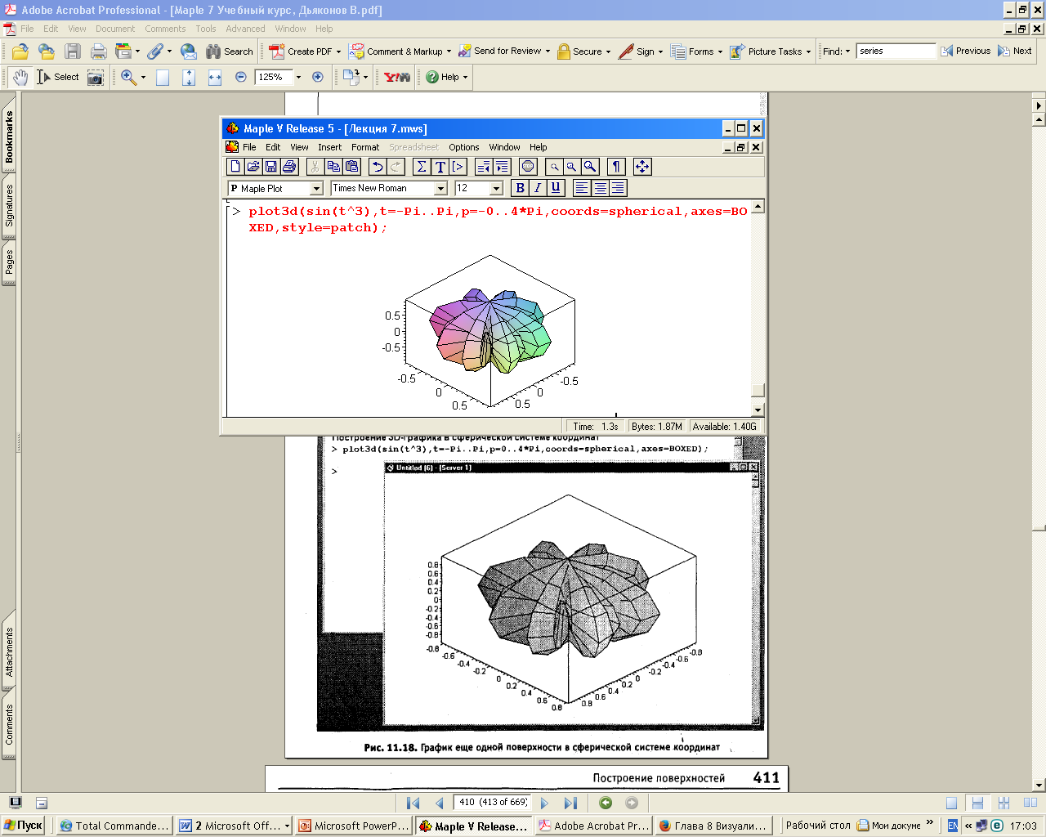

6 Графики параметрически заданных поверхностей

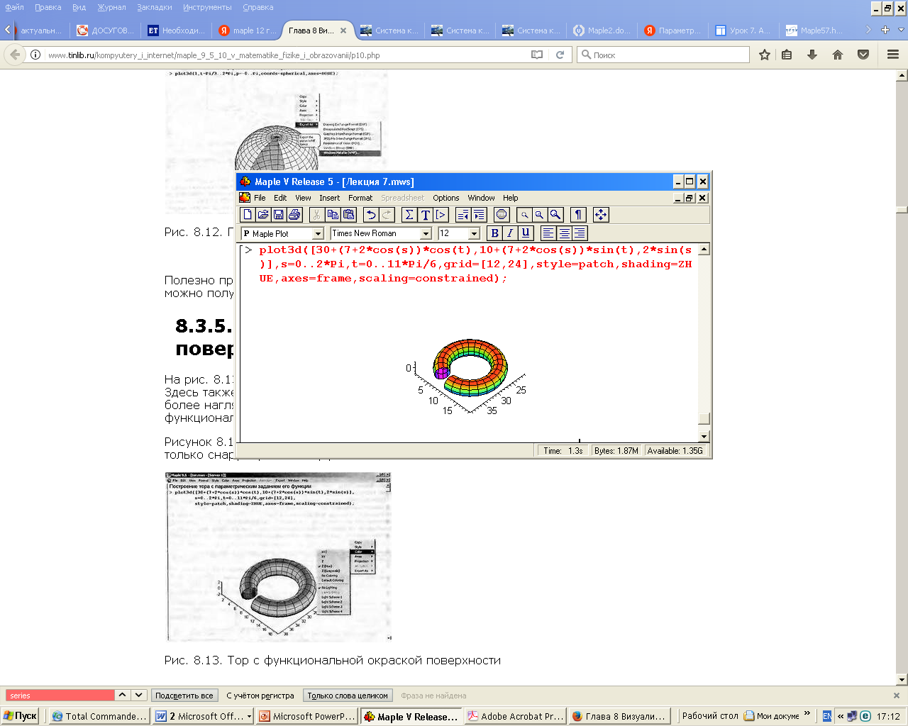

7 Масштабирование трехмерных фигур и изменение углов их обзора

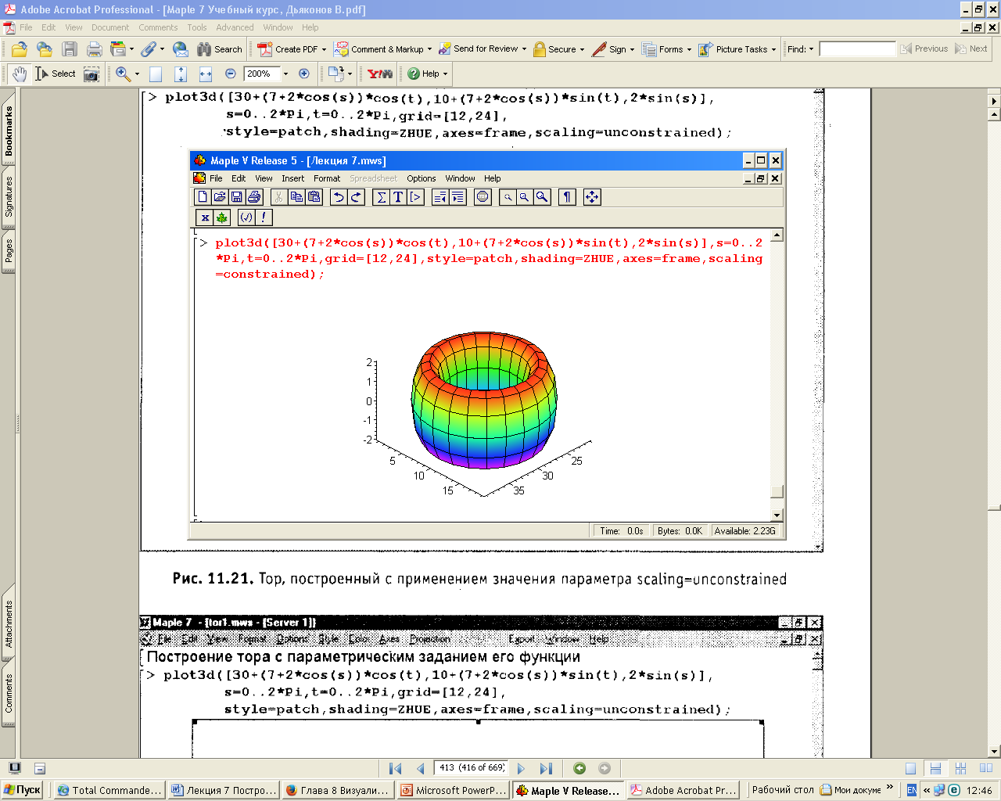

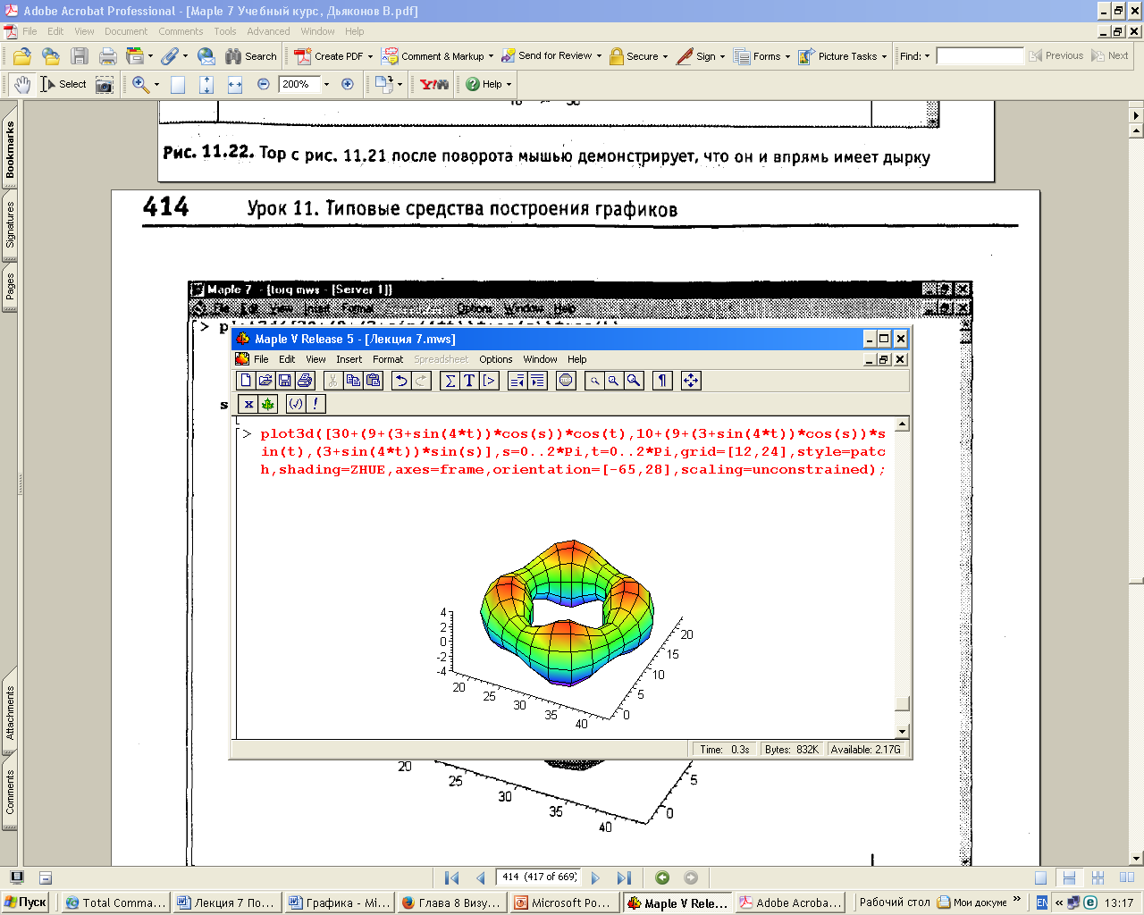

8 Занимательные фигуры – трехмерные графики

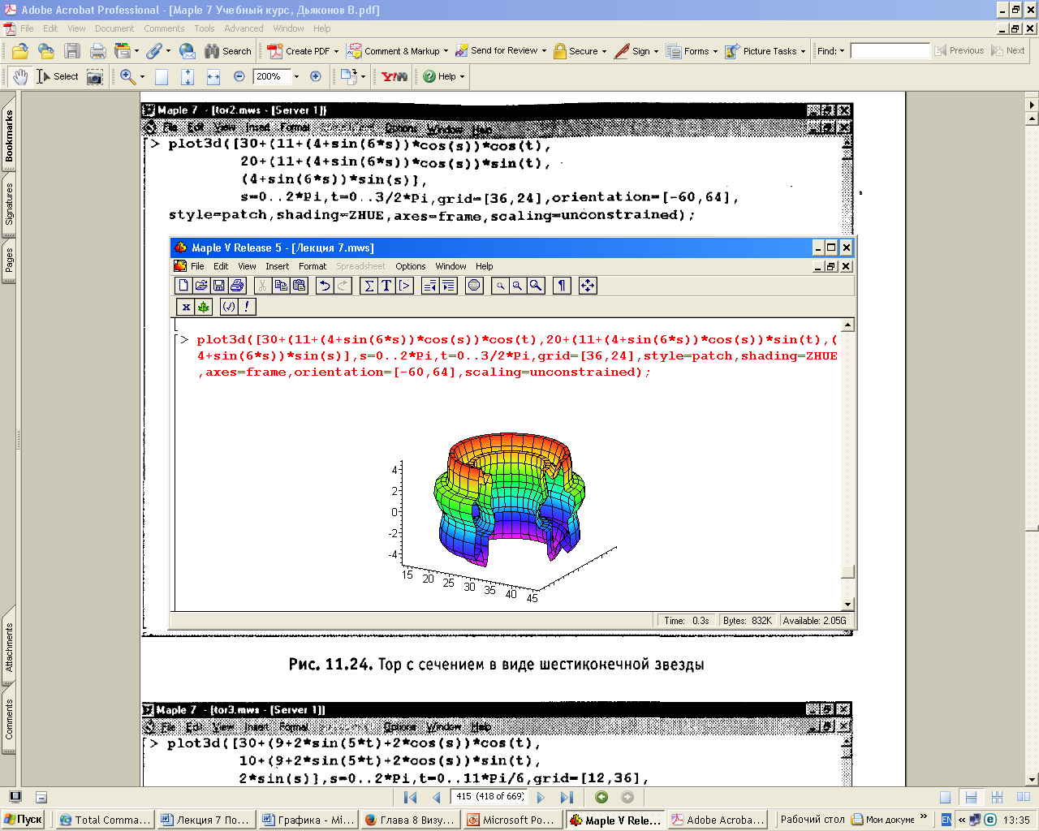

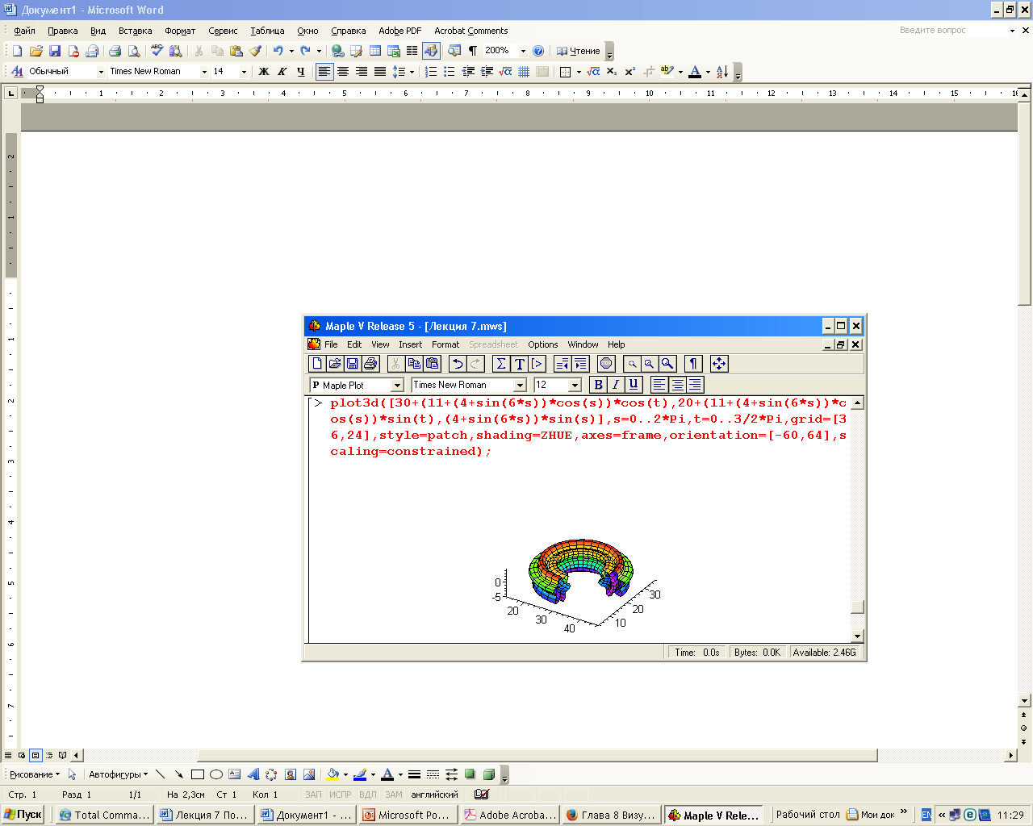

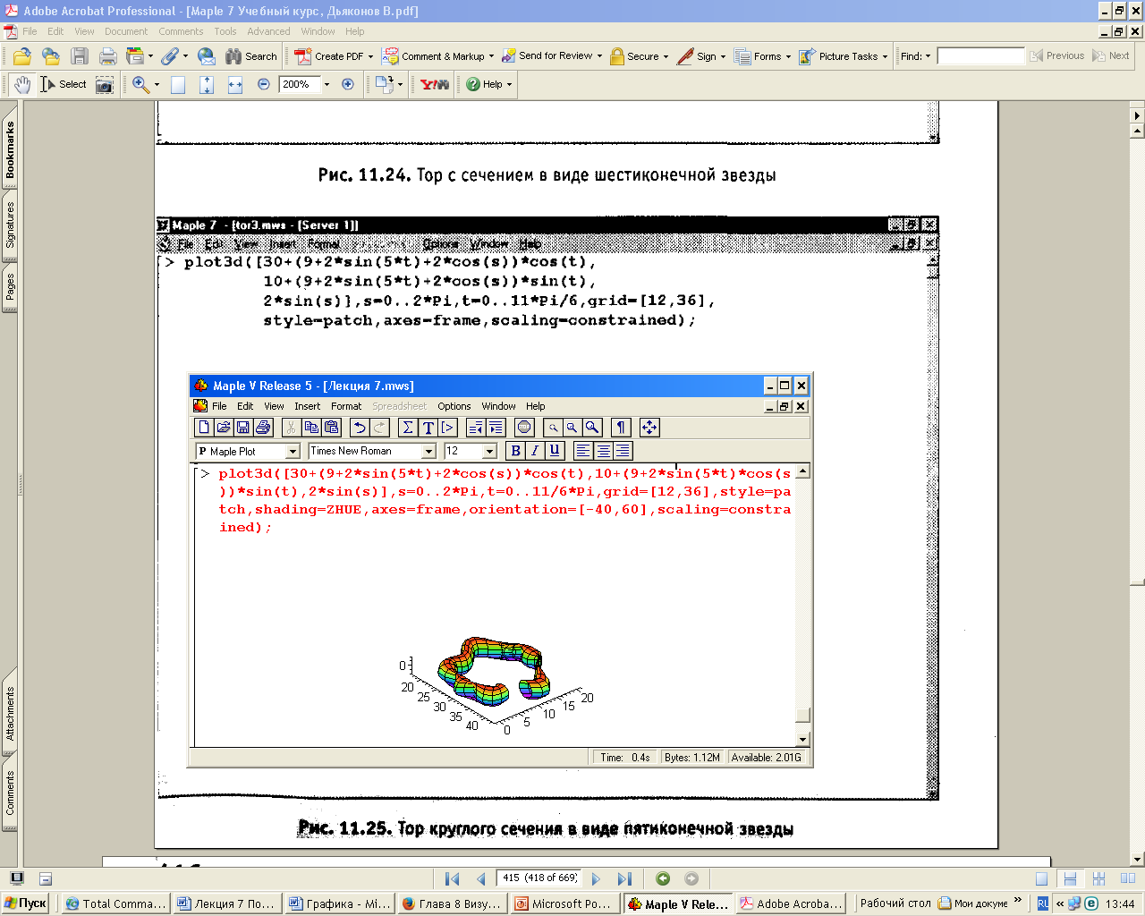

9 Построение ряда трехмерных фигур на одном графике

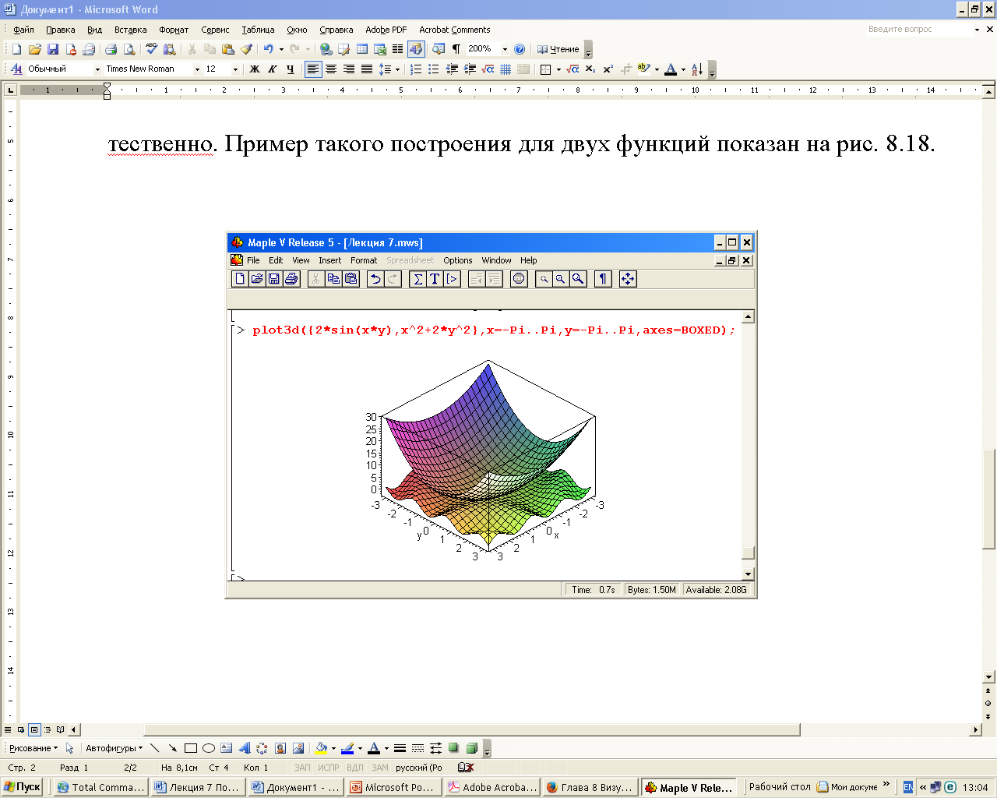

10 Быстрое построение трёхмерных графиков – smartplot3d

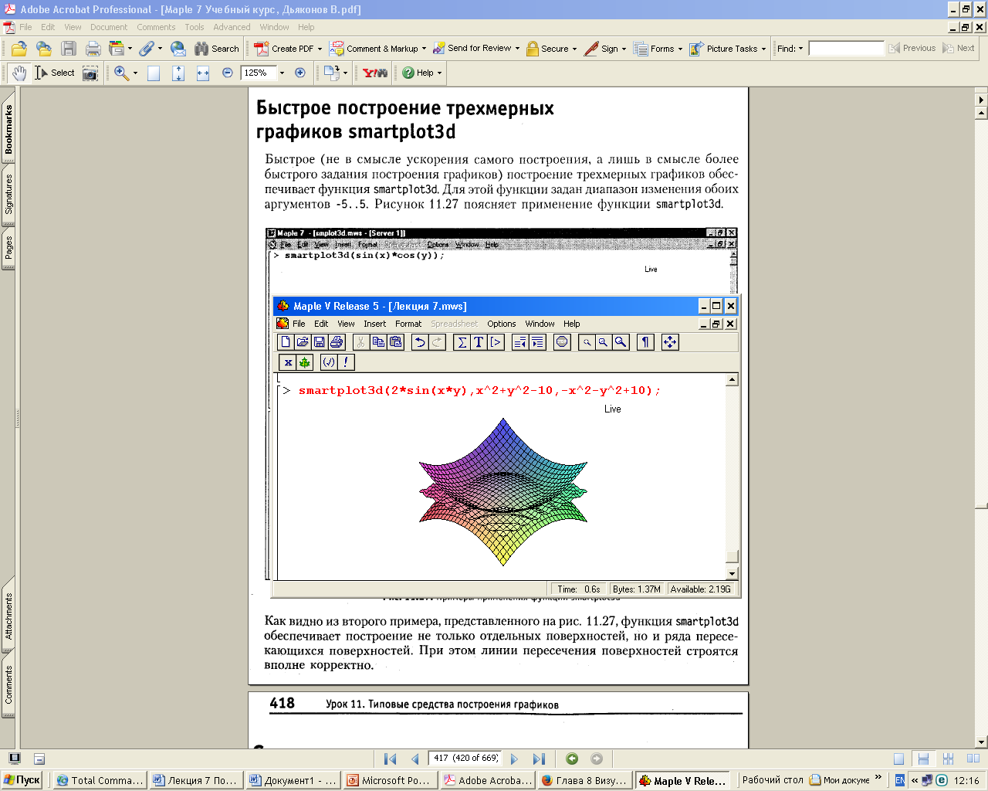

11 Построение трехмерных графиков implicitplot3d

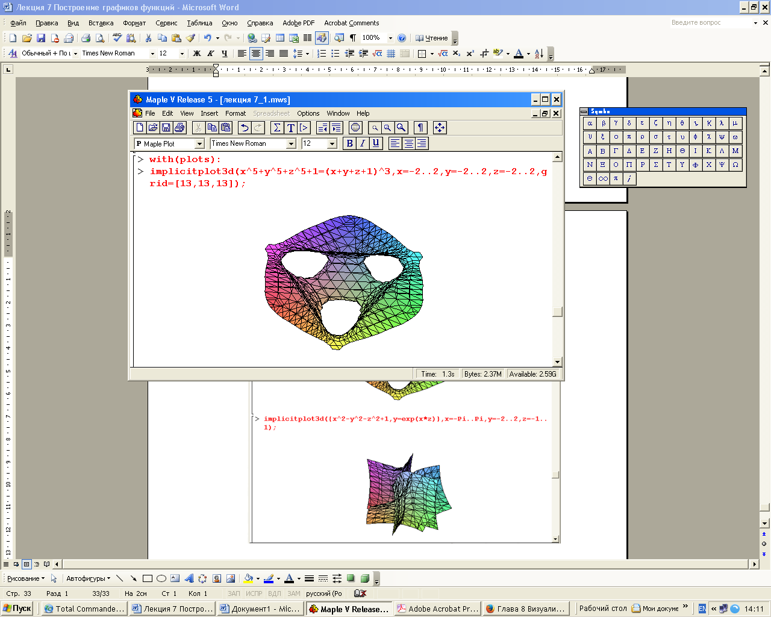

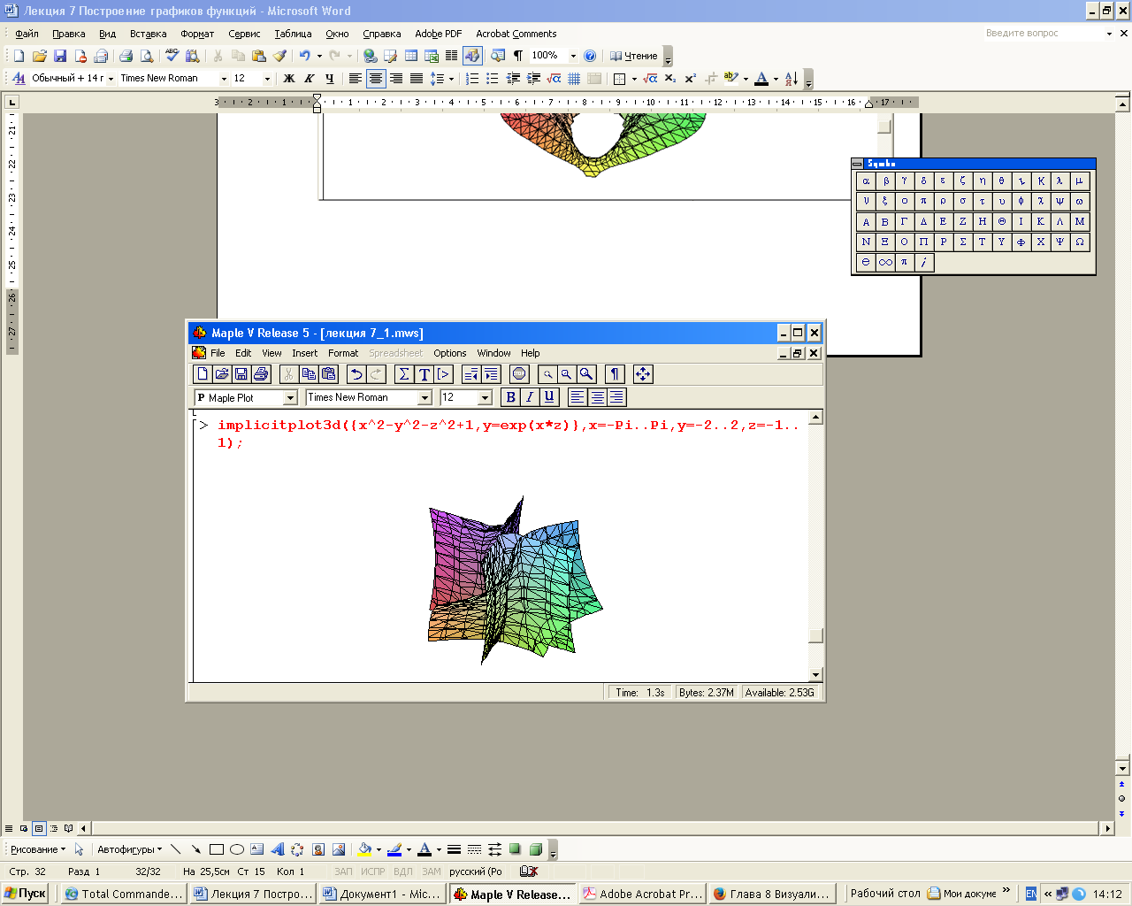

12 Построение трехмерных анимационных графиков

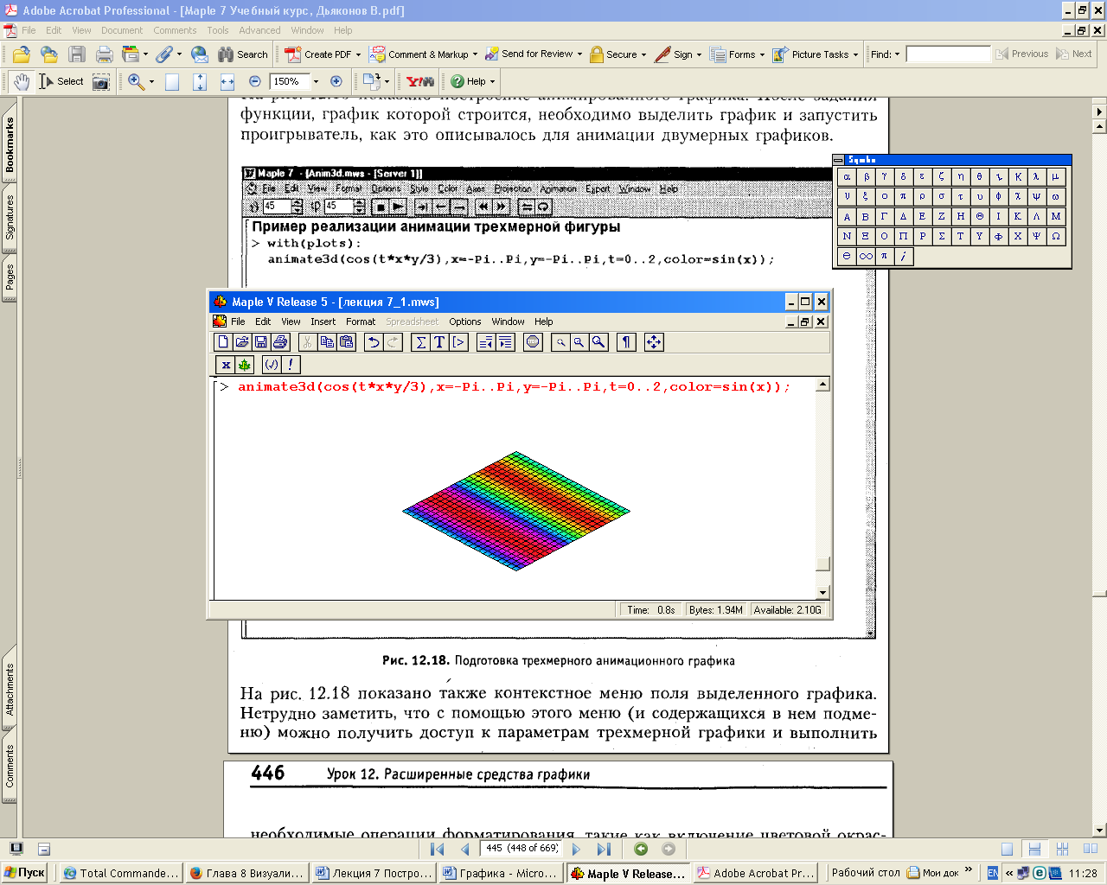

13 Анимация с помощью параметра insequence

