Conflict
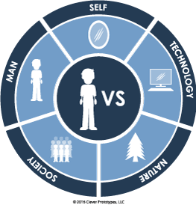
A fictional plot is usually based on a conflict. Conflict in a literary work is a situation or problem which a character tries to resolve. Conflicts can take various forms: internal – within the character’s consciousness or soul and external – a conflict between a character and outside forces.

The internal conflict (man vs. self ) takes place within the mind of the main character and is revealed through the character’s thoughts, feelings, intellectual processes, etc. This type of conflict often involves the character making a decision between right and wrong.
Different types of external conflicts are usually termed in the following way:
1. Man vs. man or character vs character is probably the most common form of external conflict, and is also known as interpersonal conflict. It is based on the struggle directly between the protagonist and the antagonist otherwise known as the good guy and the bad guy.
2. Man vs. society, when the individual fights his/her social environment openly. A protagonist sees something in a unique way. People in his town or culture don't like his way of thinking. His bold ideas diverge from tradition or the rules. They ridicule and threaten him. He is compelled to act.
3. Man vs. Nature The hero must overcome a force of nature to meet his goal. Nature can be a force of nature (like a storm, earthquake, or difficult climate) or an animal from nature. In literature, the hero sometimes meets his goal, but sometimes is defeated.
4. Man vs. machine or technology type of conflict focuses on a person or group of people fighting to overcome unemotional and unsympathetic machinery that believes it no longer requires humanity. Most often the encounter with the machine or technology is through the character's own doing. For example, it may be technology or a machine that they created, purchased, or owned with the assumption that it would make their life easier.
5. Man vs. supernatural forces (god, evil, fate etc.) type of conflict involves a mysterious force or being, representing things beyond rational scientific explanation. Many science-fiction stories involve such a conflict.
Conflict can be obvious or hidden. The plot of the story may be based on several conflicts of different types, it may involve both an internal and an external conflict.

