Plot and its Structure
Plot is a chain of fictional events arranged in a meaningful pattern. Each link in this chain helps to build suspense and to solve the problems that the characters face. The plot can be rather simple or complex (mainly in novels), consisting of a major plot and one or more subplots. The plot is usually based upon conflict. We can gain much insight into the meaning of a story by looking at the structure of its plot.
Components of the traditional plot development:
Exposition usually includes the establishment of the setting (time and place), the introduction of the theme and characters. The exposition ends with the inciting moment, which is the one incident in the story without which there would be no story. The inciting moment sets the rest of the story in motion.
Complications (or rising action) follow the exposition and, as a rule, consist of several events which become tenser as the plot moves towards the moment of decision (the climax).
Climax is the turning point in plot development, the moment when the character makes decision which course of action to take.
Falling action: During the falling action, the conflict unravels with the main character either winning or losing. The falling action might contain a moment of final suspense, during which the final outcome of the conflict is in doubt.
Denouement is the action that follows the resolution of the conflict; the event or events that bring an action to an end. At this point the fate of the main character is clarified. The conflict is resolved.
The arrangement of the parts of the plot and their relationship to each other can be described with the help of Freytag'S Pyramid.
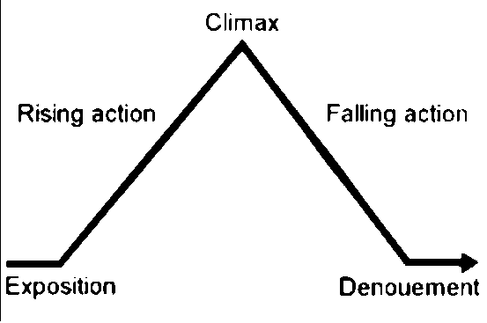
Gustav Freytag (1816-1895), German playwright, analyzed Shakespearean and ancient Greek drama; he developed a model based on his examination of the structure of those plays. The model, first published in his book Die Technik des Dramas in 1863, is known as Freytag's Pyramid. It also goes by the names of Freytag’s Triangle or Dramatic Arc.
A work of narrative prose that has all the above-mentioned elements is said to have a closed plot structure.
A literary work in which some elements are omitted or are not represented in their conventional form is said to have an open plot structure.

