**Руководство к практическому занятию по теме**

**PEOPLE AND WORKPLACES**

**Составитель: ст. преподаватель Томашук Н.В.**

**Active vocabulary**

* **staff** (staffs) *n-count-coll*

The **staff** of an organisation are the people who work for it.

*The staff were very good.*

*….members of the staff.*

*Many employers seek diversity in their staffs.*

* **staff** *n-plural*

People who are part of a particular staff are often referred to as **staff.**

*10 staff were allocated to the task.*

*He had the complete support of hospital staff.*

* **personnel** *n-plural*

The **personnel** of an organization are the people who work for it.

*There has been very little renewal of personnel in higher education.*

* **workforce**

The **workforce** is the total number of people in a country or region who are physically able to do a job and are available for work. The **workforce** is also the total number of people who are employed by a particular company.

*. ..a country where half the workforce is unemployed.*

*. ..an employer of a very large workforce.*

* **employee** (employees) *n-count*

An **employee** is a person who is paid to work for an organization or for another person.

*He is an employee of Fuji Bank.*

*Many of its employees are women.*

* **line manager** (line managers) *n-count*

Your **line manager** is the person at work who is in charge of your department, group, or project.

*He claimed his line manager, a woman, had bullied him so relentlessly that the stress caused a mental breakdown.*

*Mr Ezra was line manager to Mr Archer, 24.*

* **blue-collar** *adj*
* **white-collar** *adj*

**Blue-collar** workers work in industry, doing physical work, rather than in offices. **White-collar** workers work in offices rather than doing physical work.

*By 1925, blue-collar workers in manufacturing industry had become the largest occupational group.*

*…corporate lawyers, accountants and other white-collar workers.*

* **hierarchical** *adj*
* **flat** *adj*

A **hierarchical** system or organisation is one in which people have different ranks or positions, depending on how important they are. Companies with a **flat** structure are organized in a less hierarchical way than traditional companies, with the aim of giving all employees a relatively equal status within the company.

*They claim that the hierarchical structure of schools replicates the hierarchical structure of the workforce.*

*The management structure remains flat rather than hierarchical to make everyone feel they have an important role to play.*

***Employees and management***

The people who work for a company, all the people on its **payroll**, are its **employees**, **personnel**, **staff**, **workers** or **workforce**. But these words can mean just the people carrying out the work of a company, rather than those leading it and organizing it: the **management**.

*Note*: **Workforce**, **work-force** and **work force** are all possible.

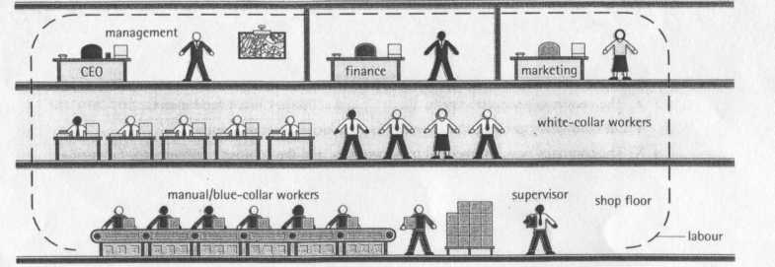

**Management and administration**

A company’s activities may be spread over different **sites.** A company’s most senior managers usually work in its **head office** or **headquarters (HQ).** Some managers have their own **individual offices**, but in many businesses, most employees work in **open-plan offices:** large areas where many people work together. Administration or, informally, admin, the everyday work supporting a company’s activities, is often done in offices like these by **administrative staff** or **support staff**. For example, those giving technical help to buyers of the company’s products are in **technical support**.

**The career ladder**

*A job for life*

Many people used to work for the same organization until they reached retirement: the age at which people retire, or end their working life. **Career paths** were clear: you could **work your way up the career ladder**, getting **promotion** to jobs that were more **senior**, with greater responsibility.

You would probably not be **demoted**: moved to a less senior job.

*A job for now*

Modco has **downsized** and **delayered**. The number of management levels in the company hierarchy has been reduced from five to three, and many managers have lost their jobs. Modco has reorganized and **restructured** in order to become **flatter** (with fewer layers of management) and **leaner** (with fewer, more productive employees).

They did this to reduce costs, and increase **efficiency** and **profits**.

Employees said the company used words like ‘restructure’ to make the situation sound positive and acceptable.

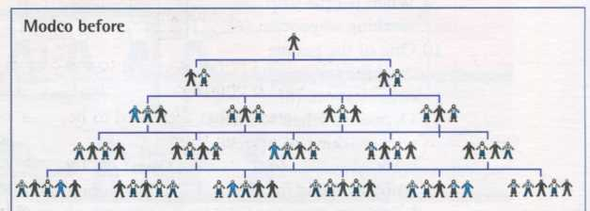

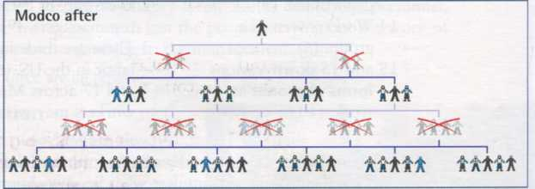

**Practice your vocabulary**

1. **Put each of the words under the correct heading.**

**a** employee

**b** staff

**с** worker

**d** workforce

**e** personnel

|  |  |
| --- | --- |
| Individual in an organization | Collective term for people in an organization |
|  |  |

1. **Which type of workplace relationship, shown by the diagrams, is most likely to include line managers?**

HIERARCHICAL STRUCTURE FLAT STRUCTURE

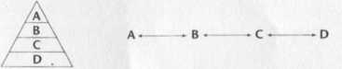

1. **Complete the tables with forms of words. You may wish to refer to a dictionary.**

|  |  |
| --- | --- |
| **Noun** | **Verb** |
|  | retire |
| demotion |  |
| lay-off |  |
|  | dismiss |
|  | terminate |
|  |  |

1. **Match the sentence beginnings (1-5) to the correct endings (a-e). The sentences all contain words from active vocabulary.**
2. Career paths aren’t what they used to be;
3. He worked his way up from
4. The new management have delayered the company,
5. We used to do printing in-house,
6. Workers are afraid their organizations will be downsized

**a** and they will be replaced by temporary workers.

**b** companies won’t take care of us for life any more.

**c** but now we outsource it.

**d** factory worker to factory manager.

**e** reducing five management levels to three.

1. **Read what four people say about where they work. Then match them to the organograms A-D below.**

**1** There are a couple of copywriters, account executives, an art director - you know. But there aren’t many full-time staff. We use freelancers a lot. The whole thing’s run by the three partners. They make all the high-level decisions.

**2** Well, I’ve never met the CEO of the company and, as for the board of directors, I don’t even know who they are. I’ve only met my boss’s boss once. I suppose it’s very formal, there are rules and regulations for everything. You always know who does what and who’s in charge.

**3**  I go in three afternoons a week to help him with his correspondence and administration. I like it because I love his books. He can be a bit difficult though.

**4** There’s the boss, and then we’re divided into three departments, each with a manager. There’s sales, admin and print production - that’s where I work.

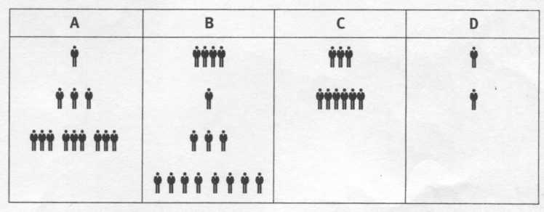

**6.** **Which of the people above works for:**

* an advertising agency?
* a printing company?
* a writer?
* a pharmaceutical company?

**7. Which of the following words refer to:**

a) all the people in a company?

b) people who are in charge of others?

Some words don’t belong in either group.

* assistant
* boss
* chief executive
* deputy
* employees
* foreman
* junior
* personnel
* staff
* supervisor
* workforce

**8. Manuel Ortiz is the founder of a Spanish computer sales company. Use the words from active vocabulary to complete what he says about it.**

I founded Computadoras Creativas 20 years ago. We started with a small (1)_________in Madrid. Our (2) ________________ , our (3)_________________is still here, but now we have sites all over Spain, with about 500 employees. Many of the offices are (4)________-_________: everyone works together, from managers to (5)_______________ , as well as people selling over the phone, and people in technical (6)_____________giving help to customers over the phone. Recruitment is taken care of in Madrid, by the Human Resources Department or HRD.

**Reading**

**Companies and corporations**

Companies are a very important part of a country's economy. Businesses produce goods and services, and they come in every shape and size. Although the vast majority of the world's companies are small, in many countries the economy is dominated by large firms. Large businesses differ from small ones in a wide variety of ways. In many countries there are nationalized companies belonging to the state, as well as private companies. A private company might be a small firm with just one owner or a very large firm with thousands of shareholders owning the firm.

In very large firms the shareholders have very little to do with the day-to-day running of the firm. This is left to the management. Large companies may be organized into several large departments, sometimes even divisions. The organizational structure of some companies is very hierarchical with a board of directors at the top and the various departmental heads reporting to them. Often the only time shareholders can influence the board is at the yearly shareholders’ meeting.

Some firms may only produce one good or service. Others may produce many different products; in fact they may seem to be like a collection of ’businesses’ inside one company. As a company gets bigger it may expand geographically. Many large firms are multinationals with manufacturing plants and trading locations in several different countries spread around the world.

***Answer the questions:***

1. In what way do different businesses or companies differ?
2. Can shareholders influence day-to-day running of a large business?

***Over to you***

**Think of a company you work for or would like to work for. Is it flat or hierarchical? Describe its organizational structure.**