План открытого занятия в группе МЭ-31
по теме «Starting a business»

1. Introduction
(на доске написан эпиграф):
“Don't aim for success if you want it; just do what you love and believe in, and it will come naturally" (David Frost).

T: Good morning, students! How are you feeling today? (answer)

Well, for a start let me thank everyone for being here today. Today is a special day and I do hope you, students, will do your best and do the kind of work that will make me very happy. In today’s programm “Business kitchen” we’ll be searching for ingredients of business startup. We’ll take a look at the challenge of running your own business. What should we take into consideration if we’d like to have a successful business in all its aspects. This is the central question of today’s talk. (ВИДЕО ЗАСТАВКА 13 сек)

Starting up
T: At first, let’s find out what makes business people successful? Please, take a look at the screen and add even more words to the list below. Choose the six from the least to the most important characteristics and create your pyramid of success. Explain your point of view.

charisma | drive | looks | nepotism | discipline
dedication | imagination | luck | ruthlessness | money

And now EXCHANGE PYRAMIDS with your partner…this is a small present for him in order to gain success in all his bussinesses.

Listening task
T: Author Malcolm Gladwell, has his own recipe of the secret of success. Before you hear what he’s talking about and to help you understand let’s practice the following exercises.

(1) match the following words that you will come across in the interview with their meanings.

- put in your hours  - nothing to do with  - to skim-read  - successful  - the equivalent  - have access to  - bestseller | - famous and rich  - a very popular book  - the same as  - to have permission to do smth  - no connection between smth  - to read smth very quickly  - to work a lot to achieve smth

(2) explain the meaning of “you aren't going to be seeing your name in lights” and “you can create your own "luck" if you're proactive enough...”.
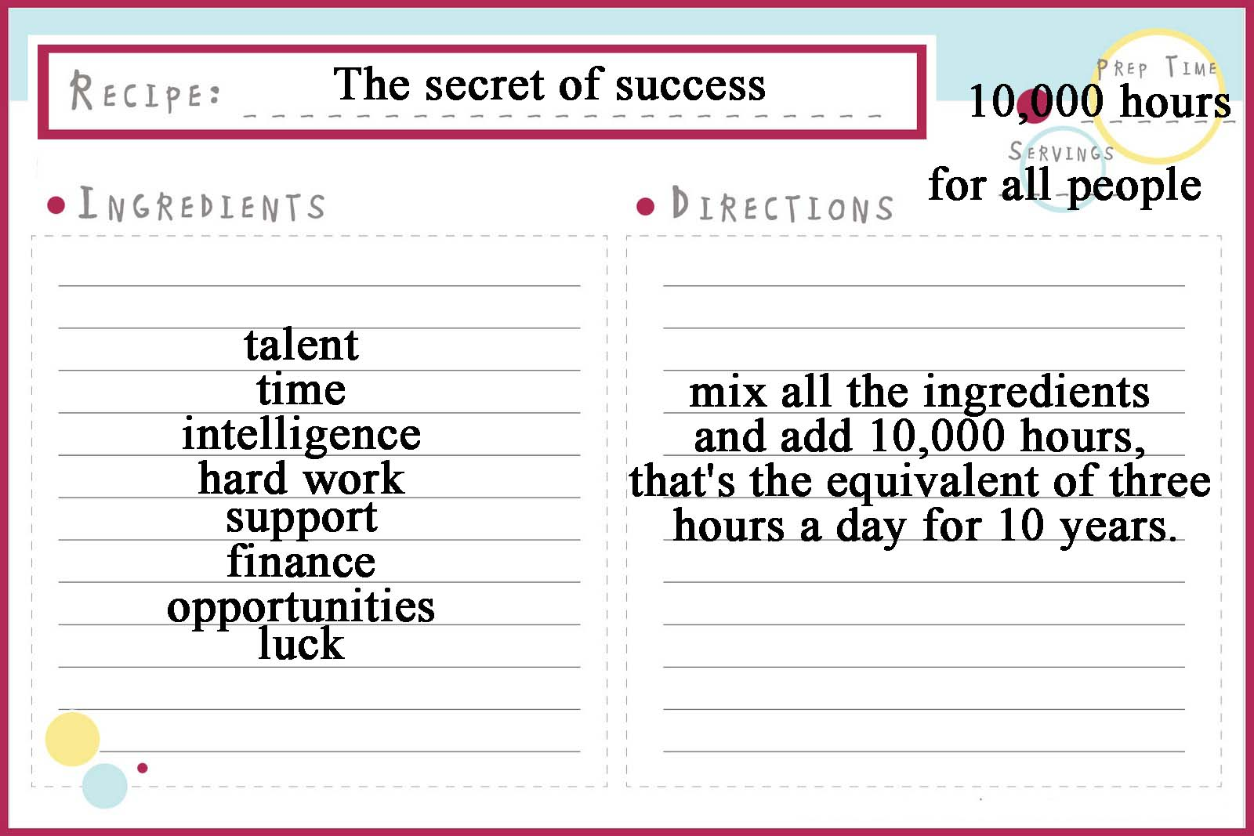
T: Listen to the FIRST part of the tape (4:16) and answer the questions.
1. What's the name of Malcolm Gladwell's book?
2. How many hours does he say that you have to practise something in order to be successful?
3. What examples of famous personalities does M.G. give as a proof to his theory?

T: Now listen to the SECOND part of the tape and complete the recipe card № 1.

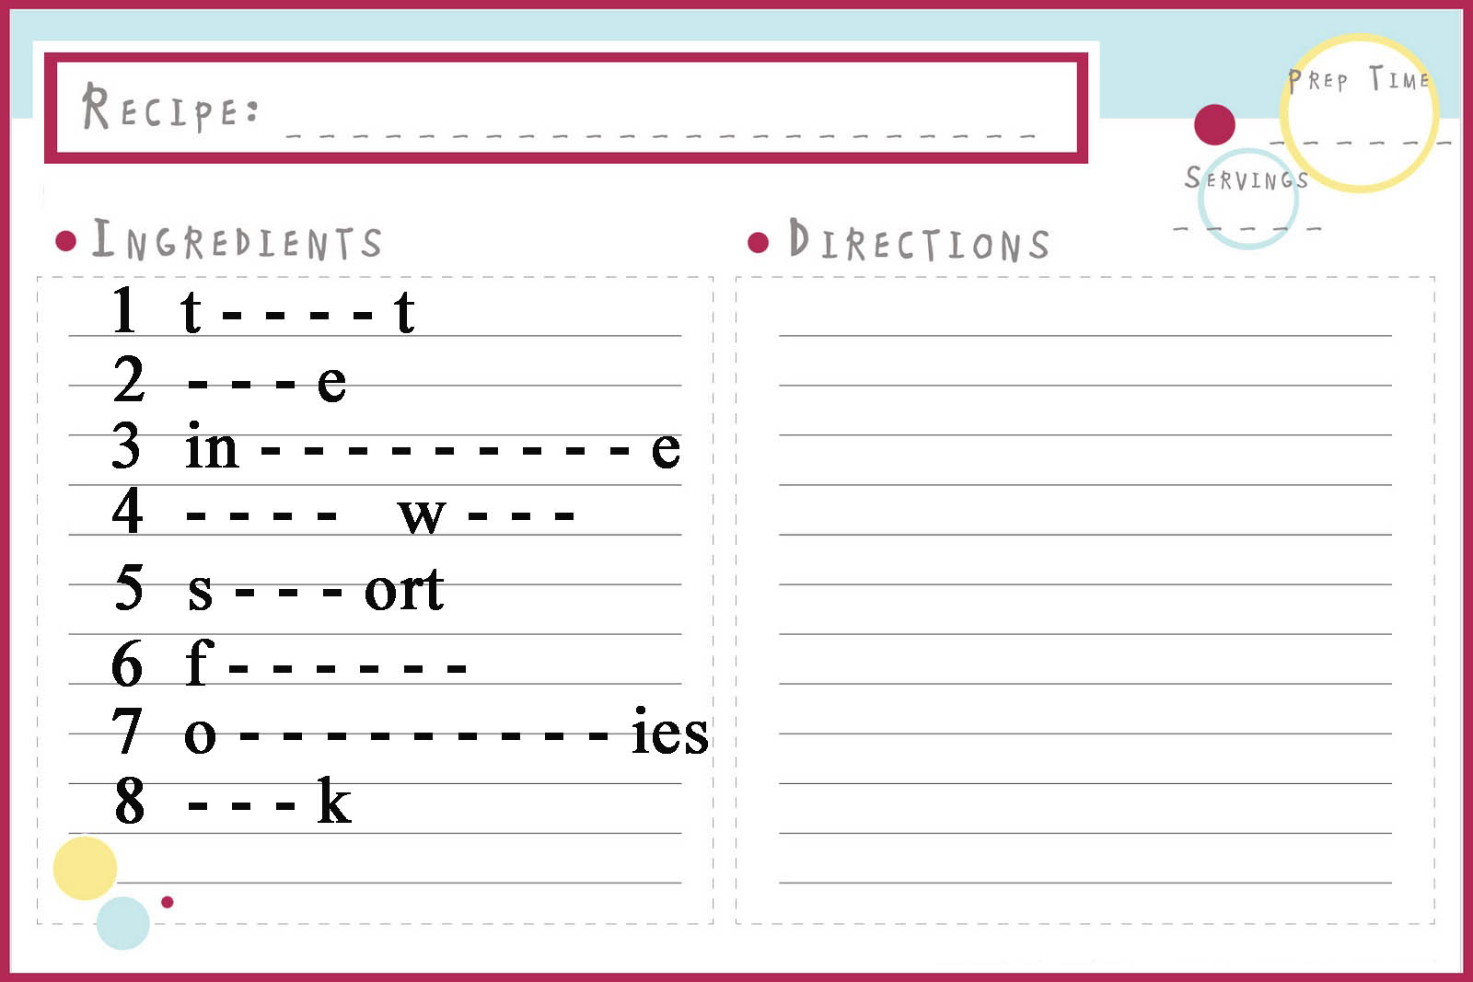
the key

So, we’ve almost discuss everything, except just one thing…
What does Gladwell say the other key ingredient to success is? Do you agree with his point of view?

Presentation “STARTING A BUSINESS”
T: So, are you ready to work on something for 10,000 hours? Have you already made your mind what it will be? (students reply: “Yes! We’d like to work on our own business! But we don’t know what should we begin with). Starting your own business…that sounds great!
Today’s special guest, Gordon Ramsay, is going to outline the key aspects that we should take into account if we’d like to start our own business. But first let’s do some exercises in order to refresh your topical vocabulary that we’ve learnt before (5-7 min).

(1) Complete using the words in the box. Use each word only once.
assets share bull market word-of-mouth cash-flow fixed costs variable costs bear market

1. We’ve had a bear market for a couple of months now, but I think it’s at or near bottom.
2. Their retail branches are a fixed costs, so the more business they put through them the better. The variable costs start from zero, since labour and material are not consumed until production starts.
3. College students rated the film as either “excellent” or “very good”, a favourable indicator for films that rely on word-of-mouth .
4. Mr. Trump will have to keep to a business plan with strict month-by-month cash-flow projections.
5. Friendly companies and banks alone own 56 % of all shares in German’s listed companies.
6. The company has a tremendous assets - 50 hectares of real estate right next to an international airport.
7. Even badly managed companies do well in a bull market.

(2) Match to make word combinations. Translate into Russian.




(the key: amortise (списывать, погашать долг в рассрочку), collateral (собственность, предлагаемая в качестве гаранта возврата кредита), liability (пассив, обязательства), leveraged (компания сбольшой долей заемных средств), dividend (часть прибыли компании), equity(капитал компании))

T: Well done! Now we’re ready to welcome … Gordon Ramsay! Hi, Gordon. How are you doing? (small talk). Gordon, will you be so kind and give us your recipe of how to start a business including all your secret ingredients?..... While listening to Gordon’s presentation, please, students, get ready to complete your recipe card…
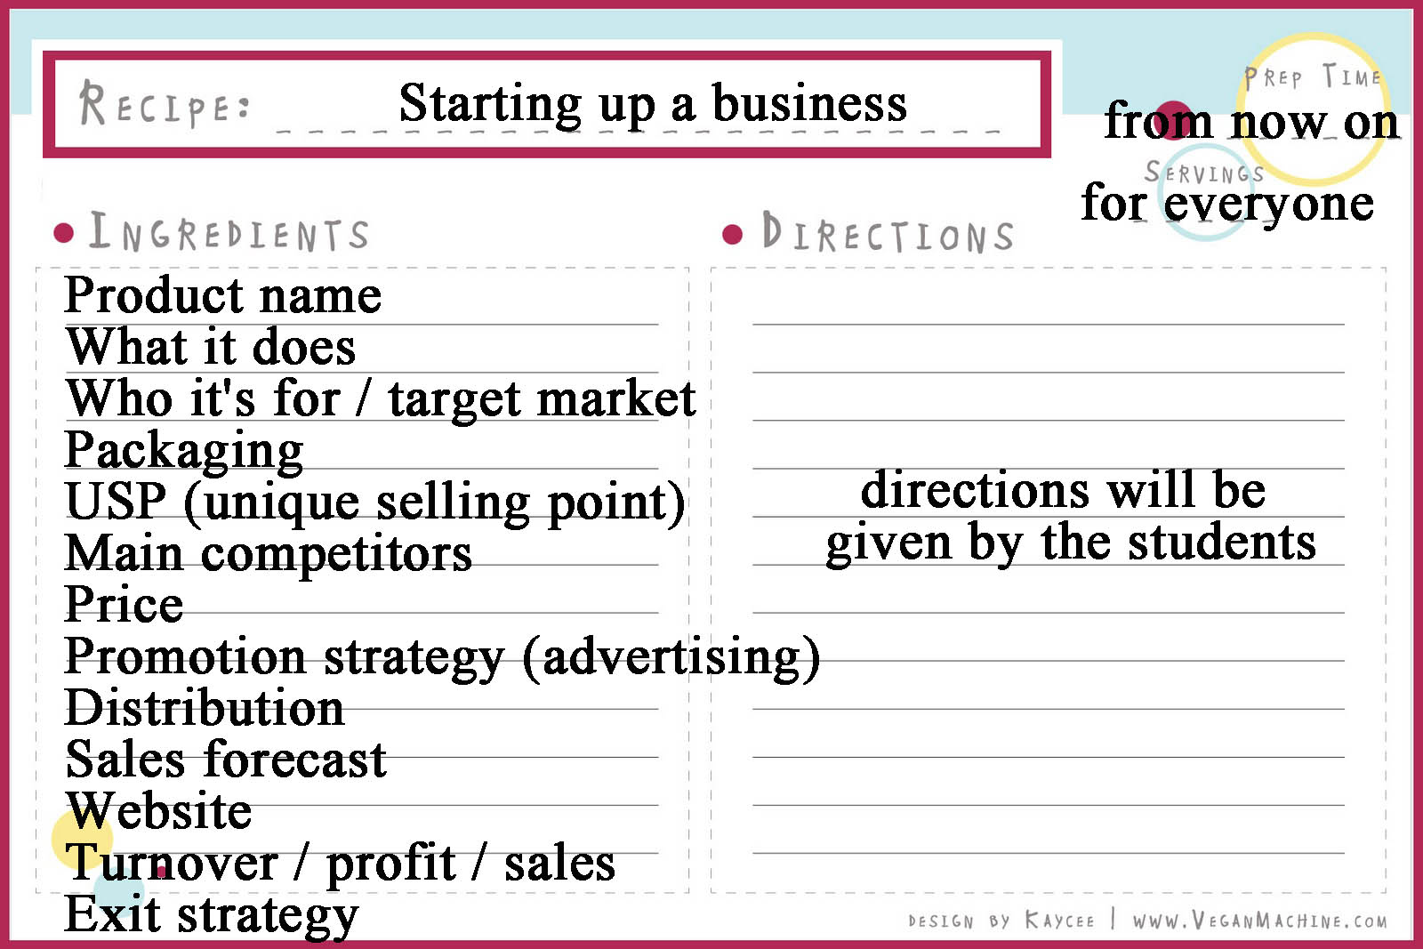
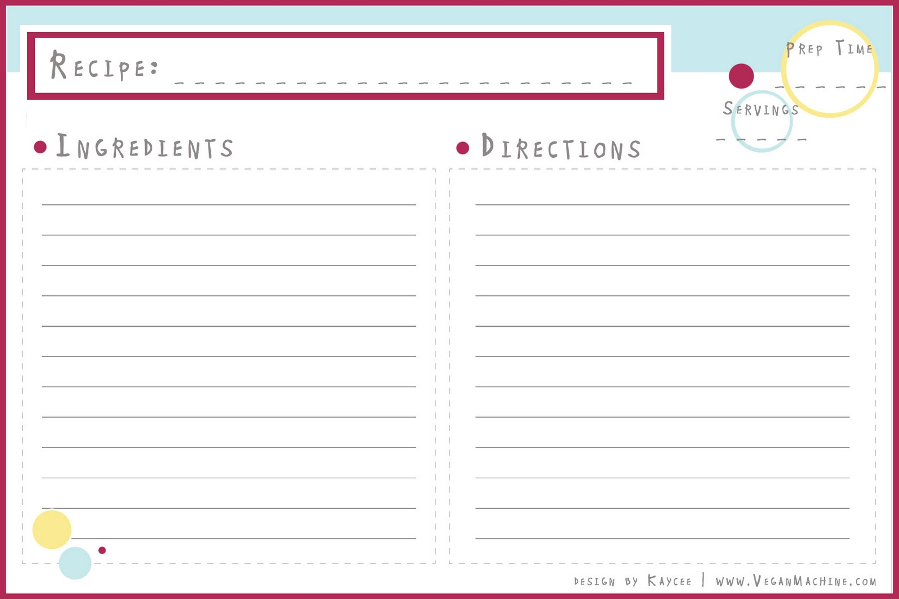

T: Thank you, Gordon, for your useful instructions. Now we have no doubts, that sooner or later we’ll manage to start our own business successfully.

So, what important aspects have you learnt from Ramsay’s presentation. With your partner work out the final version of your recipe card and present it to the class.

T: Thanks everyone for your ideas. Now we’re breaking for a commercial, stay with us and you’ll find a lot more. (перемена)

Watching INTERVIEW
T: You are watching BUSINESS KITCHEN and from now on you’re an expert of how to start your own business. But have you ever thought what s the fastest way to go public is: to find new aquaintances just outside or to join the other members of your family in order to start your family business? The next video episode (3:41) is about successful family business. You are going to hear Catherine and Luke talking about their publishing business. (10+10 min)

(1) Before you watch, can you think of any innovative ways for a small publisher to promote a new book?

(2) Now watch the FIRST part of an interview. While watching , complete the table below:

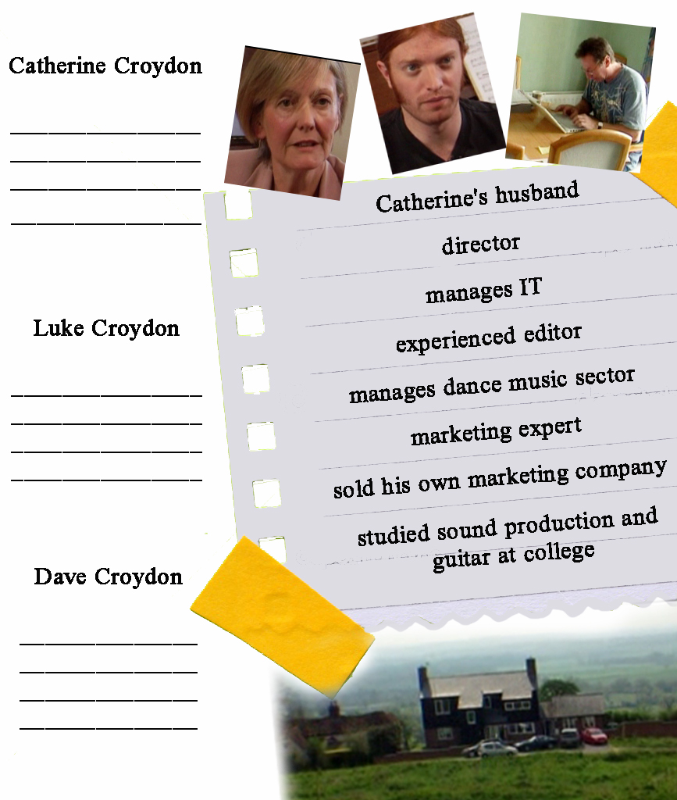

(3) Watch the SECOND part of an interview. Make notes on what Catherine and Luke say about positive points and difficulties in running your own business. What does Catherine say about innovative ways for a small publisher to promote a new book?


Answer key:
(1) To promote one of Hilltop Publishing books, the author went on a cycling tour to the places mentioned in the novel. On the way, he stopped at bookshops to sell the book. Catherine supported him with press and local radio).

(2) Hilltop Publishing: small family business; publish books, some songs; started because they thought their different areas of expertise would work well together
Catherine Croydon: director; experienced editor
Luke Croydon: works for family business; manages IT; manages dance music sector; studied sound production and guitar at college
Dave Croydon: Catherine's husband and business partner; marketing expert; sold his own marketing company

(3) Positive points of running your own business: satisfaction of choosing what is valuable and promoting it yourself
Difficulties in running your own business: finding a distributor; self-distribution is hard and time-consuming
What to do before starting a business: do a lot of research; have a good marketing plan; make sure there's a market for your product in the area where you'll be operating; don't plunge in until you're sure it's viable)

4. Answer the questions below for yourself
1. Are you impressed by the idea of starting up a family business?
2. What other difficulties may occur while starting up a business? Which way out from these problems will you recommend?

Presentations “The business of my dreams”
T: And, finally, have you already decided how the business of your dreams will look like? If yes, you are much luckier then me, because I haven’t made my mind yet. Will you share your business projects with me?... That’s great!
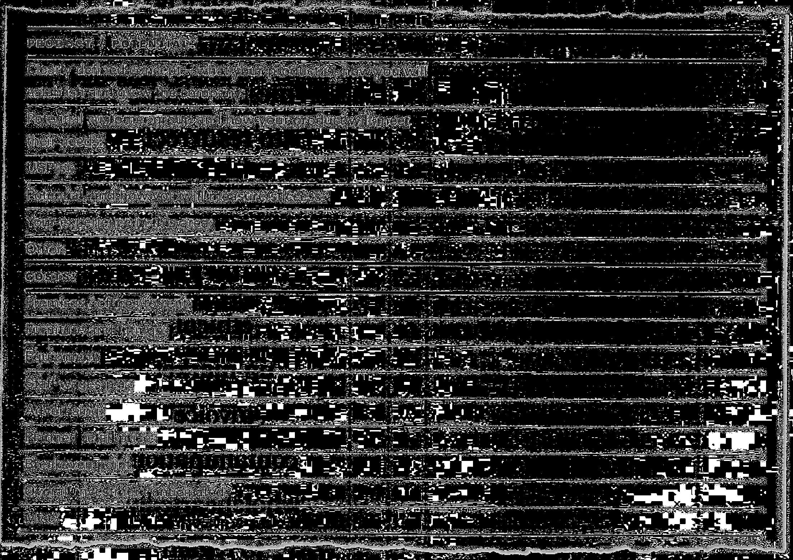
While watching the presentations, please, split into two groups of BUSINESS EXPERTS to find out if projects will be a success or a disaster in the world of business. Group A is going to give positive forecast on the projects and Group B will be searching for some drawbacks in organizing business. Take the CHART and your RECIPE CARDS that will help you to make the right decision. (презентация 2 или 3 проектов с последующим обсуждением).

T: So, today we’ve learnt the most essential thing of every business: its Startup! Though for everyone success looks different we need only 2 tiny recipes of successful business that are universal for all people in the world. How to start our own business…. This question is not a problem any more. "Don't aim for success if you want it; just do what you love and believe in, and it will come naturally" (David Frost). That is all for today, see you tomorrow!

NEPOTISM – фаворитизм по отношению к членам своей семьи (предоставление работы, продвижение по службе, заключение сделок) favouritism shown to relatives, esp. in appointment to desirable positions in a company.

fixed cost – фиксированные затраты, не зависящие от объема производства или продаж.
variable cost – переменные издержки, кот. изменяются в зависимости от объема производства.
cash-flow – поток наличности (разница между всеми наличными поступлениями и платежами компании за определенный период)

proactive - taking the initiative

Материалы подготовила
преподаватель кафедры теории и практики английского языка
САКОВИЧ ТАТЬЯНА СЕРГЕЕВНА

