Контрольная работа для студентов 2 курса факультета мировой экономики специальности «Экономист»
Предмет: Английский язык 1-й профессиональный
Тема: «Business Correspondence»
Семестр: 4
Составитель: Сахно М.Н.

Task 1: Mark the sentences as true or false on the layout/presentation of a business letter.

1. On unheaded paper you should always write your name above your address.
2. "Ref" refers to the writer's filing system.
3. In the UK, the date 2/4/99 means February 4th, 1999.
4. You should always write the name and position of the person you are writing to above his/her company address.
5. You use Dear Sir or Dear Madam when you know that the person you writing to is more senior to you.
6. If you begin with Dear Sir, you end with Yours faithfully
7. The initials p.p. indicate that the person signing the letter is doing so on behalf of someone else.
8. It is unusual for the writer to put his/her company position at the end of the letter.
9. In business letters, the date should appear as numbers separated by points (.) or oblique (/)
10.The abbreviation Ms can refer both to a married or an unmarried woman.
11.If you are writing to Mrs Anne Swanson, you open with Dear Madam.
12.Short business letters are impolite
13.Americans may begin their letters with gentlemen.
14.The letters "Encl." mean that something has been sent with the letter.

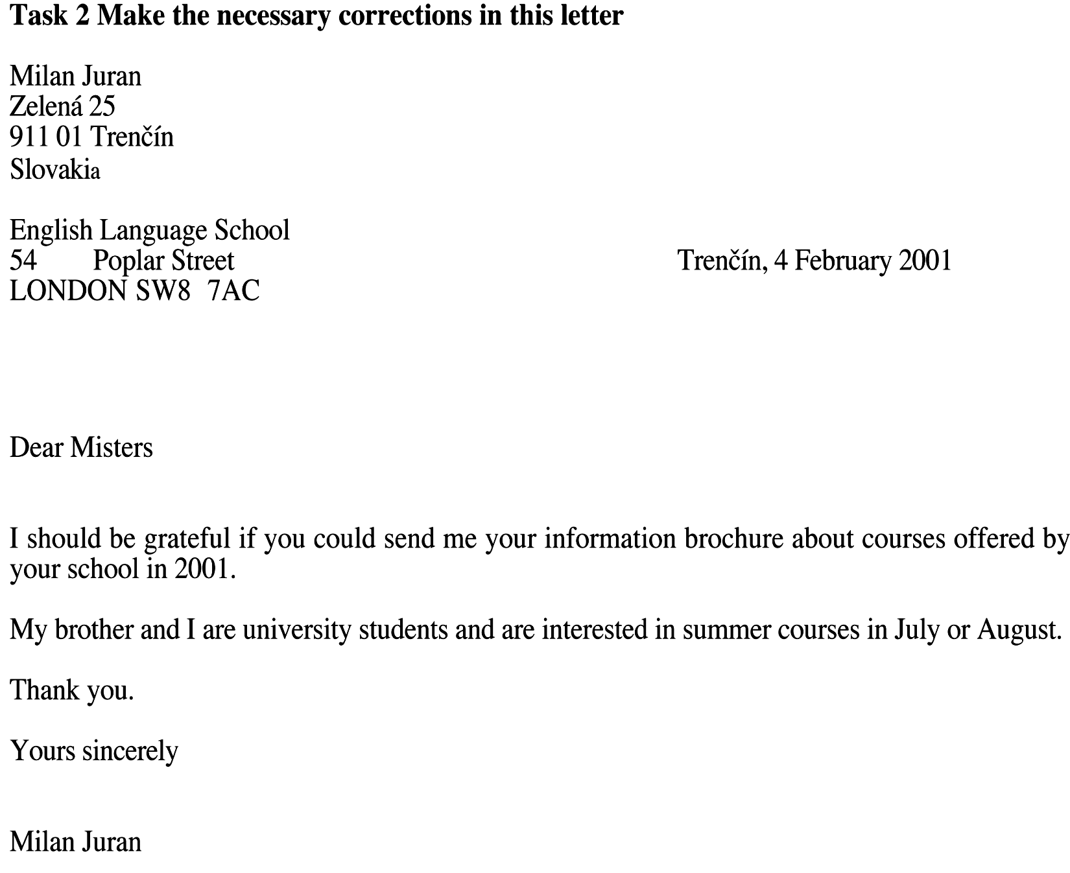
Task 2. Answer the following questions
- What types of business letters do you know?
- What should you remember when sending a letter of invitation?
- What does the form of invitation depend on?
- What is the form of reply determined by?
- When should you send the letter of congratulations?
- What should be written in a letter of apology?
- What information does a covering letter contain?
- What type of the letter do we send when we need some samples of goods or reference materials?
- What is the reply to an enquiry called?
- When do we send an intermediate answer on the enquiry?
- What should be stated in a detailed reply to the enquiry?
- What is an order?
- What does a letter of guarantee certify?
- What type of a business letter deals with the delivery of wrong goods?
- What should be explained in a reply to a letter of complaint?

Task 3. Informal letter. Fill each blank with the following words. Use each item once only.
As you know Best wishes I'm sorry Anyway
Congratulations Thanks In the end Really busy
Of course Get on Let me, know Put you up
Dear Pete,
a _for your last letter.b _ it's taken me so long to reply but I've been c _moving into my new flat. d _ on passing your driving test first time. Now all you have to do is save up for that Porsche you've always wanted - and the tax and insurance, e _! ' _ I've just started a new job as the manager of the biggest video shop in town. I was a bit nervous on my first day when I had to meet the staff, but, g _ everything turned out all right and I think we're going to h _ very well. i _the main reason I'm writing is to invite you to a party I'm having Saturday week. I do hope you can come. I've got a spare bed so I could j _ for the night. I must stop now or I'll miss the last post. Please k _ if you can come so that I can give you all the details of how to get here. l _.

Task 4. Formal Letter. Use the words below to complete the letter. Use each item once only.
grateful current issue additional charge particularly interested however eligible for package holidays under what circumstances
mentioned look forward to with reference to send me information
Dear Sir or Madam,
a _ to your advertisement in the b _ of "Summer Holiday" magazine, could you please c _ about the holidays you offer in the United States? I am d _ in your e _ to California and Florida. In your advertisement you state that there are reduced prices for children but it is not clear f _ these reductions can be obtained. We are a family of four, with two adults and two children, aged 10 and 16. Could you tell me whether my 16-year-old child would still be g _ a reduction or if he is now classed as an adult? Your advertisement also h _that a free hire car was included in the holidays in the United States. i _ there was no information about insurance. I would be j _ therefore, if you could inform me whether this is included or not. If it is not, I would like to know how much the k _ would be. I hope you will be able to answer my queries. I l _ hearing from you. Yours faithfully.

