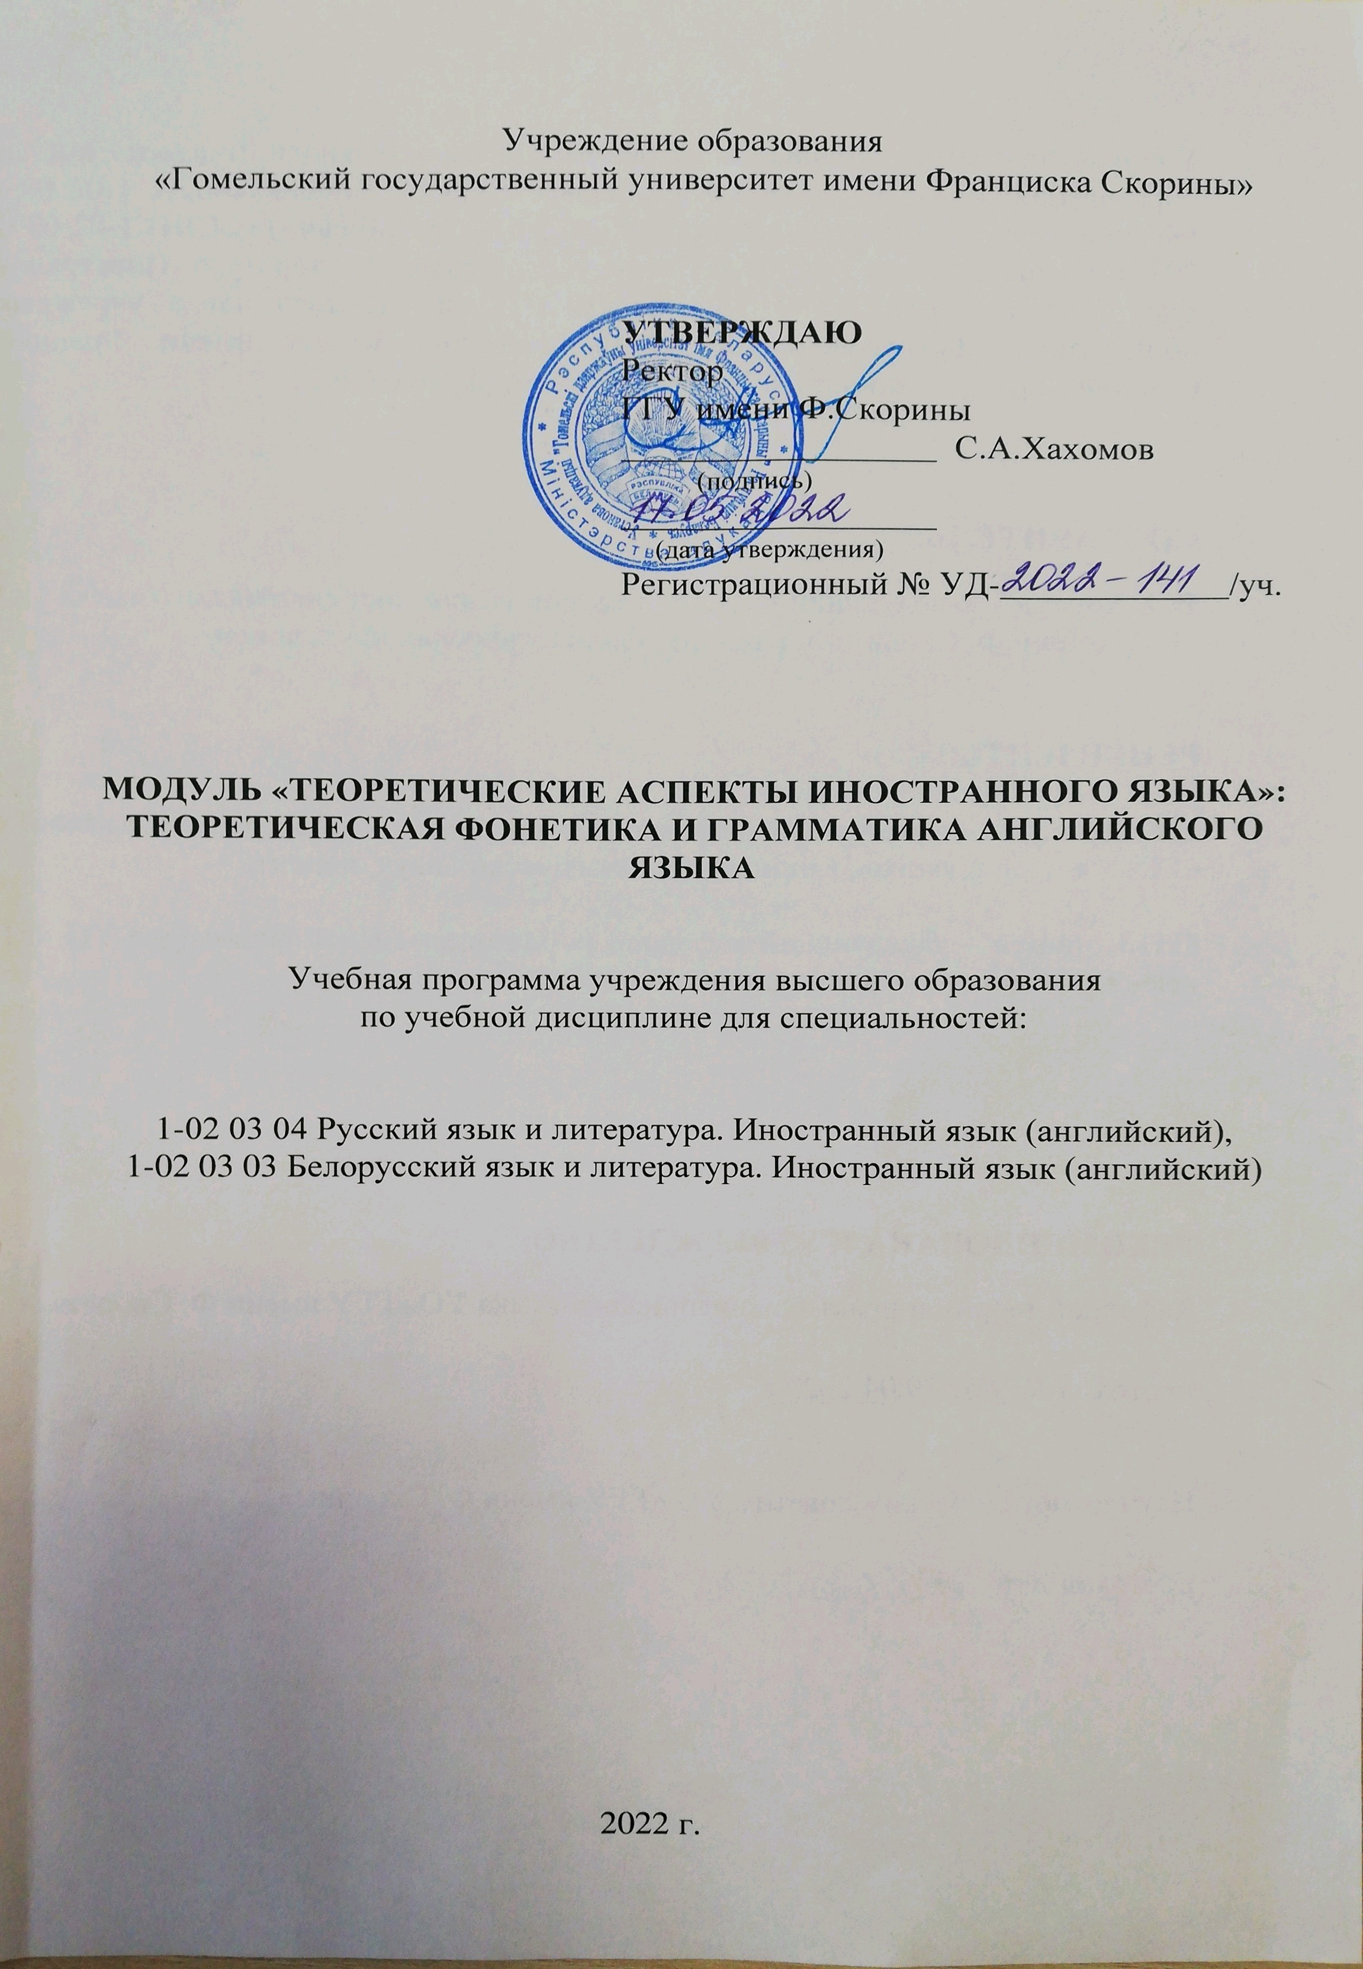

**The present perfect and the present perfect continuous**

1 We (walk) ten kilometres.

2 We (walk) for three hours.

3 You (walk) too fast. That's why you are tired.

4 I (make) sausage rolls for the party all the morning.

5 How many you (make)? ~ I (make) 200.

6 That boy (eat) seven ice-creams.

7 He (not stop) eating since he arrived.

8 The driver (drink). I think someone else ought to drive.

9 I (pull) up 100 dandelions.

10 I (pull) up dandelions all day.

11 What you (do)? ~ We (pick) apples.

12 How many you (pick)? ~ We (pick) ten basketfuls.

13 I (sleep) on every bed in this house and I don't like any of them.

14 He (sleep) since ten o'clock. It's time he woke up.

15 He (ride); that's why he is wearing breeches.

16 I (ride) all the horses in this stable.

17 What a lovely smell! ~ Mary (make) jam.

18 The students (work) very well this term.

19 I only (hear) from him twice since he went away.

20 I (hear) from her regularly. She is a very good correspondent.

21 I (grease) my car. That's why my hands are so dirty.

22 I (polish) this table all the morning and she isn't satisfied with it yet.

23 I (work) for him for ten years and he never once (say) 'Good morning' to me.

24 He (teach) in this school for five years.

25 I (teach) hundreds of students but I never (meet) such a hopeless class as this.

26 Why you (be) so long in the garage? ~  
The tyres were flat; I (pump) them up.

27 I (pump) up three tyres. Would you like to do the fourth?

28 I (look) for mushrooms but I (not find) any.

29 He (cough) a lot lately. He ought to give up smoking.

30 You (hear) the news? Tom and Ann are engaged! ~  
That's not new; I (know) it for ages!

31 I (try) to finish this letter for the last half-hour. I wish you'd go away or stop talking. ~  
I hardly (say) anything.

32 The driver of that car (sound) his horn for the last ten minutes.

33 It (rain) for two hours and the ground is too wet to play on, so the match (be) postponed.

34 He (hope) for a rise in salary for six months but he (not dare) to ask for it yet.

35 Mr Smith, you (whisper) to the student on your right for the last five minutes. You (help) him with his exam paper or he (help) you?

36 Why you (make) such a horrible noise? ~  
I (lose) my key and I (try) to wake my wife by throwing stones at he window. ~  
