**Communicative Activities in Practising Vocabulary**

(Из Андреасян)

* **There is a jumbled list of notions necessary in teaching vocabulary. Complete the diagram below with the notions from the list.**

**Appropriaricy**

**Meaning Word use**

**Word formation Practice**

**Presentation**

***Usefulness, collocation, formal/informal, demonstration, part of speech, context, concise, definition, spelling, sounds, countable/uncountable, picture, detailed description, receptive, pronunciation, denotation, written/spoken, vocabulary network, stress, demonstration (acting), translation, antonyms, mind map, illusration (object), using a dictionary, connotation, appropriateness , synonyms.***

* **Work in pairs. Read through the following exercises and say which aspect of each vocabulary they focus on. Discuss the importance of "mind maps" for creating vocabulary fields.**

1. ***Complete the grid.***

|  |  |  |  |  |  |
| --- | --- | --- | --- | --- | --- |
|  | a door | a dog | a plant | a child | a car |
| damage  injure  hurt |  |  |  |  |  |

1. ***Give an example of:***

* something that is *complicated*
* a piece of furniture that is *uncomfortable*
* something that makes you *nervous*
* a *nasty* habit
* a *boring* way to spend an evening

*Write the opposites of the words in italics.*

1. ***Find words and expressions in the text that mean:***

very surprised =

wanted to go =

normal =

make a short visit =

1. ***Add to this "word wheel".***

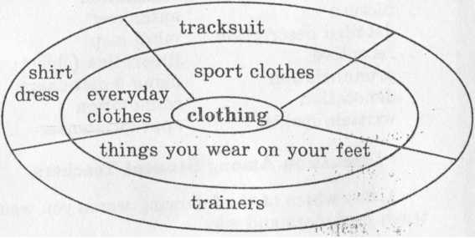

1. ***Say, which of these qualities are most important for you in a friend. Place them in order of importance. Prove your choice.***

Tolerance, compassion, sincerity, modesty, patience, imagination, sensitivity, frankness, generosity, passion, courage, ambition, humility, creativity.

1. ***Match these words and expressions with their definitions:***
2. dramatic 1. of a relating to the chemistry of living things
3. relieve 2. person who offers to do something
4. biochemical 3. specialist in a particular kind of treatment or cure
5. volunteer 4. to allow light to reach (a film, a person, etc.)
6. expose 5. medical attention to a sick person
7. hyperactive 6. abnormally active and unable to relax
8. therapeutist 7. exciting and impressive
9. treatment 8. information that gives a reason for believing something or proves
10. evidence something

9. lessen or remove (pain, anxiety, etc.)

1. ***Discuss and write down the personal characteristics (good or bad) that you would expect to find in these people.***

* a nurse
* an actor
* a politician
* a teacher
* a manager of a company

1. ***Working with your partner, put the following events that happen in a restaurant into the correct order.***

look at the menu ______________

give the waiter a tip ______________

have dessert ______________

pay the bill ______________

book a table ______________

decide to go out for a meal ______________

leave the restaurant ______________

have the starter ______________

go to the restaurant ______________

have the main course ______________

sit down ______________

order the meal ______________

ask for the bill ______________

* **Look through the exercises below and say in which way they develop the learner’s autonomy.**

1. ***There is a “vocabulary network”. Can you complete it with words from the box? Then add one more object for each room.***

|  |
| --- |
| *saucepans, shower, sofa, towels, kettle, alarmclock, video, sheets,*  *sink, washbasin, chest of drawers, coffee table* |

1. ***Look at the headings below. List under each heading four or five words which describe your own school or college. Then compare and discuss your answers with a partner.***

School buildings School activities

__________________ ___________________

__________________ ___________________

__________________ ___________________

School atmosphere School teaching style

__________________ ___________________

__________________ ___________________

__________________ ___________________

1. ***Acting out the poem.***

Encourage your pupils to associate adjectives with movements. Ask the children to suggest an action or mime the adjective. Get the children to do the actions as you call out the adjectives. Ask the children to stand up and say the poem together, doing the actions.

I’m big.

I’m small.

I’m short.

I’m tall.

I’m happy.

I’m sad.

I’m good.

I’m bad.

We’re friends.

That’s the end.

1. ***Circle the Easter pictures.***



1. ***Say what you look for in your family life at home and why. Put the features below in the order of priority. Discuss them with уour partner.***

* good things to eat
* friendly atmosphere
* isolation and independence
* care and attention
* support in troubles
* good reasonable advice
* interesting people to meet
* living space
* amenities of home life
* all modern conveniences

1. ***Ask your students to bring postcards of different artists’ paintings, to give every picture a number and pin them up around the classroom. Ask students to walk around and have a good look at the paintings. Then ask them the following question:***

* Which of these pictures would you like to have on the wall beside your bed, so that it’s the last thing you see at night and the first thing you see in the morning?

***Ask students to make their choices and to tell those nearby which one they selected and why. While students are talking monitor their conversation.***