Контрольные задания
по практической фонетике английского языка
для студентов заочного факультета
специальности «Английский язык»

Контрольное задание №2 – 3 семестр
(для подготовки к зимней сессии 2 курса)
Составители:
Берещенко Н.В., Насон Н.В., Полевая Т.Н.

Для того, чтобы выполнить задание №3, необходимо усвоить следующие темы:
- ядерное и неядерное ударение, позиция ядерного слова во фразе;
- интонация вводных слов, слов автора, обращений;
- интонация разговорных формул (приветствия, поздравления, выражения сочувствия, удивления и др.);
- интонация общих, специальных, разделительных и кратких вопросов, ответов на вопросы различных типов;
- интонация советов, приказов, условных предложений;
- интонация предложений со словами «too, either, only, even».

Литература:
Home-listening course (запись на аудио-носителе);
Practical English Phonetics. Advanced course. Под ред. Е.Б. Карневской.

Вариант 2

Exercise 1. Intone the following sentences and dialogues:

a) Mind the intonation of reporting phrases and reported speech:
1) Jane said, “Grandma, I’ve brought you some snacks”.
2) “What are you?” asked the pigeon.
3) Then the girl asked, why her granny had such big ears.

b) Mind the intonation of parentheses:
    - By the way, did you ski much when you were there?
    - No, I didn’t. Unfortunately, I can’t ski. I’ve never skied in my life, I’m too fat, as you can see, that’s why I’ve never even tried to ski.
    - Nonsense! It seems to me, you are thinner than I am. For my own part, I learnt to ski a couple of years ago. You must have a try, I think.

c) Mind the intonation of direct addresses:
    - Mike, give the rag to me and I’ll wipe the floor.
    - No, let me, my darling.
    - For heaven’s sake, dear, turn that tap off! Can you hear me, Mike? Mike, what are you doing? You’ve splashed my dress!
    - Sorry, Helen.

Exercise 2. Complete the following phrases as they were recorded in the home-listening course. Put down the intonation of conversational formulas.

a) Greetings:
1. If it is bedtime, of course, you say: … This is used for …
2. Now, when you meet someone for the first time… The other person replies … This is not really …

b) Thanks and Apologies:
1. Notice, that when Mr. Watkins says “Thank you” … In a situation like this, … because …
But when someone is really grateful, …
2. Sorry to keep you waiting, Alan. - … As you can hear, …
3. Notice, that we use “Excuse me” only … Don’t …

c) Congratulations, Sympathy and Surprise:
1. When it’s not such a big surprise, …
2. Another way of congratulating someone is like this: …
3. We often say “…” when it’s not so serious.

d) Reassurances:
1. Reassurances are …
2. Very often reassurances use the word … As you can hear, there is more than reassurance here, …

Exercise 3. The following phrases were used in the home-listening course. Choose the nuclear tones for each sentence as you hear them and write a piece of theory illustrating the usage of the tones.

А) Yes/No Questions:
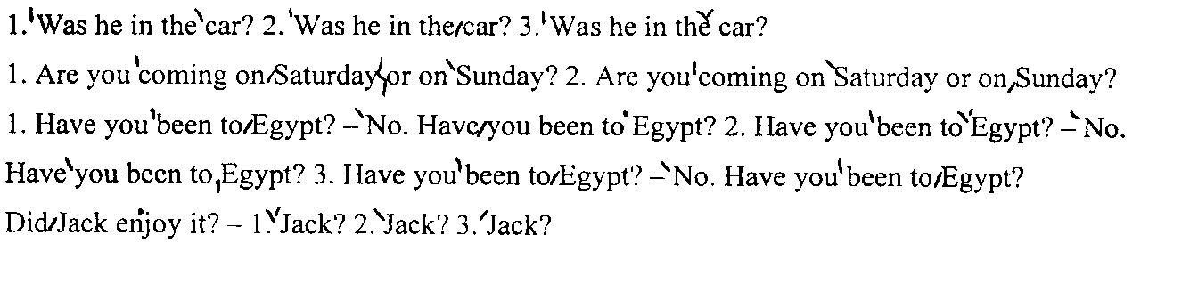
B) Answers to Yes/No Questions:
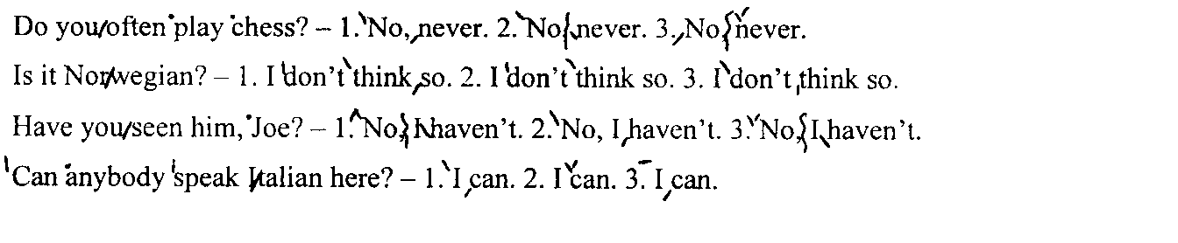
C) Asking Wh-questions:
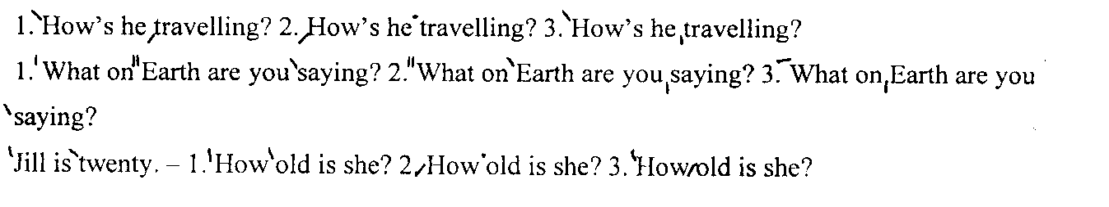

D) Giving information:
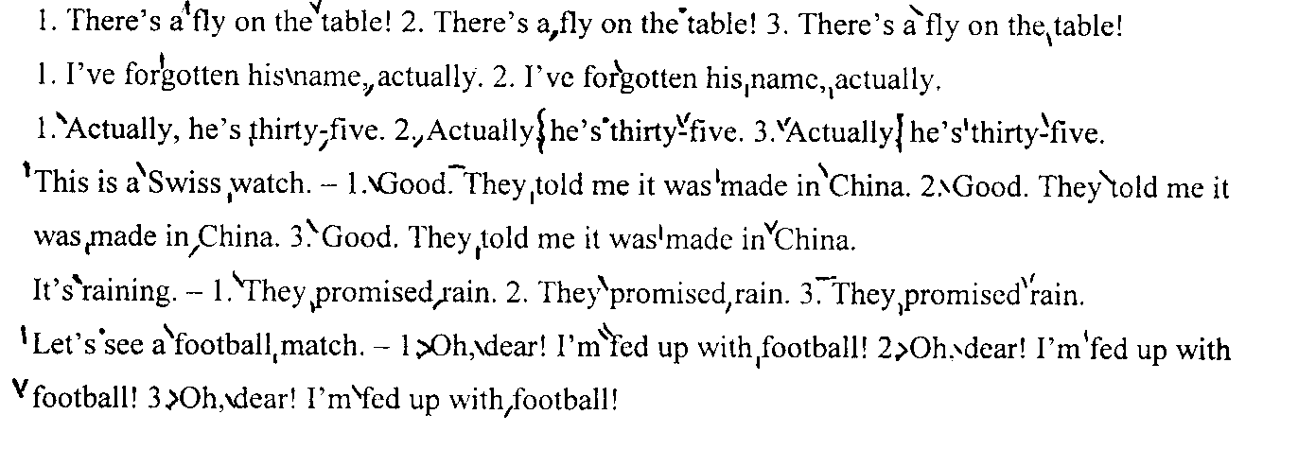

E) Invitations, warnings, orders and advice:
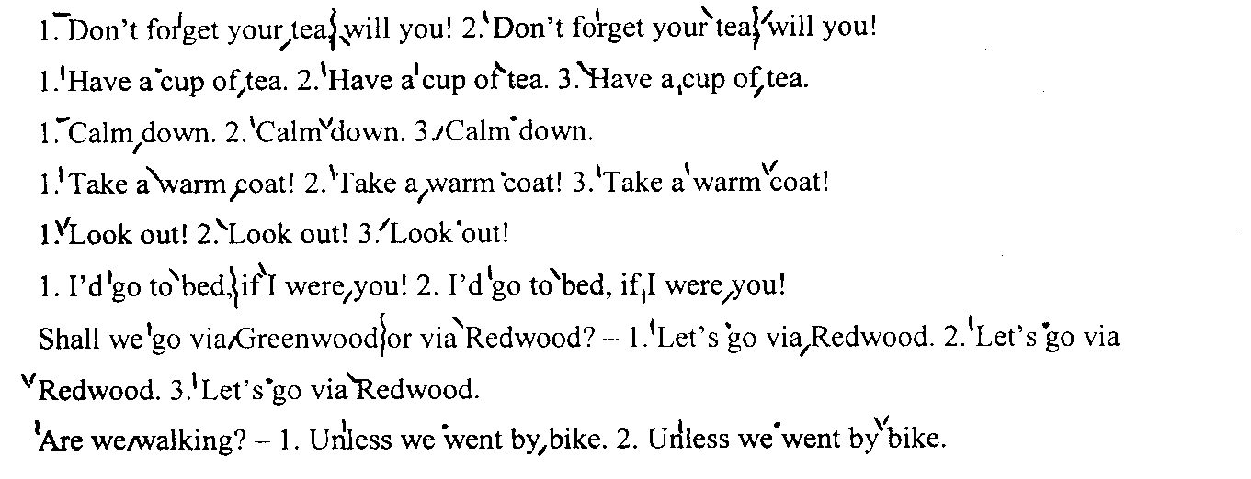
F) Hopes and wishes:
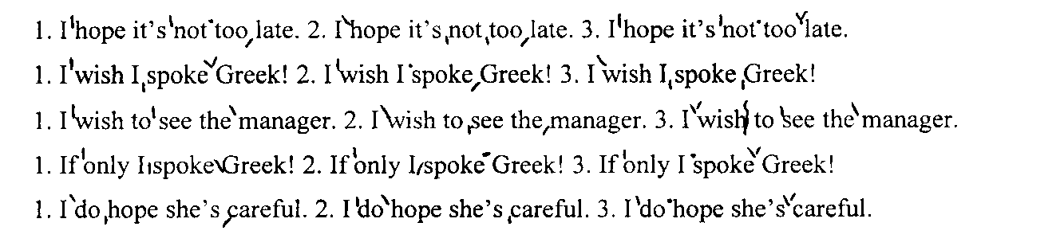
G) Intonation of too, either, only, just, even:
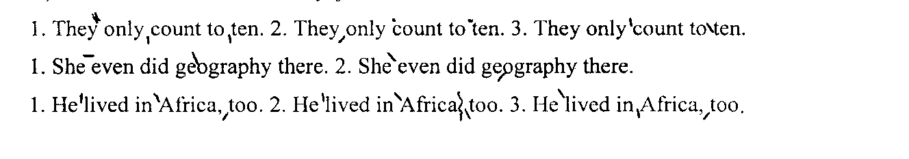

Exercise 4. Intone the following extract, marking all the necessary pauses, static and kinetic stresses; find and put down all the phonetic phenomena.

Model: He was `glad. ||
1) glad – A case of lateral plosion in the consonant cluster [gl].

So he began to climb the tree. He climbed and he climbed and he climbed and as he climbed he sang a little song to himself. Then he climbed a little further. . . and a little further . . . and then just a little further. By that time he had thought of another song.
It's a very funny thought that, if Bears were Bees,
They'd build their nests at the bottom of trees.
And that being so (if the Bees were Bears),
We shouldn't have to climb up all these stairs.
He was getting rather tired by this time, so that is why he sang a Complaining Song. He was nearly there now, and if he just stood on that branch . . .Crack !
"Oh, help!" said Pooh, as he dropped ten feet on the branch below him.
"If only I hadn't--" he said, as he bounced twenty feet on to the next branch.
"You see, what I meant to do," he explained, as he turned head-over-heels, and crashed on to another branch thirty feet below, "what I meant to do--"…
"Of course, it was rather--" he admitted, as he slithered very quickly through the next six branches.

