Контрольные задания
по практической фонетике английского языка
для студентов заочного факультета
специальности «Английский язык»

Контрольное задание №3

Для того, чтобы выполнить задание №3, необходимо усвоить следующие темы:
- ядерное и неядерное ударение;
- редукция служебных слов;
- позиция ядерного слова во фразе;
- интонация поздравлений, выражений сочувствия, удивления;
- интонация общих, специальных, кратких вопросов, ответов на вопросы различных типов;
- интонация советов, приказов, условных предложений;
- интонация предложений со словами «too, either, only, even».

Литература:
Home-listening course (запись на аудио-носителе);
Practical English Phonetics. Advanced course. Под ред. Е.Б. Карневской.

Вариант 2

Exercise 1. Intone the following conversational situations. Distinguish between the new and the repeated semantic items, using nuclear tones on proper words. Use appropriate kinetic tones.

- They accused Dobson of telling lies. – But he didn’t tell lies, did he?
- Well, I think the Gruntleys will help. – Are you certain they’ll help?
- Must Mary type it at once? – Obviously, she must. It’s full of mistakes.
- Shall we be on time? – We’ll be ahead of time.
- I go there quite often. – How often, if you don’t mind my asking?

Exercise 2. Intone the following phrases (replies only). Put down the tone patterns – a nuclear tone and a head – you’ve chosen.

- A: I’m going to the party, but Charlie isn’t. – B: I was hoping that you’d both be here. (emphasis, concern)
- A: Of course, the office may be closed. – B: Then what should I do? (despairing)
- A: She’ll never do any better. – B: I have a feeling she will. (contradiction)
- A: He’s obviously guilty. – B: It’ll be hard to prove. (impatient)
- A: Will you help? – B: How could I possibly refuse? (disclaiming responsibility)
- A: Pat is always early. – B: You’re always late. (contrast)
- A: Would you like to fetch it for him? – B: No, you fetch it. (disclaiming responsibility)
- A: I think it’s time to leave. – B: Does everyone agree? (skeptical)
- A: We’ll never get there. – B: It’s not as far as you imagine. (encouraging)
- A: The sandwiches have all gone, haven’t they? – B: There might be one left. (contrast)
- A: Miss Brown, did you ever hear of Jane Jason? – B: Jane Jason? Yes, I suppose so. I don’t know who she is. (resentful, casual)
- A: I’ll be back at three o’clock. – B: Can’t you come a bit earlier? (insistent)

Exercise 3. The following phrases were used in the home-listening course. Choose the nuclear tones for each sentence as you hear them and write a piece of theory illustrating the usage of the tones.

А) Yes/No Questions:
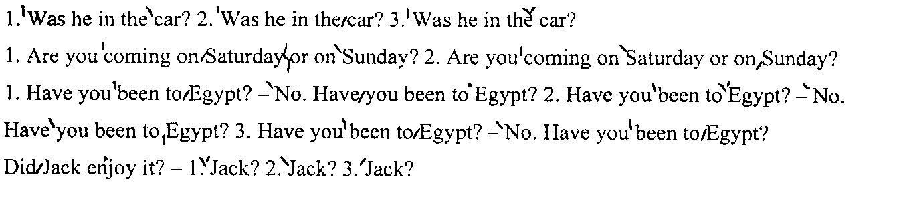
B) Answers to Yes/No Questions:
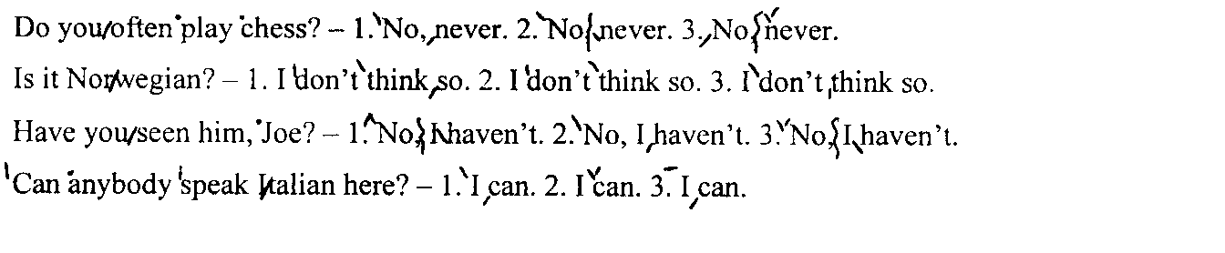
C) Asking Wh-questions:
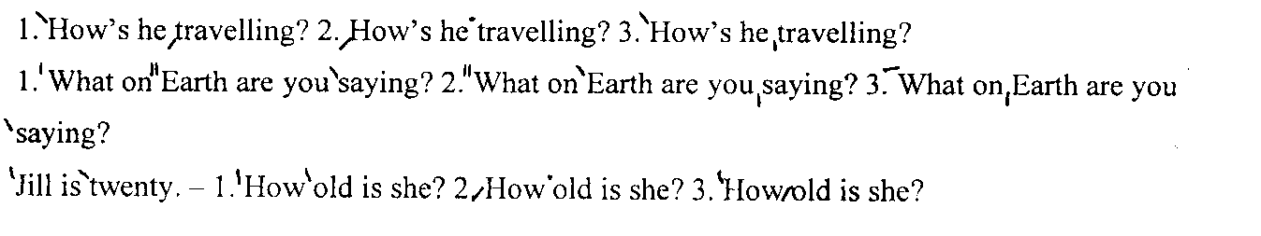
D) Giving information:
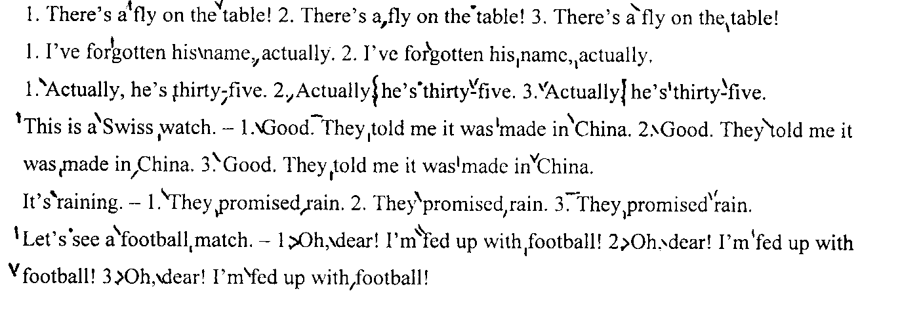

E) Invitations, warnings, orders and advice:
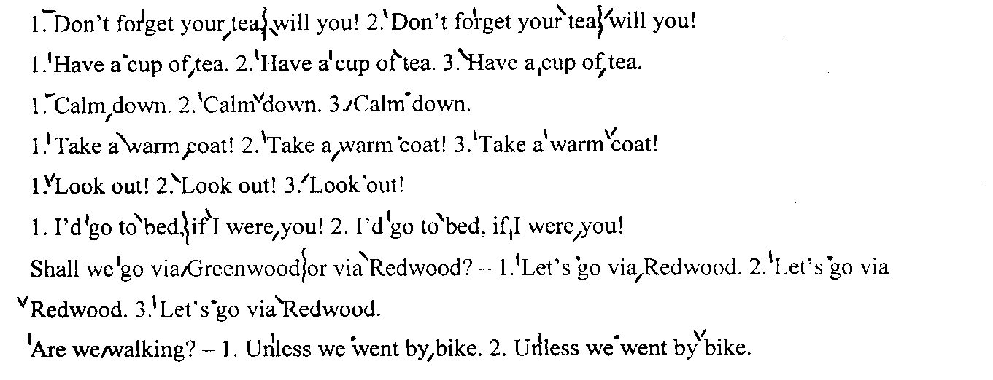
F) Hopes and wishes:
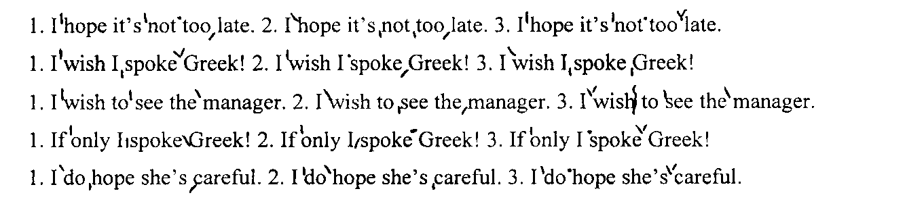
G) Intonation of too, either, only, just, even:
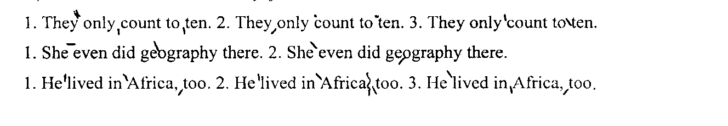

Exercise 4. Intone the following extract, marking all the necessary pauses, static and kinetic stresses; find and put down all the phonetic phenomena.

Model: He was glad. (HF) - Was he? (HNR)
1) glad – A case of lateral plosion in the consonant cluster [gl].

So he began to climb the tree. He climbed and he climbed and he climbed and as he climbed he sang a little song to himself. Then he climbed a little further. . . and a little further . . . and then just a little further. By that time he had thought of another song.
It's a very funny thought that, if Bears were Bees,
They'd build their nests at the bottom of trees.
And that being so (if the Bees were Bears),
We shouldn't have to climb up all these stairs.
He was getting rather tired by this time, so that is why he sang a Complaining Song. He was nearly there now, and if he just stood on that branch . . .Crack !
"Oh, help!" said Pooh, as he dropped ten feet on the branch below him.
"If only I hadn't--" he said, as he bounced twenty feet on to the next branch.
"You see, what I meant to do," he explained, as he turned head-over-heels, and crashed on to another branch thirty feet below, "what I meant to do--"…
"Of course, it was rather--" he admitted, as he slithered very quickly through the next six branches.

