Контрольные задания
по практической фонетике английского языка
для студентов заочного факультета
специальности «Английский язык»

Контрольное задание №3

Для того, чтобы выполнить задание №3, необходимо усвоить следующие темы:
- ядерное и неядерное ударение;
- редукция служебных слов;
- позиция ядерного слова во фразе;
- интонация поздравлений, выражений сочувствия, удивления;
- интонация общих, специальных, кратких вопросов, ответов на вопросы различных типов;
- интонация советов, приказов, условных предложений;
- интонация предложений со словами «too, either, only, even».

Литература:
Home-listening course (запись на аудио-носителе);
Practical English Phonetics. Advanced course. Под ред. Е.Б. Карневской.

Вариант 1

Exercise 1. Intone the following conversational situations. Distinguish between the new and the repeated semantic items, using nuclear tones on proper words. Use appropriate kinetic tones.

- I’m getting old, I’m afraid. – Aren’t all of us getting old!
- It shouldn’t take long. – It’ll take at least a week.
- You said he was leaving this morning. – I said tonight.
- Have you been here long? – We’ve been waiting for ages.
- They stayed away for a very good reason. – For what good reason?

Exercise 2. Intone the following phrases (replies only). Put down the tone patterns – a nuclear tone and a head – you’ve chosen.

- A: Do you know where William is? – B: Perhaps he’s gone to a football match. (doubt)
- A: It’s not my duty. – B: Whose duty is it then? (antagonistic)
- A: I like this crystal vase. – B: Which do you mean? (reserved)
- A: Jack is not in the mood for staying in tonight. – B: Then why not go out for a walk? (concerned)
- A: I can’t talk to you now. – B: May I phone again tomorrow? (insistent)
- A: Pete is thinking of buying a new car. – B: Can he afford it? (skeptical)
- A: Would you like to fetch it for him? – B: No, you fetch it. (disclaiming responsibility)
- A: I think it’s time to leave. – B: Does everyone agree? (skeptical)
- A: We’ll never get there. – B: It’s not as far as you imagine. (encouraging)
- A: The sandwiches have all gone, haven’t they? – B: There might be one left. (contrast)
- A: Miss Brown, did you ever hear of Jane Jason? – B: Jane Jason? Yes, I suppose so. I don’t know who she is. (resentful, casual)
- A: I’ll be back at three o’clock. – B: Can’t you come a bit earlier? (insistent)

Exercise 3. The following phrases were used in the home-listening course. Choose the nuclear tones for each sentence as you hear them and write a piece of theory illustrating the usage of the tones.

А) Yes/No Questions:
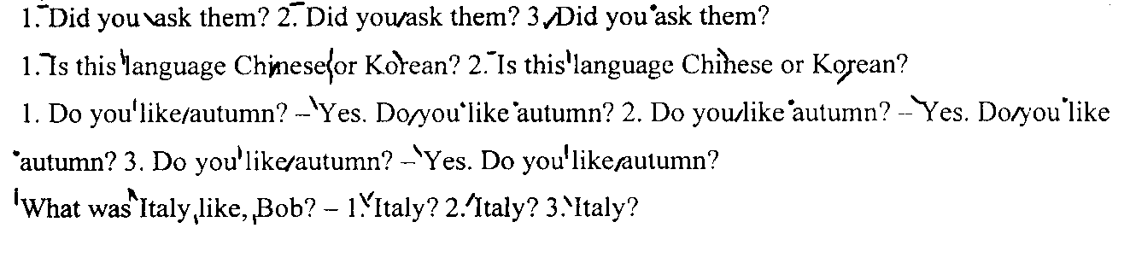
B) Answers to Yes/No Questions:
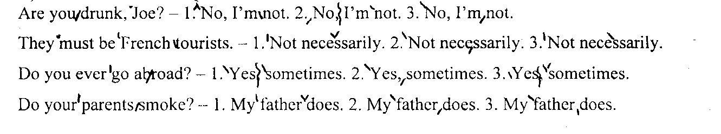
C) Asking Wh-questions:
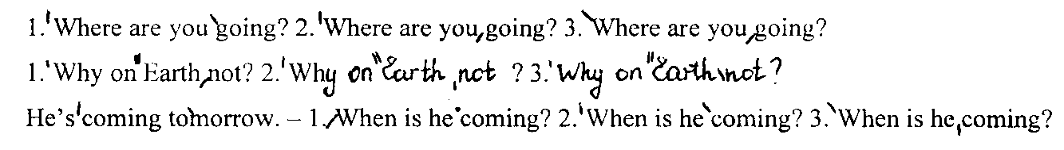
D) Giving information:
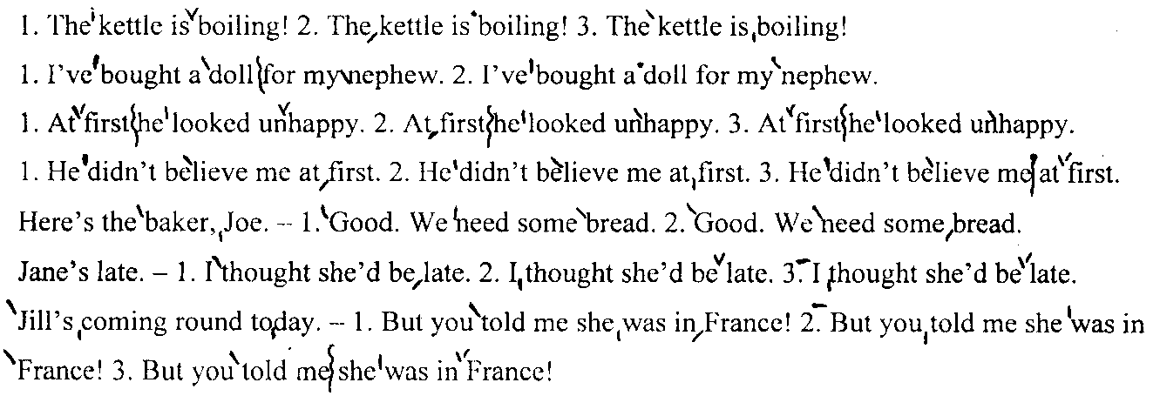
E) Invitations, warnings, orders and advice:
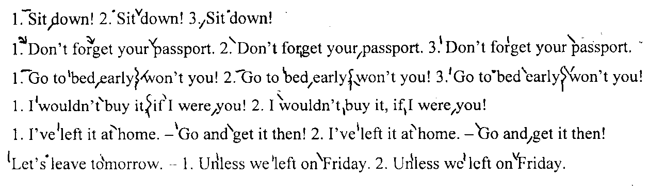
F) Hopes and wishes:
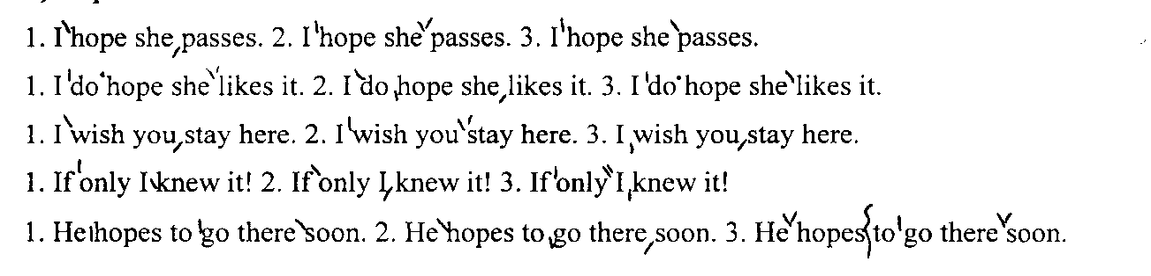
G) Intonation of too, either, only, just, even:
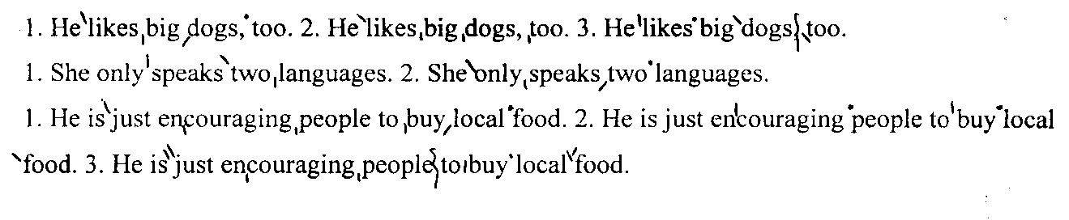
Exercise 4. Intone the following extract, marking all the necessary pauses, static and kinetic stresses; find and put down all the phonetic phenomena.

Model: He was glad. (HF) - Was he? (HNR)
1) glad – A case of lateral plosion in the consonant cluster [gl].

Once upon a time, a very long time ago now, about last Friday, Winnie-the-Pooh lived in a forest all by himself under the name of Sanders.
One day when he was out walking, he came to an open place in the middle of the forest, and in the middle of this place was a large oak-tree, and, from the top of the tree, there came a loud buzzing-noise. Winnie-the-Pooh sat down at the foot of the tree, put his head between his paws and began to think. First of all he said to himself: "That buzzing-noise means something. You don't get a buzzing-noise like that, just buzzing and buzzing, without its meaning something. If there's a buzzing-noise, somebody's making a buzzing-noise, and the only reason for making a buzzing-noise that I know of is because you're a bee." Then he thought another long time, and said: "And the only reason for being a bee that I know of is making honey." And then he got up, and said: "And the only reason for making honey is so as I can eat it."

