Teaching is the profession that teaches all of
the other professions

Гомельский государственный университет имени Франциска Скорины
Студенческая газета кафедры английского языка

WELCOME!
октябрь 2020 г.
Кафедра английского языка обеспечивает преподавание дисциплины «Английский язык» на восьми факультетах университета на дневной и заочной формах обучения, в группах магистрантов. Поэтому каждый выпуск студенческой газеты будет подготовлен студентами и магистрантами разных факультетов, что позволит читателям увидеть точки зрения на события и узнать новости из жизни представителей различных специальностей.

WHAT IS THE NEWS?
В первое воскресенье октября в Беларуси традиционно отмечается День учителя. Для каждого представителя профессии, связанной с обучением, этот праздник – один из самых любимых и значимых. Со слезами на глазах принимали поздравления от студентов преподаватели всех факультетов Гомельского государственного университета имени Франциска Скорины.

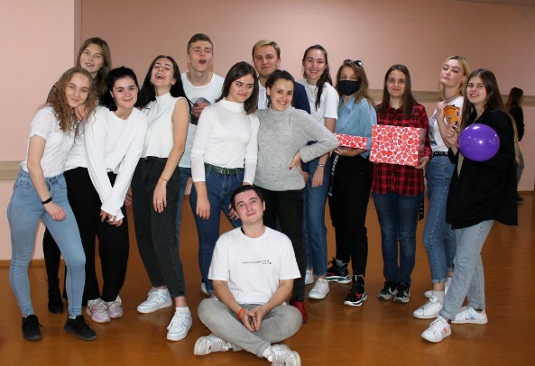

14 октября – День матери в Беларуси. Прекрасные женщины принимают поздравления, пожелания и слова благодарности в этот светлый день.
Существует два мнения об истории данного события. Согласно первому, это дань уважения матерям, благодаря которым у каждого из нас есть незабываемые светлые чувства и воспоминания, а также тем, кто преподал первые уроки доброты, нравственности, духовности и человеколюбия. Кроме того, есть версия, что история этого особого дня начинается с православного праздника Покрова Пресвятой Богородицы. День матери отмечают во многих странах мира, однако именно в Беларуси он приурочен к этому религиозному торжеству.

OUR EVENTS …
23 октября на факультете иностранных языков прошла юбилейная Х Международная научная конференция «Актуальные проблемы романо-германской филологии и методики преподавания иностранных языков», которая объединила ученых, проводящих научно-практические исследования в областях дискурс-анализа, сравнительно-сопоставительного языкознания, лингвистики и стилистики текста, прагматики, методики преподавания иностранных языков и т.д. В этом году конференция объединила ученых с разных континентов (Америка, Африка, Евразия). С докладами выступили ученые из Беларуси, России, США, Сербии, Казахстана, которые являются давними и надежными партнерами нашего факультета, в тесном сотрудничестве с которыми в жизнь были воплощены многочисленные проекты и, без всяких сомнений, еще будут реализованы в ближайшем будущем.
Преподаватели кафедры английского языка приняли активное участие в данной конференции.
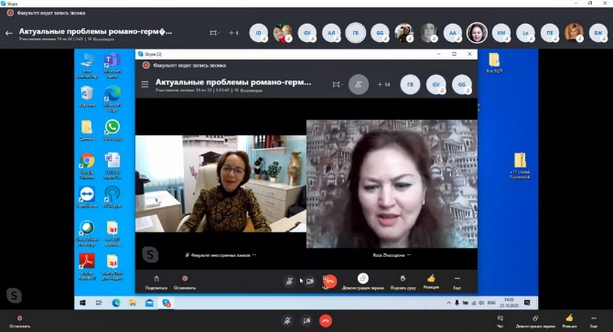

В Общественно-культурном центре Гомеля состоялась диалоговая площадка по обсуждению государственной молодежной политики. Обсуждались такие тематические аспекты, предложенные участниками для рассмотрения на государственном уровне как: – совершенствование системы участия заказчиков-кадров в подготовке будущих молодых специалистов в учреждениях высшего образования и в обеспечении первым рабочим местом;
– варианты работы с перспективной студенческой молодежью;
– развития предпринимательской инициативы студенческой молодежи и развитие социального предпринимательства в регионе; – повышение привлекательности и востребованности рабочих профессий;
– развитие системы наставничества для молодых специалистов и поддержка их профессионального развития и др.

29 октября на факультете математики и технологий программирования прошел англоязычный вебинар «Как войти в ИТ» для студентов 1 и 2 курсов.
Студенты принимали активное участие в вебинаре, задавали вопросы докладчикам на английском языке. Без знания английского языка практически невозможно получить работу в любой IT-компании. В крупных IT-компаниях на английском языке не только ведут переговоры с заказчиками, но и общаются внутри команды при работе над проектами. Поэтому студенту, не владеющему в должной мере английским языком, невозможно стать конкурентоспособным современным IT-специалистом.
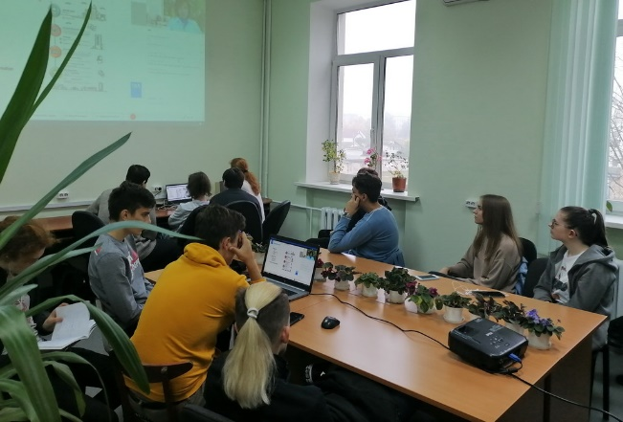

World’s news

Is it possible to change a chicken's sex before it hatches?

Billions of unwanted male chicks are slaughtered by the farming industry. Now a startup claims to have found a surprising solution to the problem.
The eggs we eat have a hidden cost. About 7bn male chicks are killed worldwide every year to produce them. Farmers need to replenish their supply of egg-laying hens but, by nature, half the chicks that hatch are male and growing them for meat is uneconomic – that industry uses faster growing breeds. In many countries they are tossed into shredding machines, although in the UK they are gassed.
But what if those male chicks could instead hatch out as functional females, able to grow into egg-laying birds? That’s the vision of Israeli startup Soos Technology. Founded in 2017, the company, which has received $3.3m in investment and prize winnings, wants to make commercial hatcheries kinder and more economic by changing the effective sex of poultry embryos as they develop.
Its technology exposes eggs to sound vibrations which, it says, alters the gene expression in developing male embryos, so rather than testes, an ovary forms instead (birds have only one). The company says its experiments are currently producing batches of chicks where 60% are observably female and it expects this to increase. “We are changing the sex of the chicken to dramatically decrease male chicks culled,” says Yael Alter, Soos’s CEO. Even if all male chicks aren’t converted, it could still make a difference. The company is currently piloting its technology at a commercial egg farm in Israel and has other pilots lined up with an Italian and a US egg producer.
Other startups are also working to solve the male chick problem. But they are focused on detecting egg sex prior to hatching, so the male eggs can be removed from incubators and disposed of earlier. Techniques include sampling the egg fluid and optical technologies to see inside. Hatcheries are looking to these as some European governments are trying to put an end to killing male chicks – including France by the end of 2021. Alter says Soos’s technology transforms eggs, so they don’t need disposal.
The idea that sound could be used to change the functional sex of chickens might seem far-fetched. But another external environmental factor, temperature, determines sex in many reptiles and some fish – though this does not apply in birds. And there is science that indicates gene expression can be influenced by sound. It was recently shown that when some types of cultured mouse cell were bombarded with sound emissions, genes involved in bone formation and wound healing were suppressed. “It is not yet widely accepted, but sound can be a biostimulation source at cellular level that triggers gene responses,” says Masahiro Kumeta, a researcher at Kyoto University in Japan pioneering this work. First, they note that a genetically male bird transformed by reducing DMRT1 so it developed an ovary would still look like a male bird: with more muscle, male feather patterns and bigger wattles and spurs. That is because birds seem to be less influenced by gonadal hormones, which in mammals masculinise or feminise the body after testes or ovaries have formed. Chicken cells have been shown to “know” innately whether they are genetically male or female, independently of hormones. “You can get males that have ovaries after modulating DMRT1, but the rest of the bird is still male,” Smith explains.
Second, a recent study by Clinton, not yet published, demonstrates that genetically male birds whose sex is “reversed” after reducing DMRT1 when they are embryos do not lay eggs. “We think the male brain does not provide the appropriate signals to the ovary,” says Clinton.
Soos acknowledges more testing is needed. “We are working towards publishing,” says Rotem Kadir, Soos’s scientific director. He notes that while the DMRT1 gene is the prime candidate for how the sound has an effect, it isn’t certain. “There could be other genes,” he says.
Soos is planning experiments in chicken cell cultures this year to try and elucidate the mechanism of the effect. But the focus at the moment is on increasing the number of females in each hatching cycle by developing a system to improve how sound is transmitted in the incubator, so each individual egg “hears” it at the same, optimal volume.
Both the campaign group People for the Ethical Treatment of Animals (Peta) and the producer’s group the British Egg Industry Council (BEIC) agree that if the technology is effective, it could be useful. Though Peta says it still won’t make eating supermarket eggs ethical because hens are still being exploited. The BEIC stresses that culled male chicks aren’t wasted – they are in high demand as a food source for reptiles and birds of prey in zoos and kept privately.
Alter knows what she would like stamped on egg boxes one day: “No male chicks killed to produce these eggs,” she says. “It is important for consumers to know.”

From http://www.theguardian.com

A GLIMPSE OF BRITAIN

Top 9 British etiquette tips

1) Complaining
The British love to complain! They will happily moan to one another about bad weather and overpriced food. They’re not, however, as accomplished at complaining when they have an actual problem with a product or receive poor service. When they do, they do it in an apologetic way! You’ll find Brits are polite even when they are complaining.

2) Queuing
Whether at the supermarket, train station or a concert, people across the UK will often be seen forming neat and tidy queues, awaiting their turn at the front. The worst mistake one can commit is queue-jumping – pushing ahead in the line. This will always be met with disapproval from those who have been waiting patiently.

3) Being polite
Saying “please” and “thank you” are two important things to remember in British etiquette. It doesn’t matter who you’re speaking to. Politeness and good manners are always welcomed.

4) Table manners
Table manners vary all over the world. From slurping to burping, each country has different ideas about how one should act during a meal. Although formal occasions have their own rules, everyday diners should remember to eat at a relaxed pace, put their cutlery down between bites and never talk with their mouth full.

5) Tipping
Sometimes even the Brits find it difficult to know how much to tip a server in cafes and restaurants, if anything at all. Following a meal, begin by checking the bill. If it reads ‘service not included’, this means you can leave a tip for the person that served you and the amount is at your discretion. If the service was good, it is customary to add an extra ten per cent on top of the bill total. Many Brits tip taxi drivers and hairdressers too, but the exact amount is the customer’s preference.

6) Using mobile phones in public
As we continue to use our mobile phones more frequently, it’s important to observe some unwritten etiquette about handheld devices. Using a mobile phone at the dinner table is considered impolite, as is speaking loudly when making a call, especially on public transport.

7) Good sportsmanship
Nobody, the adage goes, likes a bad loser. Sulking, arguing or complaining having lost at any form of competition is considered poor manners. Whether you’ve been outdone on the sports pitch or exceeded in the classroom, congratulate your opponent with good grace, no matter how upset you feel underneath.

8) Chivalry
Chivalry in gentlemen and other more traditional etiquette guidelines still stand. For instance, holding a door open for a lady and standing up when one enters the room for the first time are still considered good manners for the men of Britain.

9) Apologising
No guide to etiquette would be complete without mentioning the Brits’ love of apologising. Although one would expect to say sorry for stepping on a shopper’s toe or bumping into a passer-by, many will be surprised to find when two Brits engaged in a stand-off, both will offer their apologies for being in the other’s way. They don’t care who is at fault. Apologising is a default reaction to many of life’s little incidents. This is a quirk Brits are famed for!
«Welcome», студенческая газета кафедры английского языка ГГУ им. Ф. Скорины.
Редколлегия: Соболевич В.Ю., Пантелеенко М, Шевко В.
Уважаемые студенты и преподаватели! Присылайте в редакцию нашей газеты стихи, фотоработы, статьи и заметки на электронный адрес: victory_star.86@mail.ru
Наш адрес: 246019, г. Гомель, ул. Советская, 102, аудитория 3-19

